CHAPTER 2
SUPPLY AND DEMAND

SOLUTIONS TO END-OF-CHAPTER QUESTIONS

Demand
1.1 When the price of coffee changes, the change in the quantity demanded reflects a movement along the demand curve. When other variables that affect demand change, the entire demand curve shifts. For example, when income changes, this causes coffee demand to shift.
1.2 = 0.1.
An increase in Y shifts the demand curve to the right, from D₁ to D₂.
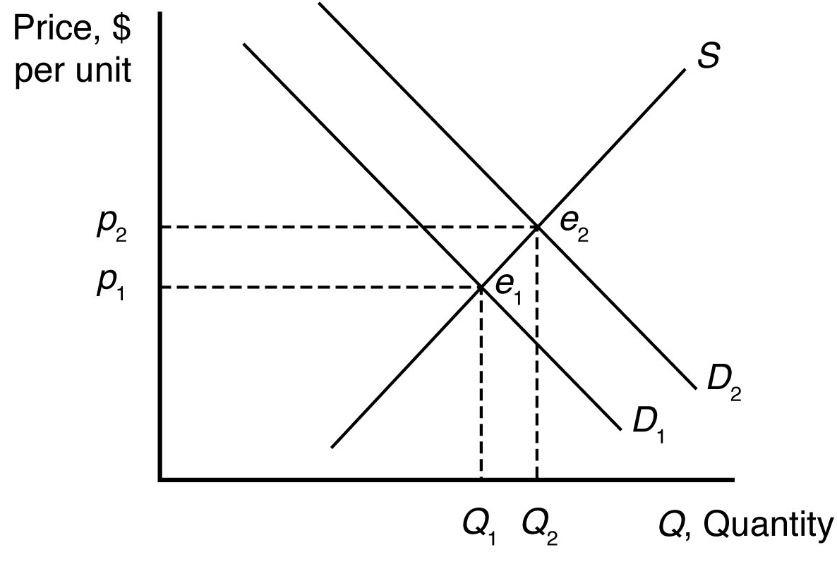
1.3 The relationship between the quantity of coffee ($Q$) and the price of sugar ($p_{s}$) is defined by the coefficient on the $p_{s}$ term in the equation. Since this coefficient is negative (it’s value is −0.3), an increase in the price of sugar ($p_{s}$) will decrease the quantity of coffee. This is the definition of a complementary good. More specifically, if the price of sugar goes up by $1.00 per pound, then the demand for coffee will fall by 300,000 tons.
1.4 The market demand curve is the sum of the quantity demanded by individual consumers at a given price. Graphically, the market demand curve is the horizontal sum of individual demand curves.
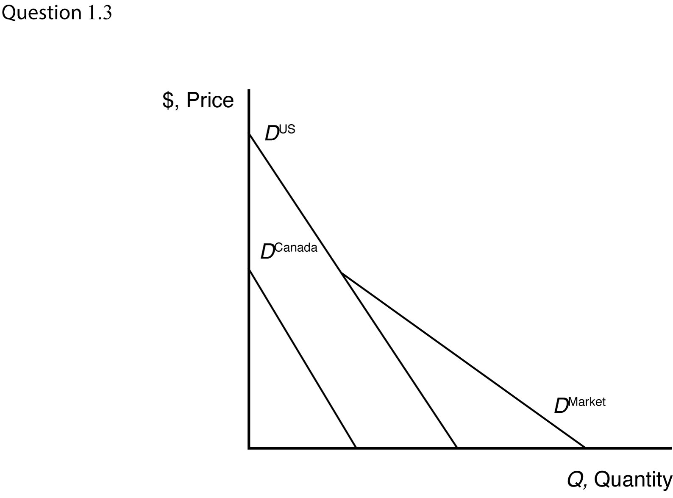
1.5 a. The inverse demand curve for other town residents is p = 200 − 0.5Q_{r}.
- At a price of $300, college students demand 100 units of firewood, and other residents demand no firewood. Other residents will demand zero units of firewood if the price is greater than or equal to $200.
- The market demand curve is the horizontal sum of individual demand curves, as illustrated below.
s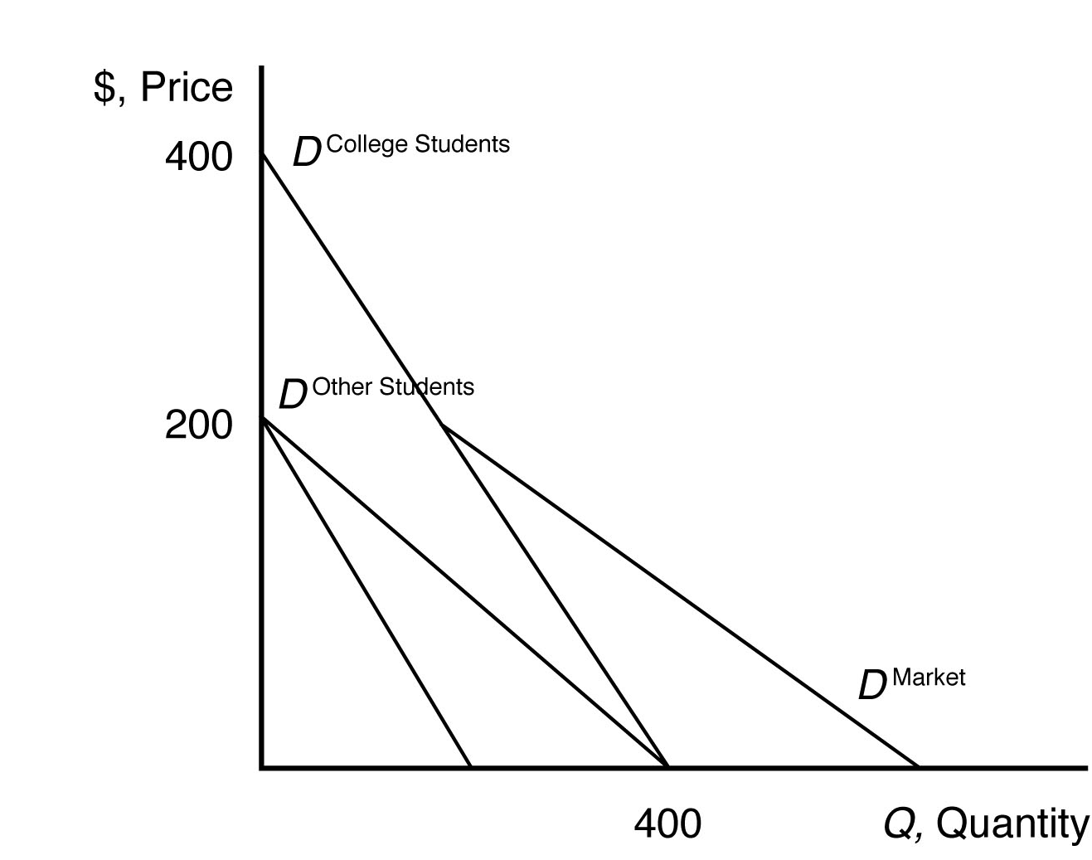

Supply
2.1 The effect of a change in p_{f} on Q is
= −20p_{f}
= −20(1.10)
= −22 units.
Thus, an increase in the price of fertilizer will shift the avocado supply curve to the left by 22 units at every price (i.e., a parallel shift to the left).
2.2 When the price of avocados changes, the change in the quantity supplied reflects a movement along the supply curve. When costs or other variables that affect supply change, the entire supply curve shifts. For example, the price of fertilizer represents a key factor of avocado production, which affects the cost of avocado production, shifting the avocado supply curve. This is because avocado prices are measured on a graph axis. Other factors that affect supply are not measured by a graph axis.
2.3 Given the supply function,
Q = 58 + 15p–20p_{f},
The effect of a change in p on Q is
= 15p.
To change quantity by 60, price would need to change by
60 = 15p
p = $4.00.
2.4 The market supply curve is the sum of the quantity supplied by individual producers at a given price. Graphically, the market supply curve is the horizontal sum of individual supply curves.
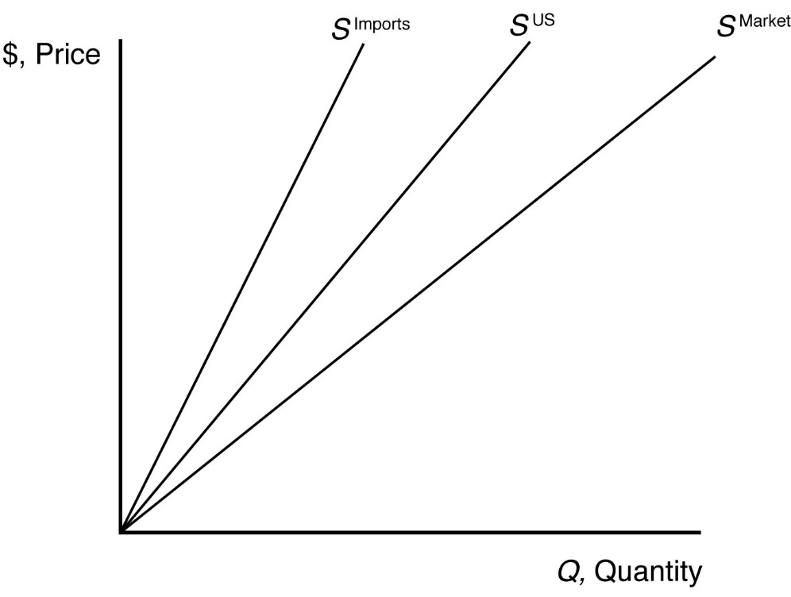

Market Equilibrium
3.1 The supply curve is upward sloping and intersects the vertical price axis at $6. The demand curve is downward sloping and intersects the vertical price axis at $4. When all market participants are able to buy or sell as much as they want, we say that the market is in equilibrium: a situation in which no participant wants to change its behavior. Graphically, a market equilibrium occurs where supply equals demand. An equilibrium does not occur at a positive quantity because supply does not equal demand at any price.
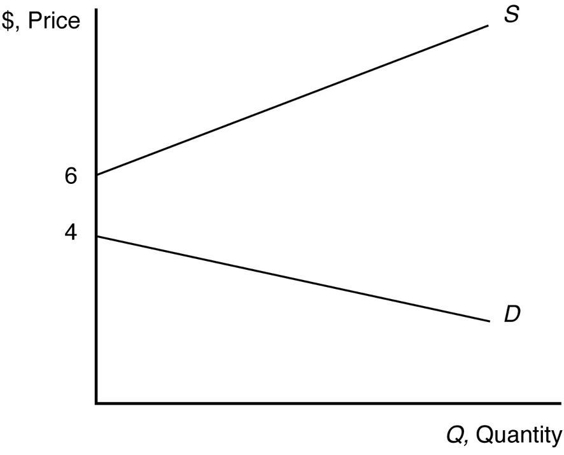
3.2 The equilibrium price is p = $300, and the equilibrium quantity is Q = 2000.
3.3 Given that p_{s} = $0.20, p_{c} = $5, and Y = $55,000 (note Y is measured in thousands, so the value to use here is 55), the demand for coffee can be rewritten as
Q = 14 − p
and the supply of coffee can be rewritten as
Q = 8.6 + 0.5p.
When all market participants are able to buy or sell as much as they want, we say that the market is in equilibrium: a situation in which no participant wants to change its behavior. Graphically, a market equilibrium occurs where supply equals demand. Thus, the equilibrium price is
D = S
14 − p = 8.6 + 0.5p
5.4 = 1.5p
p = $3.60.
Find the equilibrium quantity by substituting this price into either the supply or demand function. For example, using the supply function, the equilibrium quantity is
Q = 8.6 + 0.5p
Q = 8.6 + 0.5(3.60)
Q = 8.6 + 1.8
Q = 10.4 units.
3.4 If Y = $55,000, p_{s} = 0.20, p_{c} = $5, and p = 4, the quantity demanded is Q = 8.56 − 4 − 0.3(0.2) + 0.1(55) = 10. The quantity supplied is Q = 9.6 + 0.5(4) − 0.2(5) = 10.6. There is an excess supply equal to 10.6 − 10.0 = 0.6 in this case. Because of the excess supply, firms unable to sell at the price of $4 would lower their prices, forcing the market price down. Price would fall until the equilibrium price was reached.

Shocks to the Equilibrium
4.1 a. The new equilibrium with the horizontal supply curve is where the new demand curve intersects the horizontal supply curve. The new equilibrium price is unchanged. See figure.
- The new equilibrium with the vertical supply curve is where the new demand curve intersects the vertical supply curve. The new equilibrium price is higher. See figure.
- The new equilibrium with the upward-sloping supply curve is where the new demand curve intersects the upward-sloping supply curve. The new equilibrium price is higher. See figure.

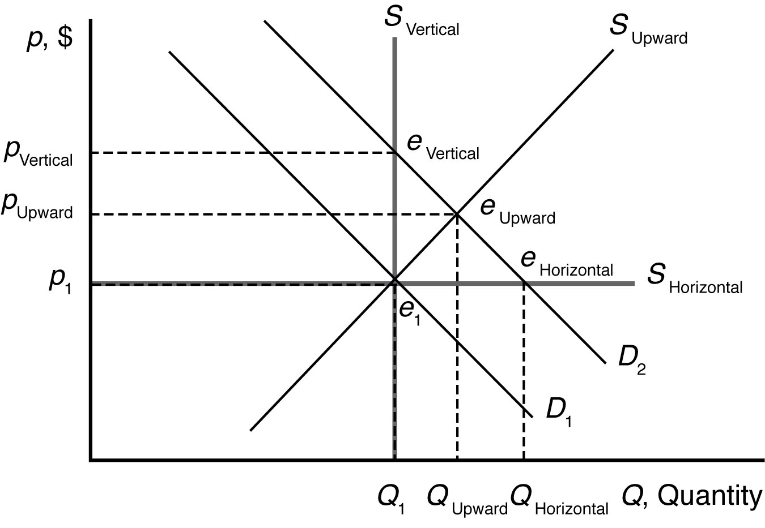
  - a. Health benefits from drinking coffee shift the demand curve for coffee to the right because more coffee is now demanded at each price. The new market equilibrium is where the original supply curve intersects the new coffee demand curve, at a higher price and larger quantity.
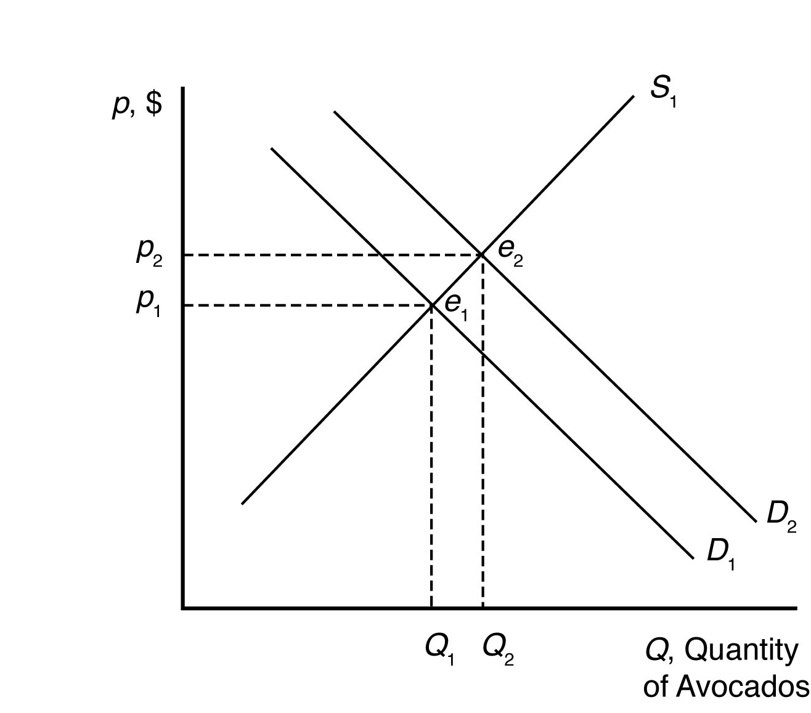
- An increase in the usefulness of cocoa will increase demand for cocoa. This will drive up the equilibrium price of cocoa. Since cocoa and coffee are likely substitutes, this will increase the demand for coffee. The new market equilibrium is where the original supply curve intersects the new coffee demand curve, at a higher price and higher quantity.
- A recession shifts the demand curve for coffee to the left because less coffee is now demanded at each price. The new market equilibrium is where the original supply curve intersects the new coffee demand curve, at a lower price and lower quantity.
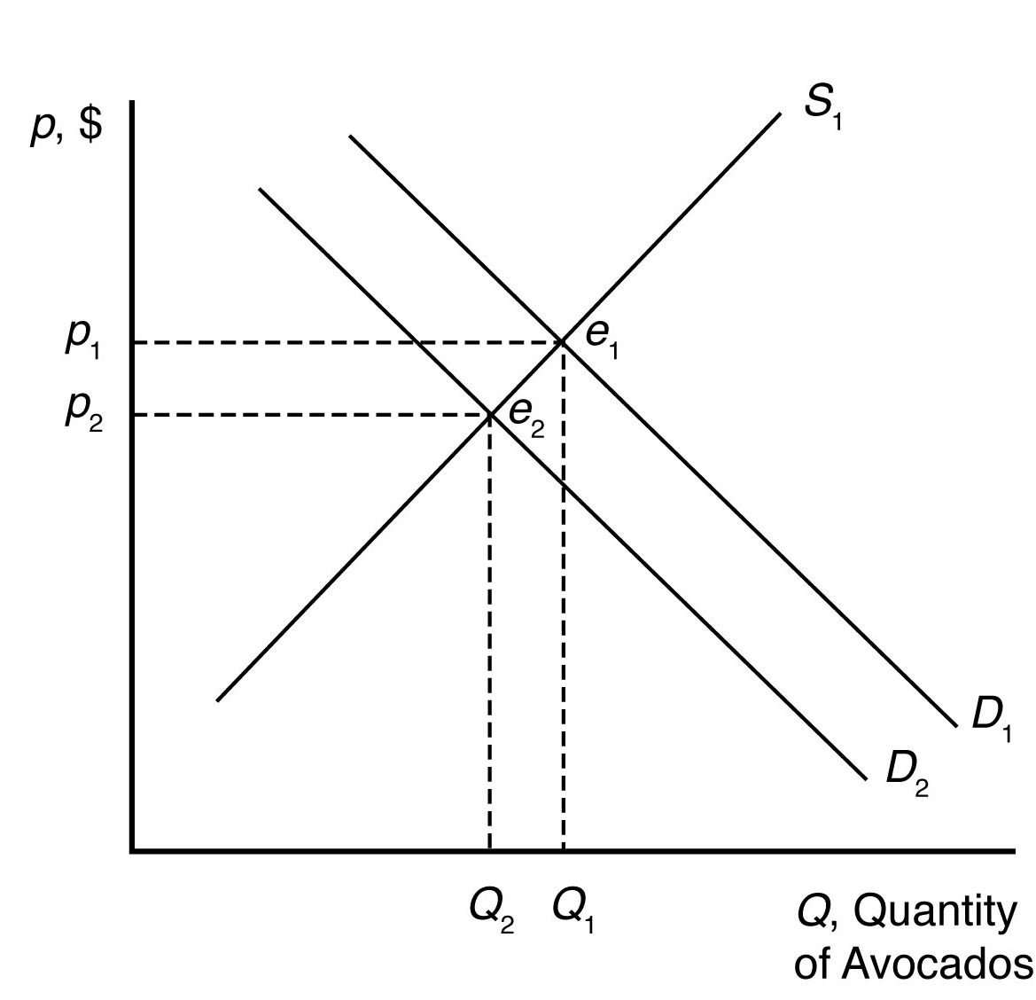
- New technologies increasing yields shift the supply curve for coffee to the right because more coffee is now supplied at each price. The new market equilibrium is where the original demand curve intersects the new avocado supply curve, at a lower price and higher quantity.
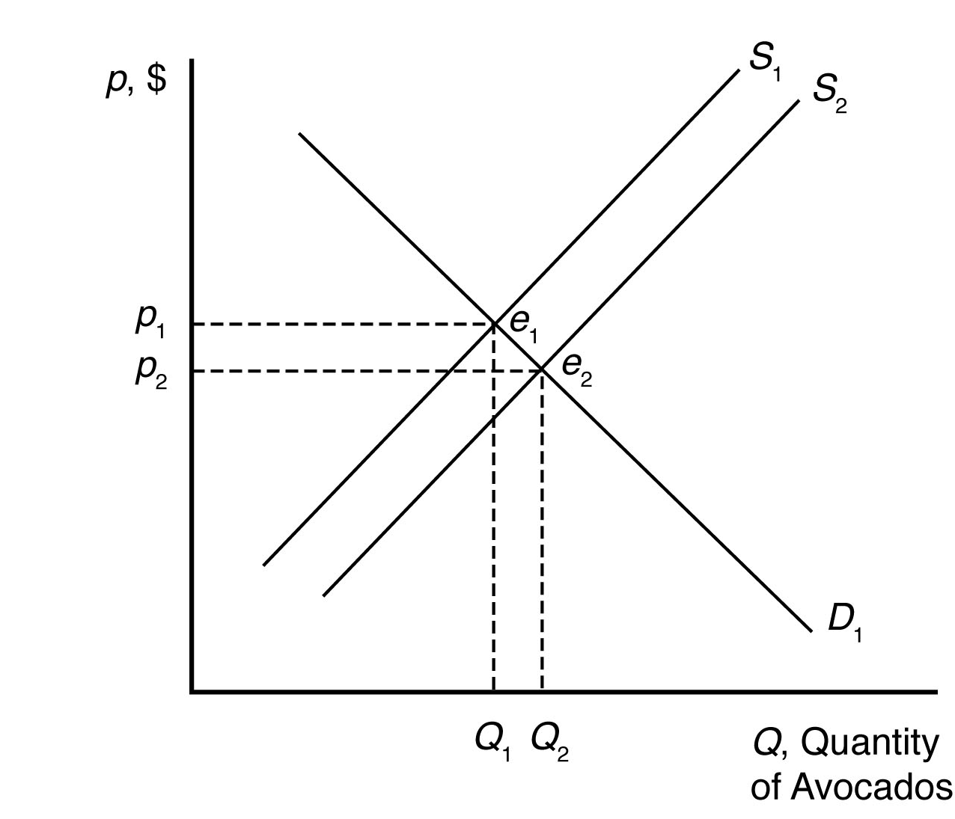
4.3 Outsourcing shifts the labor demand curve to the right because more Indian workers are demanded at each wage. The new market equilibrium is where the original supply curve intersects the new labor demand curve.
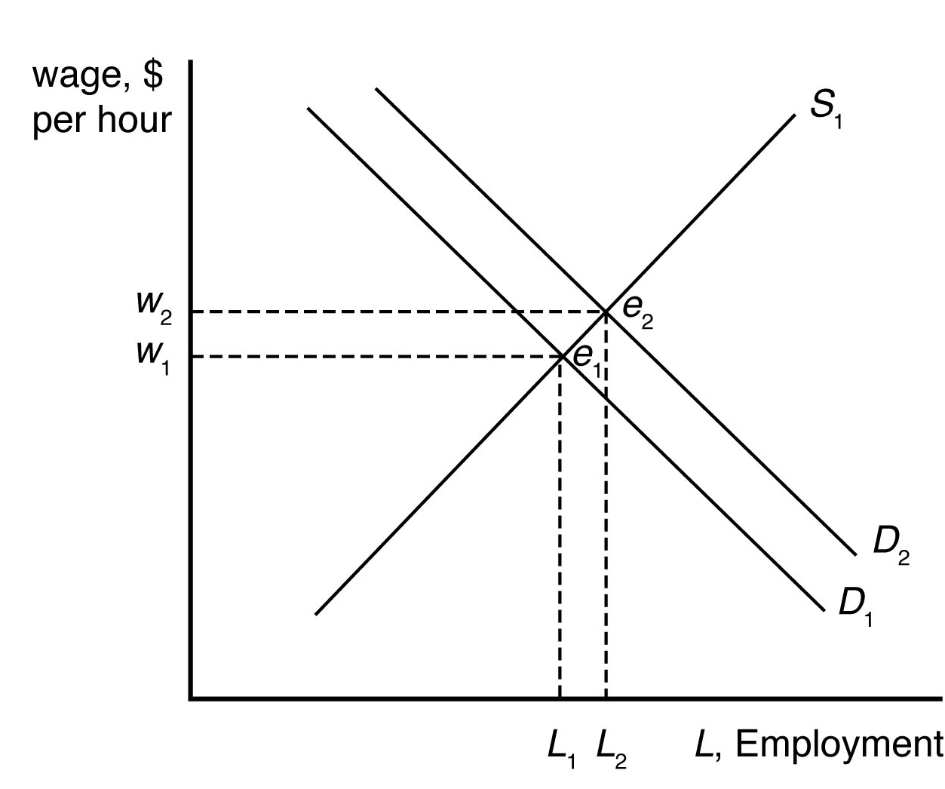
4.4 Given that p_{t} = $0.80, the demand for avocados can be rewritten as
Q = 160 − 40p
and the supply of avocados can be rewritten as
Q = 50 + 15p.
When all market participants are able to buy or sell as much as they want, we say that the market is in equilibrium: a situation in which no participant wants to change its behavior. Graphically, a market equilibrium occurs where supply equals demand. Thus, the equilibrium price is
D = S
160 − 40p = 50 + 15p
110 = 55p
p = $2.00.
Find the equilibrium quantity by substituting this price into either the supply or demand function. For example, using the supply function, the equilibrium quantity is
Q = 50 + 15p
Q = 50 + 15(2.00)
Q = 50 + 30
Q = 80 units.
When the price of tomatoes increases to $1.35, the demand curve for avocados shifts out to
Q = 171 − 40p
The supply of avocados is unchanged. The new equilibrium is found where
D = S
171 − 40p = 50 + 15p
121 = 55p
p = $2.20.
The equilibrium quantity is found as before
Q = 50 + 15p
Q = 50 + 15(2.20)
Q = 50 + 33
Q = 83 units.

4.5 A leftward shift in the labor supply curve will drive up wages and reduce employment. The size of these effects will depend on the relative slopes of the supply and demand curves for labor.
4.6 The damage reduces the supply of oranges, increasing the equilibrium price and decreasing the equilibrium quantity of orange juice.
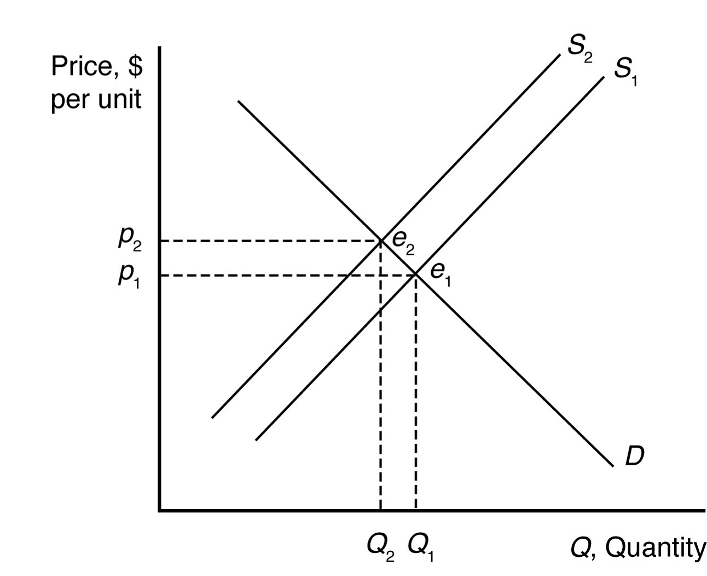
The demand for grapefruit juice increases as the price of orange juice increases because grapefruit juice is a substitute. As the demand for grapefruit juice increases, the equilibrium price and quantity of grapefruit juice increase.
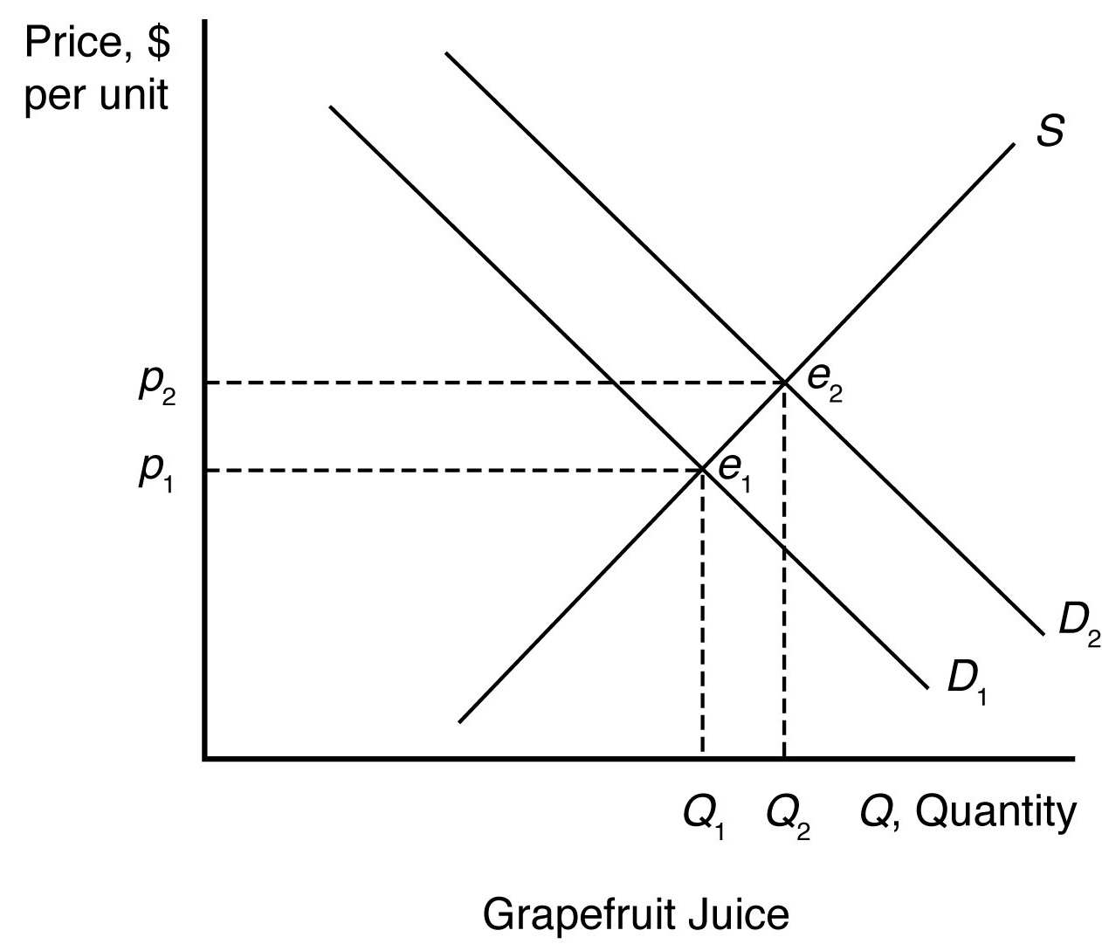
4.7 The increased use of corn for producing ethanol will shift the demand curve for corn to the right. This increases the price of corn overall, reducing the consumption of corn as food.
4.8 Suppose supply is initially S₁, but it decreases by a small amount to S₂ after the BP oil spill. When all market participants are able to buy or sell as much as they want, we say that the market is in equilibrium: a situation in which no participant wants to change its behavior. Graphically, a market equilibrium occurs where supply equals demand. The original market equilibrium is where the original demand curve intersects the original supply curve (e₁). The new market equilibrium is where the original demand curve intersects the new supply curve (e₂). When the supply curve shifts by a relatively small amount, the change in the equilibrium price is likely to be small.
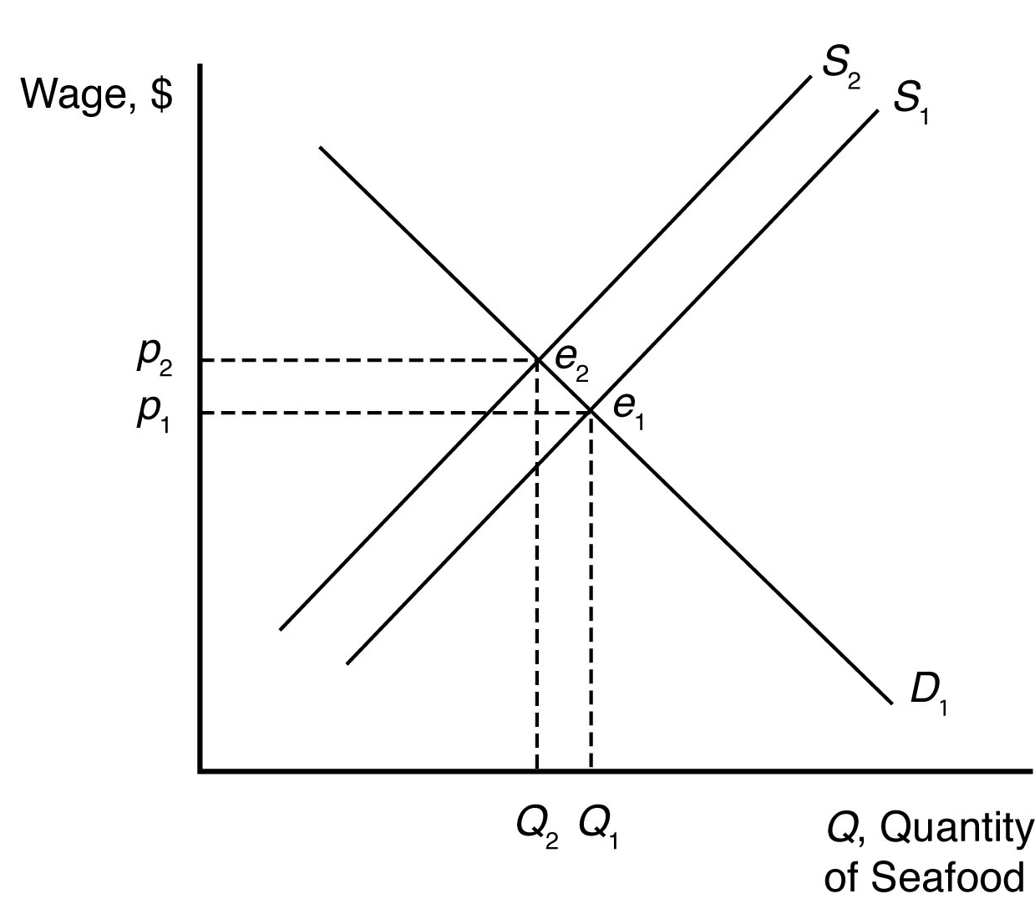
4.9 Concerns about botulism caused the demand curve for baby formula to shift in. (A lower quantity was demanded at any given price.) This demand curve shift would put downward pressure on price and quantity. The removal of production permits caused the supply curve to shift in. (A lower quantity was supplied at any given price.) This supply curve shift would put upward pressure on price and downward pressure on quantity. Overall, the price could rise or fall depending on the relative size of the demand curve and supply curve shifts. However, quantity would have to fall.

p2
p1

Q1
Q2

4.10 An increase in petroleum prices shifts the aluminum supply curve to the left because the cost of producing aluminum is more expensive at each price. An increase in the cost of petroleum also shifts the demand curve for aluminum to the right because the petroleum price increase makes a substitute, plastic, more expensive (by making the cost of plastic production higher). The new equilibrium is where the new aluminum supply curve intersects the new aluminum demand curve.
When the supply curve shifts to the left, the new equilibrium price is higher and the new equilibrium quantity is lower. When the demand curve shifts to the right, the new equilibrium price is higher and the new equilibrium quantity is higher. When both curves shift, the new equilibrium price is higher, but the new equilibrium quantity could be higher, lower, or unchanged.
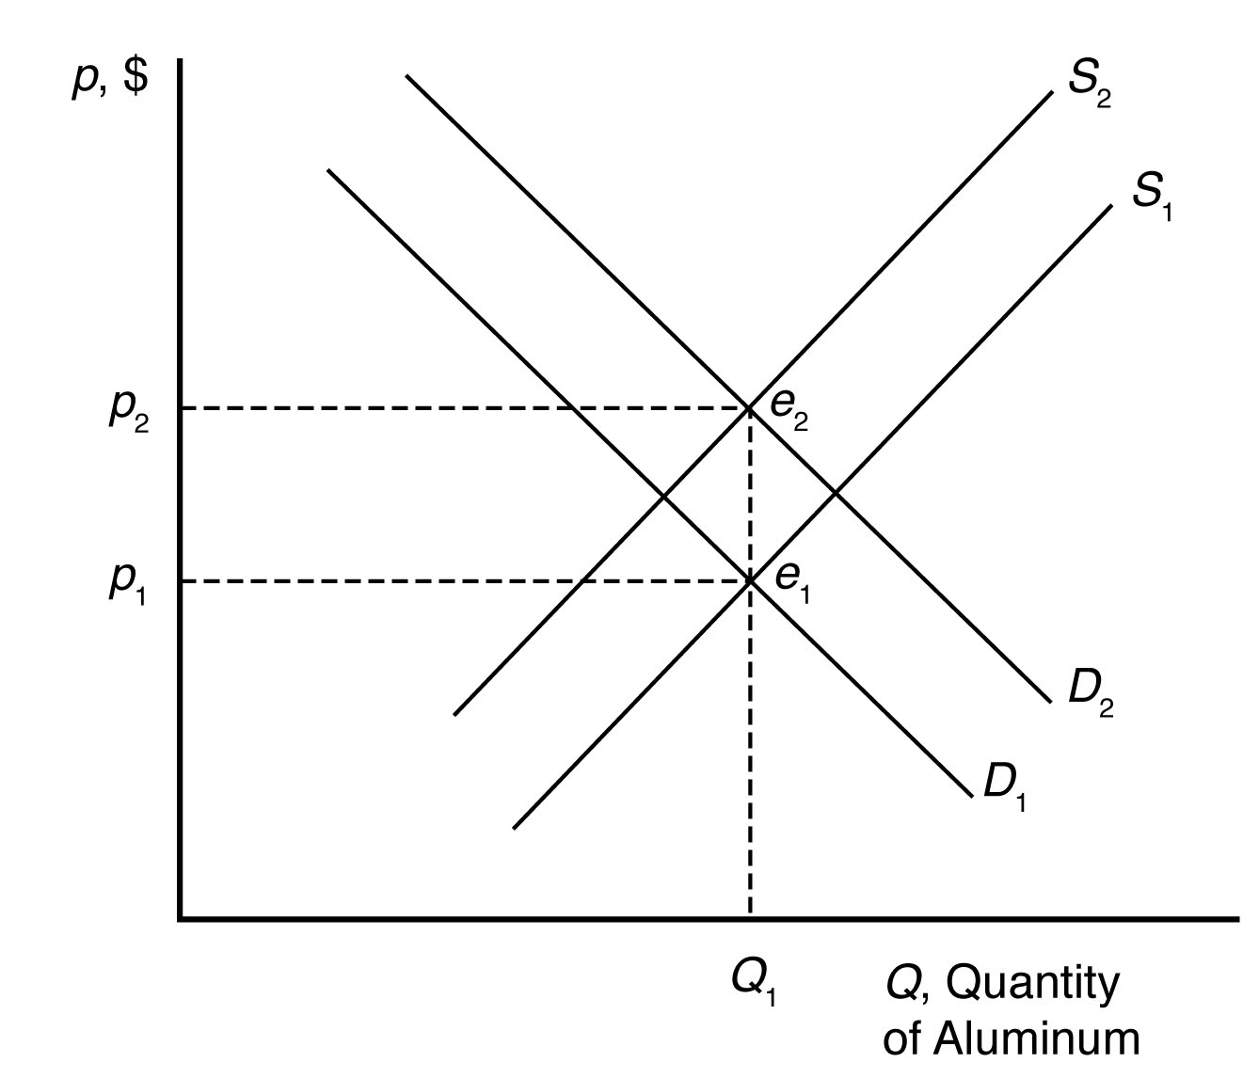
4.11 The cartoon seems to show a bumper harvest of lobsters. A large increase in the catch will shift the supply curve to the right (from S₁ to S₂) which will cause price to fall from p₁ to p₂.

4.12 When drilling increases in response to the rising price of crude oil, the demand for bentonite increases as well. The demand curve will shift to the right and cause the equilibrium price and quantity of bentonite to increase. This is illustrated in the picture below:

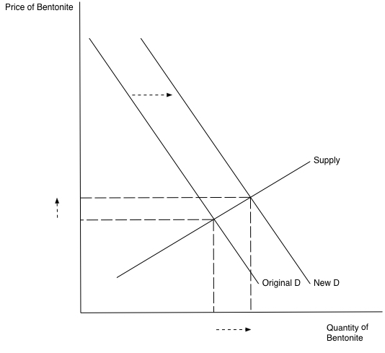

Effects of Government Interventions

5.1 The effect of vendor licensing is to reduce the number of street vendors relative to the undistorted market equilibrium. Therefore, the number of handbags (and other products) offered for sale by street vendors is less than it would be without licensing (with free entry). As a result, the supply curve for handbags available from street vendors has shifted in compared with what it would be without licensing. The diagram representing the street vendor handbag market is therefore similar to the diagram in Q&A 2.2. The market price is higher and the quantity sold is lower than it would be without mandatory licensing.
5.2 In the absence of price controls, the leftward shift of the supply curve as a result of Hurricane Katrina would push market prices up from p₀ to p₁ and reduce quantity from q₀ to q₁. At a government imposed maximum price of p₂, consumers would want to purchase q^{d} units, but producers would only be willing to sell q^{s} units. The resulting shortage would impose search costs on consumers making them worse off. The reduced quantity and price also reduced firms’ profits.
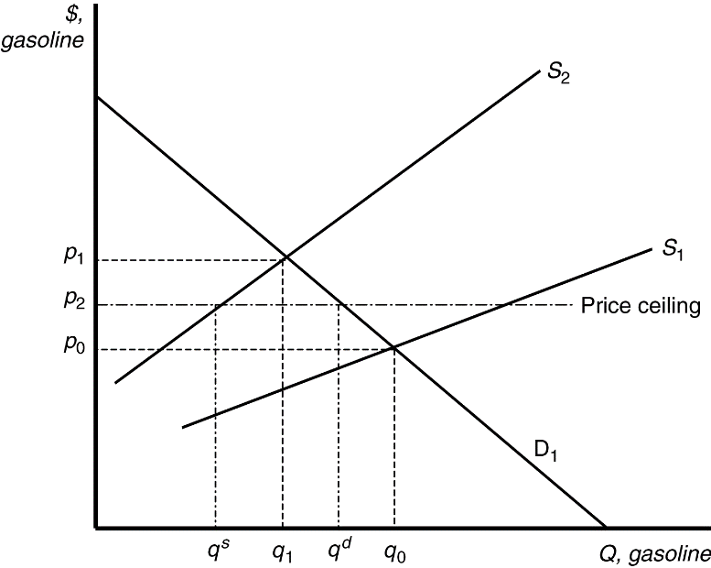
5.3 With a binding price ceiling, such as a ceiling on the rate that can be charged on loans, some consumers who demand loans at the rate ceiling will be unable to obtain them. This is because the demand for bank loans is greater than the supply of bank loans to low-income households with the usury law.
5.4 With the binding rent ceiling, the quantity of rental dwellings demanded is that quantity where the rent ceiling intersects the demand curve (Q_{D}). The quantity of rental dwellings supplied is that quantity where the rent ceiling intersects the supply curve (Q_{S}). With the rent control laws, the quantity supplied is less than the quantity demanded, so there is a shortage of rental dwellings.
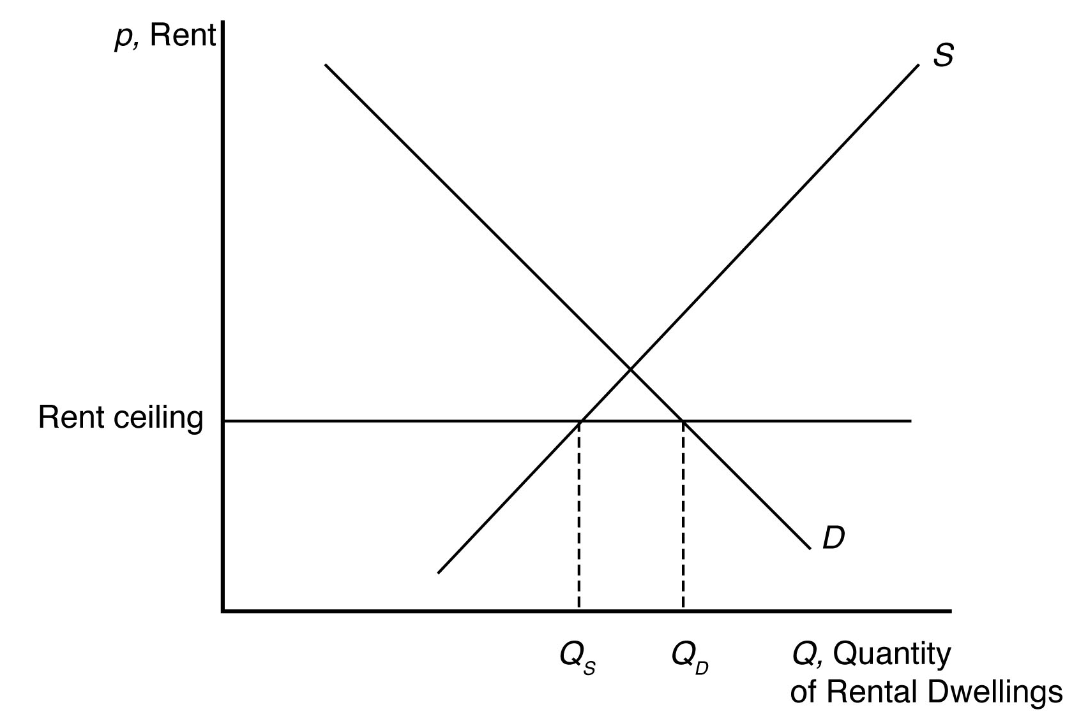
5.5 We can determine how the total wage payment, W = wL(w), varies with respect to w by differentiating. We then use algebra to express this result in terms of an elasticity:
where ε is the elasticity of demand of labor. The sign of dW/dw is the same as that of 1 + ε. Thus, total labor payment decreases as the minimum wage forces up the wage if labor demand is elastic, ε < –1, and increases if labor demand is inelastic, ε > –1.
For a graphical explanation, see the figures below. In the top panel with very flat supply and demand curves, the imposition of a minimum wage causes overall wage payments to fall dramatically. On the other hand, when supply and demand curves are steep (as in the bottom panel), overall wage payments increase substantially.
5.6 Before the tax is imposed, the demand for avocados can be rewritten as
Q = 160 − 40p
and the supply of avocados is given as
Q = 50 + 15p.
When all market participants are able to buy or sell as much as they want, we say that the market is in equilibrium: a situation in which no participant wants to change its behavior. Graphically, a market equilibrium occurs where supply equals demand. Thus, the equilibrium price is
D = S
160 − 40p = 50 + 15p
110 = 55p
p = $2.00.
Find the equilibrium quantity by substituting this price into either the supply or demand function. For example, using the supply function, the equilibrium quantity is
Q = 50 + 15p
Q = 50 + 15(2.0)
Q = 50 + 30
Q = 80 units.
If a $0.55 tax is imposed, the demand curve can be rewritten to account for the tax. First, the demand curve can be rewritten as inverse demand by solving for p
Q = 160 − 40p
p = 4 − 0.025Q.

The tax is subtracted from inverse demand to give
p = 3.45 − 0.025Q
and then this inverse demand curve can be turned back into a demand curve
Q = 138 − 40p.

Setting supply equal to demand, the new equilibrium (pretax) price is
D = S
138 − 40p = 50 + 15p
88 = 55p
p = $1.60.
The after-tax price is $2.15.

Using the supply function, the equilibrium quantity is
Q = 50 + 15p
Q = 50 + 15(1.60)
Q = 50 + 24
Q = 74 units.
5.7 a. If demand is vertical and supply is upward sloping, then all the tax burden is paid by consumers because they are not price sensitive.
- If demand is horizontal and supply is upward sloping, then all the tax burden is paid by producers because consumers are infinitely price sensitive.
- If demand is downward sloping and supply is horizontal, then all the tax burden is paid by consumers because producers are infinitely price sensitive.
5.8 If instead of the tax being levied on producers it is collected from consumers, then the effect will be a decrease in demand. The demand curve will shift left until the vertical distance between the original demand curve and the new one is equal to the tax of $2.40. This new demand curve, call it D², will intersect the original supply curve (S1) at a price of $5.60 and a quantity of 11.6. In addition to the price of $5.60 per bushel, buyers will also have to pay the $2.40 tax for a total, after-tax price of $8.00. The seller will receive the $5.60 per bushel, and the government will collect $27.84 billion in tax revenue (the $2.40 tax multiplied by the 11.6 billion bushels of corn traded in the new equilibrium).

This equilibrium is not the same as the case in Q&A 2.3 because in that problem the supply curve is perfectly elastic, while in this case it is not. In Q&A 2.3, the seller passes on the entire tax to consumers, while here, the tax is split with $0.80 being paid by consumers and $1.60 paid by producers.
5.9 A tax on consumers will undoubtedly shift the demand curve down by an amount equal to the size of the tax. The new equilibrium price and quantity with the tax will be where the new demand curve intersects the original supply curve. The decrease in quantity will be larger (and tax revenue smaller) the more horizontal the supply curve is. Just the opposite is true if the supply curve is more vertical—quantity effects will be small, and revenue generation from the tax will be large.
When to Use the Supply-and-Demand Model
6.1 The supply-and-demand model is accurate in perfectly competitive markets, which are markets in which all firms and consumers are price takers: no market participant can affect the market price. If there is only one seller of a good or service—a monopoly—that seller is a price taker and can affect the market price. Firms are also price setters in an oligopoly—a market with only a small number of firms. Experience has shown that the supply-and-demand model is reliable in a wide range of markets, such as those for agriculture, financial products, labor, construction, many services, real estate, wholesale trade, and retail trade.

Managerial Problem
7.1 A tax paid by consumers shifts the demand curve down by an amount equal to the size of the tax. Just the opposite, suspending a tax on consumers should raise the demand curve by an amount equal to the size of the suspended tax. Although fuel supply is more likely to be vertical in the short run than in the long run, equilibrium fuel prices will increase when the demand curve shifts up whether the supply curve is vertical or upward sloping.

SOLUTIONS TO SPREADSHEET EXERCISES
Solutions Available on MyLab Economics

