Chapter 1
The Corporation
1-1. What is the most important difference between a corporation and all other organizational forms?
A corporation is a legal entity separate from its owners.

1-2. What does the phrase limited liability mean in a corporate context?
Owners’ liability is limited to the amount they invested in the firm. Stockholders are not responsible for any encumbrances of the firm; in particular, they cannot be required to pay back any debts incurred by the firm.

1-3. Which organizational forms give their owners limited liability?
Corporations and limited liability companies give owners limited liability. Limited partnerships provide limited liability for the limited partners, but not for the general partners.

1-4. What are the main advantages and disadvantages of organizing a firm as a corporation?
Advantages: Limited liability, liquidity, infinite life
Disadvantages: Double taxation, separation of ownership and control

1-5. Explain the difference between an S corporation and a C corporation.
C corporations must pay corporate income taxes; S corporations do not pay corporate taxes, but must pass through the income to shareholders to whom it is taxable. S corporations are also limited to 100 shareholders and cannot have corporate or foreign stockholders.

1-6. You are a shareholder in a C corporation. The corporation earns $2 per share before taxes. Once it has paid taxes it will distribute the rest of its earnings to you as a dividend. The corporate tax rate is 40% and the personal tax rate on (both dividend and non-dividend) income is 30%. How much is left for you after all taxes are paid?
First, the corporation pays the taxes. After taxes, is left to pay dividends. Once the dividend is paid, personal tax must be paid, which leaves . So, after all the taxes are paid, you are left with 84¢.

1-7. Repeat Problem 6 assuming the corporation is an S corporation.
An S corporation does not pay corporate income tax. So it distributes $2 to its stockholders. These stockholders must then pay personal income tax on the distribution. So they are left with .
1-8. You have decided to form a new start-up company developing applications for the iPhone. Give examples of the three distinct types of financial decisions you will need to make.
As the manager of an iPhone applications developer, you will make three types of financial decisions.
i. You will make investment decisions, such as determining which type of iPhone application projects will offer your company a positive NPV and that your company, therefore, should develop.
ii. You will make the decision on how to fund your iPhone application investments and what mix of debt and equity your company will have.
iii. You will be responsible for the cash management of your company, ensuring that your company has the necessary funds to make investments, pay interest on loans, and pay your employees.

1-9. When a pharmaceutical company develops a new drug, it often receives patent protection for that medication, allowing it to charge a higher price. Explain how this public policy of providing patent protection might help align the corporation’s interests with society’s interests.
Without patent protection, the developer of the drug would be forced to lower prices to compete with generic manufacturers. Because this price competition would lower expected future profits, the developer would be willing to spend much less in R&D to develop the drug initially, and drug innovation would be curtailed.

Alternatively, by allowing the drug’s developer to earn higher profits that are commensurate with the value of the drug to society, drug developers will find it in their best interests to spend more on R&D, and drug innovation is enhanced. Thus, patent protection can align the corporation’s and society’s interests and provide for more efficient spending on drug R&D.

1-10. Corporate managers work for the owners of the corporation. Consequently, they should make decisions that are in the interests of the owners, rather than their own. What strategies are available to shareholders to help ensure that managers are motivated to act this way?
Shareholders can do the following.
i. Ensure that employees are paid with company stock and/or stock options.
ii. Ensure that underperforming managers are fired.
iii. Write contracts that ensure that the interests of the managers and shareholders are closely aligned.
iv. Mount hostile takeovers.

1-11. Suppose you are considering renting an apartment. You, the renter, can be viewed as an agent while the company that owns the apartment can be viewed as the principal. What principal-agent conflicts do you anticipate? Suppose instead that you work for the apartment company. What features would you put into the lease agreement that would give the renter incentives to take good care of the apartment?
The agent (renter) will not take the same care of the apartment as the principal (owner) because the renter does not share in the costs of repairing damage to the apartment. To mitigate this problem, having the renter pay a deposit should motivate the renter to keep damages to a minimum. The deposit forces the renter to share in the costs of repairing any problems that they cause.

1-12. You are the CEO of a company and you are considering entering into an agreement to have your company buy another company. You think the price might be too high, but you will be the CEO of the combined, much larger, company. You know that when the company gets bigger, your pay and prestige will increase. What is the nature of the agency conflict here and how is it related to ethical considerations?
There is an ethical dilemma when the CEO of a firm has the opposite incentives to those of the shareholders. In this case, you (as the CEO) have an incentive to potentially overpay for another company (which would be damaging to your shareholders) because your pay and prestige will improve.

1-13. Are hostile takeovers necessarily bad for firms or their investors? Explain.
No. They are a way to discipline managers who are not working in the interests of shareholders.

1-14. What is the difference between a public and private corporation?
The shares of a public corporation are traded on a public exchange (or “over the counter” in an electronic trading system), while the shares of a private corporation are not traded on a public exchange.

1-15. Describe the important changes that have occurred in stock markets over the last decade.
Markets have become more fragmented, stocks no longer predominantly trade on the markets on which they are listed, off-exchange transactions in dark pools are now much more common, and official market makers have largely disappeared, replaced now by the limit order book.

1-16. Explain why the bid-ask spread is a transaction cost.
Investors always buy at the ask and sell at the bid. Because ask prices always exceed bid prices, investors “lose” this difference. It is one of the costs of transacting. Because the market makers take the other side of the trade, they make this difference.

1-17. Explain how the bid-ask spread is determined in most markets today.
The bid-ask spread of a stock is determined by the outstanding limit orders. The limit sell order with the lowest price is the ask price. The limit buy order with the highest price is the bid price. The bid-ask spread is determined by the best bid and offer prices in the limit order book

1-18. The following quote on Altaba (formerly Yahoo!) stock appeared on June 13, 2018, on Yahoo!
Finance:
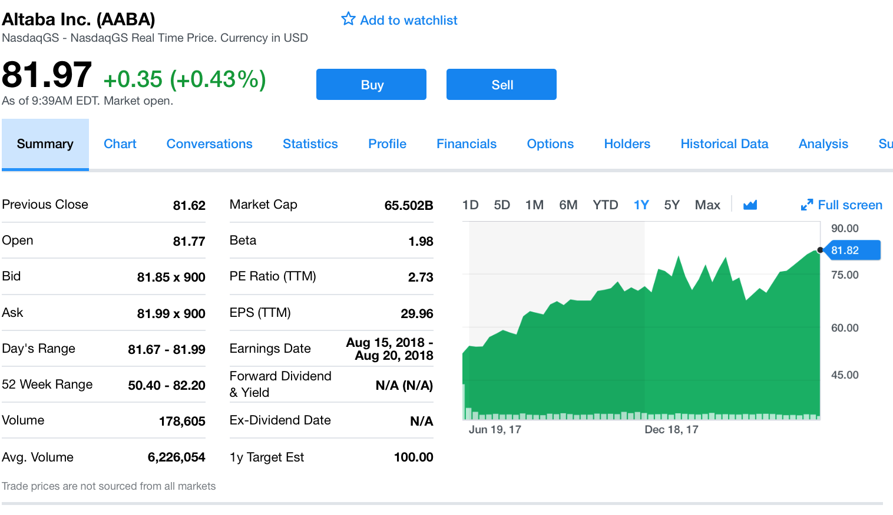

If you wanted to buy Altaba, what price would you pay? How much would you receive if you wanted to sell Altaba?
You would buy at $81.99 and sell for $81.85.

1-19. Suppose the following orders are received by an exchange for Cisco stock:
• Limit Order: Buy 200 shares at $25
• Limit Order: Sell 200 shares at $26
• Limit Order: Sell 100 shares at $25.50
• Limit Order: Buy 100 shares at $25.25

a) What are the best bid and ask prices for Cisco stock?
Best bid = $25.25, Best ask = $25.50
b) What is the current bid-ask spread for Cisco stock?
Bid-Ask spread = $25.50 – 25.25 = $0.25
c) Suppose a market order arrives to buy 200 shares of Cisco. What average price will the buyer pay?
Buy 100 shares at $25.50 and 100 shares at $26, for an average price of $25.75
d) After the market order in (c) clears, what are the new best bid and ask prices, and what is the new bid-ask spread for Cisco?
Best bid = $25.75, Best ask = $26, Bid-Ask spread = $0.25

1-20. Why has finance historically been an early adopter of new technology?
The financial industry has very large profits and is very competitive. Adopting the latest technology can lead to a competitive advantage. Given the large profits that a competitive advantage provides, the incentives to use the technology are high.

1-21. How are the following companies utilizing new technology in the provision of financial services?
a) Wealthfront
Wealthfront is a financial planning and robo-advisor. It used the advances in artificial intelligence to provide computer based investment advice.
b) LendingTree
Lending Tree is an alternative loan platform that links consumers to individual lenders using their online platform.
c) Metromile
Metromile is a car insurer that allows consumers to pay by the number of miles they drive. The data on how much its customers are driving is collected automatically through a small wireless device located in each insured car.
d) Acorns
Acorns is a robo-advisor with a twist. They link to customer purchases and automatically invest their money based on a rule such as “taking the change”. They combine both the artificial intelligence technology of how to invest with the communications technology of being able to implement rules like invest the change from every purchase.

