Personal Finance, 13e (Kapoor)
Chapter 1 Personal Finance Basics and the Time Value of Money

1) Increased demand for a product or service will usually result in lower prices for the item.

Answer: FALSE
Difficulty: 1 Easy
Topic: Economic conditions and factors
Learning Objective: 01-02 Assess personal and economic factors that influence personal financial planning.
Bloom's: Understand
Accessibility: Keyboard Navigation; Screen Reader Compatible
Gradable: automatic

2) Inflation reduces the buying power of the dollar.

Answer: TRUE
Difficulty: 1 Easy
Topic: Economic conditions and factors
Learning Objective: 01-02 Assess personal and economic factors that influence personal financial planning.
Bloom's: Remember
Accessibility: Keyboard Navigation; Screen Reader Compatible
Gradable: automatic

3) Lenders benefit more than borrowers in times of high inflation.

Answer: FALSE
Difficulty: 3 Hard
Topic: Economic conditions and factors
Learning Objective: 01-02 Assess personal and economic factors that influence personal financial planning.
Bloom's: Understand
Accessibility: Keyboard Navigation; Screen Reader Compatible
Gradable: automatic

4) Economics is the study of using money to achieve financial goals.

Answer: FALSE
Difficulty: 2 Medium
Topic: Economic conditions and factors
Learning Objective: 01-02 Assess personal and economic factors that influence personal financial planning.
Bloom's: Remember
Accessibility: Keyboard Navigation; Screen Reader Compatible
Gradable: automatic

5) Reduced spending causes unemployment from staff reduction.

Answer: TRUE
Difficulty: 2 Medium
Topic: Economic conditions and factors
Learning Objective: 01-02 Assess personal and economic factors that influence personal financial planning.
Bloom's: Understand
Accessibility: Keyboard Navigation; Screen Reader Compatible
Gradable: automatic

6) A financial plan is another name for a budget.

Answer: FALSE
Difficulty: 2 Medium
Topic: Financial plan development
Learning Objective: 01-05 Identify strategies for achieving personal financial goals for different life situations.
Bloom's: Remember
Accessibility: Keyboard Navigation; Screen Reader Compatible
Gradable: automatic

7) Developing and using a budget is part of the "obtaining" component of financial planning.

Answer: FALSE
Difficulty: 1 Easy
Topic: Components of Financial Planning
Learning Objective: 01-05 Identify strategies for achieving personal financial goals for different life situations.
Bloom's: Remember
Accessibility: Keyboard Navigation; Screen Reader Compatible
Gradable: automatic

8) Planning to buy a car is an example of an intangible-purchase goal.

Answer: FALSE
Difficulty: 2 Medium
Topic: Financial Goals
Learning Objective: 01-03 Develop personal financial goals.
Bloom's: Understand
Accessibility: Keyboard Navigation; Screen Reader Compatible
Gradable: automatic

9) Opportunity costs refer to what a person gives up when making a choice.

Answer: TRUE
Difficulty: 2 Medium
Topic: Opportunity Costs
Learning Objective: 01-04 Calculate time value of money to analyze personal financial decisions.
Bloom's: Remember
Accessibility: Keyboard Navigation; Screen Reader Compatible
Gradable: automatic

10) Personal opportunity costs refer to time, effort, and health that are given up when a decision is made.

Answer: TRUE
Difficulty: 2 Medium
Topic: Opportunity Costs
Learning Objective: 01-04 Calculate time value of money to analyze personal financial decisions.
Bloom's: Remember
Accessibility: Keyboard Navigation; Screen Reader Compatible
Gradable: automatic

11) Time value of money refers to changes in consumer spending when inflation occurs.

Answer: FALSE
Difficulty: 2 Medium
Topic: Time value of money - interest rates and inflation
Learning Objective: 01-04 Calculate time value of money to analyze personal financial decisions.
Bloom's: Remember
Accessibility: Keyboard Navigation; Screen Reader Compatible
Gradable: automatic

12) Interest on savings is calculated by multiplying the principal amount times the opportunity cost times the annual interest rate.

Answer: FALSE
Difficulty: 3 Hard
Topic: Time value of money - interest rates and inflation
Learning Objective: 01-04 Calculate time value of money to analyze personal financial decisions.
Bloom's: Remember
Accessibility: Keyboard Navigation; Screen Reader Compatible
Gradable: automatic

13) Present value is often referred to as compounding.

Answer: FALSE
Difficulty: 2 Medium
Topic: Present Value
Learning Objective: 01-04 Calculate time value of money to analyze personal financial decisions.
Bloom's: Remember
Accessibility: Keyboard Navigation; Screen Reader Compatible
Gradable: automatic

14) Opportunity costs may be viewed only in terms of financial resources.

Answer: FALSE
Difficulty: 1 Easy
Topic: Opportunity Costs
Learning Objective: 01-04 Calculate time value of money to analyze personal financial decisions.
Bloom's: Remember
Accessibility: Keyboard Navigation; Screen Reader Compatible
Gradable: automatic

15) Gross Domestic Product (GDP) measures the total value of goods and services produced within a country's borders, excluding items produced with foreign resources.

Answer: FALSE
Difficulty: 2 Medium
Topic: Economic conditions and factors
Learning Objective: 01-02 Assess personal and economic factors that influence personal financial planning.
Bloom's: Remember
Accessibility: Keyboard Navigation; Screen Reader Compatible
Gradable: automatic

16) Trade balance is defined as the difference between a country's exports and its imports.

Answer: TRUE
Difficulty: 1 Easy
Topic: Economic conditions and factors
Learning Objective: 01-02 Assess personal and economic factors that influence personal financial planning.
Bloom's: Remember
Accessibility: Keyboard Navigation; Screen Reader Compatible
Gradable: automatic

17) The main goal of personal financial planning is managing your money to:
A) save and invest for future needs.
B) reduce a person's tax liability.
C) achieve personal economic satisfaction.
D) spend to achieve financial objectives.
E) save, spend, and borrow based on current needs.

Answer: C
Difficulty: 1 Easy
Topic: Financial Planning Process
Learning Objective: 01-01 Analyze the process for making personal financial decisions.
Bloom's: Remember
Accessibility: Keyboard Navigation; Screen Reader Compatible
Gradable: automatic

18) Inflation is likely to result from:
A) lower demand by consumers.
B) increased production by business.
C) lower interest rates.
D) increased demand by consumers without increased supply.
E) an increase in the supply of a product.

Answer: D
Difficulty: 2 Medium
Topic: Economic conditions and factors
Learning Objective: 01-02 Assess personal and economic factors that influence personal financial planning.
Bloom's: Understand
Accessibility: Keyboard Navigation; Screen Reader Compatible
Gradable: automatic

19) Who is most likely to benefit from inflation?
A) Retired people
B) Lenders
C) Borrowers
D) Low-income consumers
E) Government

Answer: C
Difficulty: 2 Medium
Topic: Economic conditions and factors
Learning Objective: 01-02 Assess personal and economic factors that influence personal financial planning.
Bloom's: Understand
Accessibility: Keyboard Navigation; Screen Reader Compatible
Gradable: automatic

20) Higher consumer prices are likely to be accompanied by:
A) lower union wages.
B) lower interest rates.
C) lower production costs.
D) higher interest rates.
E) higher exports.

Answer: D
Difficulty: 3 Hard
Topic: Economic conditions and factors
Learning Objective: 01-02 Assess personal and economic factors that influence personal financial planning.
Bloom's: Understand
Accessibility: Keyboard Navigation; Screen Reader Compatible
Gradable: automatic

21) With an inflation rate of 8 percent, prices would double in about ________ years.
A) 4
B) 6
C) 9
D) 10
E) 12

Answer: C
Explanation: Rule of 72, 72/8 = 9
Difficulty: 2 Medium
Topic: Economic conditions and factors
Learning Objective: 01-02 Assess personal and economic factors that influence personal financial planning.
Bloom's: Apply
Accessibility: Keyboard Navigation; Screen Reader Compatible
Gradable: automatic

22) Increased consumer spending will usually cause:
A) lower consumer prices.
B) reduced employment levels.
C) lower wages.
D) lower interest rates.
E) higher employment levels.

Answer: E
Difficulty: 2 Medium
Topic: Economic conditions and factors
Learning Objective: 01-02 Assess personal and economic factors that influence personal financial planning.
Bloom's: Understand
Accessibility: Keyboard Navigation; Screen Reader Compatible
Gradable: automatic

23) Higher interest rates can be caused by:
A) a lower money supply.
B) an increase in the money supply.
C) a decrease in consumer borrowing.
D) lower consumer spending.
E) increased saving and investing by consumers.

Answer: A
Difficulty: 3 Hard
Topic: Economic conditions and factors
Learning Objective: 01-02 Assess personal and economic factors that influence personal financial planning.
Bloom's: Understand
Accessibility: Keyboard Navigation; Screen Reader Compatible
Gradable: automatic

24) The risk premium you receive as a saver is based:
A) on your credit rating.
B) on the amount of money you are borrowing.
C) only on the uncertainty associated with getting your money back.
D) only on the expected rate of inflation.
E) in part on the uncertainty associated with getting your money back and the expected rate of inflation.

Answer: E
Difficulty: 3 Hard
Topic: Economic conditions and factors
Learning Objective: 01-02 Assess personal and economic factors that influence personal financial planning.
Bloom's: Understand
Accessibility: Keyboard Navigation; Screen Reader Compatible
Gradable: automatic

25) Which of the following would increase the risk of a loan to the lender?
A) Inflation rate greater than loan rate
B) A short time to maturity
C) Consumer Price Index
D) Rule of 72
E) Inflation rate lower than loan rate

Answer: A
Difficulty: 2 Medium
Topic: Economic conditions and factors
Learning Objective: 01-02 Assess personal and economic factors that influence personal financial planning.
Bloom's: Understand
Accessibility: Keyboard Navigation; Screen Reader Compatible
Gradable: automatic

26) The stages in the family and financial needs of an adult are called the:
A) financial planning process.
B) budgeting procedure.
C) personal economic cycle.
D) adult life cycle.
E) tax planning process.

Answer: D
Difficulty: 1 Easy
Topic: Life Cycle
Learning Objective: 01-02 Assess personal and economic factors that influence personal financial planning.
Bloom's: Remember
Accessibility: Keyboard Navigation; Screen Reader Compatible
Gradable: automatic

27) The study of how wealth is created and distributed is:
A) financial planning.
B) opportunity cost.
C) inflation.
D) economics.
E) a market economy.

Answer: D
Difficulty: 1 Easy
Topic: Economic conditions and factors
Learning Objective: 01-02 Assess personal and economic factors that influence personal financial planning.
Bloom's: Remember
Accessibility: Keyboard Navigation; Screen Reader Compatible
Gradable: automatic

28) The main economic influence that causes inflation is:
A) Changes in the stock market.
B) Decreases in interest rates.
C) Increases in employment.
D) Decreases in government spending.
E) Increases in demand without increases in supply.

Answer: E
Difficulty: 2 Medium
Topic: Economic conditions and factors
Learning Objective: 01-02 Assess personal and economic factors that influence personal financial planning.
Bloom's: Remember
Accessibility: Keyboard Navigation; Screen Reader Compatible
Gradable: automatic

29) The Fed refers to:
A) government regulation of business.
B) Congress.
C) the Federal Reserve System.
D) the Federal Deposit Insurance Corporation.
E) spending by the federal government.

Answer: C
Difficulty: 2 Medium
Topic: Financial system
Learning Objective: 01-02 Assess personal and economic factors that influence personal financial planning.
Bloom's: Remember
Accessibility: Keyboard Navigation; Screen Reader Compatible
Gradable: automatic

30) The main responsibility of The Fed is to:
A) maintain an adequate supply of money.
B) approve spending by Congress.
C) set federal income tax rates.
D) determine illegal business activities.
E) maintain a balanced budget for the federal government.

Answer: A
Difficulty: 2 Medium
Topic: Financial system
Learning Objective: 01-02 Assess personal and economic factors that influence personal financial planning.
Bloom's: Remember
Accessibility: Keyboard Navigation; Screen Reader Compatible
Gradable: automatic

31) Some savings and investment choices have the potential for higher earnings. However, these may also be difficult to convert to cash when you need the funds. This problem refers to:
A) inflation risk.
B) interest rate risk.
C) income risk.
D) personal risk.
E) liquidity risk.

Answer: E
Difficulty: 2 Medium
Topic: Liquidity
Learning Objective: 01-01 Analyze the process for making personal financial decisions.
Bloom's: Remember
Accessibility: Keyboard Navigation; Screen Reader Compatible
Gradable: automatic

32) Which of the following would cause consumer prices to drop?
A) Increased consumer borrowing
B) Higher spending by consumers
C) A demand for higher wages
D) Hidden inflation
E) Increased supply by business without increased consumer demand

Answer: E
Difficulty: 3 Hard
Topic: Economic conditions and factors
Learning Objective: 01-02 Assess personal and economic factors that influence personal financial planning.
Bloom's: Understand
Accessibility: Keyboard Navigation; Screen Reader Compatible
Gradable: automatic

33) Attempts to increase financial resources are part of the ________ component of financial planning.
A) planning
B) obtaining
C) saving
D) sharing
E) protecting

Answer: B
Difficulty: 1 Easy
Topic: Components of Financial Planning
Learning Objective: 01-05 Identify strategies for achieving personal financial goals for different life situations.
Bloom's: Remember
Accessibility: Keyboard Navigation; Screen Reader Compatible
Gradable: automatic

34) A major activity in the planning component of financial planning is:
A) selecting insurance coverage.
B) evaluating investment alternatives.
C) gaining occupational training and experience.
D) anticipating spending through budgeting.
E) establishing a line of credit.

Answer: D
Difficulty: 2 Medium
Topic: Components of Financial Planning
Learning Objective: 01-05 Identify strategies for achieving personal financial goals for different life situations.
Bloom's: Remember
Accessibility: Keyboard Navigation; Screen Reader Compatible
Gradable: automatic

35) The ability to readily convert financial resources into cash without loss of value is referred to as:
A) bankruptcy.
B) liquidity.
C) investing.
D) saving.
E) opportunity cost.

Answer: B
Difficulty: 1 Easy
Topic: Liquidity
Learning Objective: 01-05 Identify strategies for achieving personal financial goals for different life situations.
Bloom's: Remember
Accessibility: Keyboard Navigation; Screen Reader Compatible
Gradable: automatic

36) The problem of bankruptcy is associated with misuse of credit in the ________ component of financial planning.
A) sharing
B) saving
C) obtaining
D) borrowing
E) protecting

Answer: D
Difficulty: 1 Easy
Topic: Components of Financial Planning
Learning Objective: 01-05 Identify strategies for achieving personal financial goals for different life situations.
Bloom's: Remember
Accessibility: Keyboard Navigation; Screen Reader Compatible
Gradable: automatic

37) A question associated with the saving component of financial planning is:
A) Do you have an adequate emergency fund?
B) Is your will current?
C) Is your investment program appropriate to your income and tax situation?
D) Do you have a realistic budget for your current financial situation?
E) Are your transportation expenses minimized through careful planning?

Answer: A
Difficulty: 1 Easy
Topic: Components of Financial Planning
Learning Objective: 01-05 Identify strategies for achieving personal financial goals for different life situations.
Bloom's: Understand
Accessibility: Keyboard Navigation; Screen Reader Compatible
Gradable: automatic

38) A formalized report that summarizes your current financial situation, analyzes your financial needs, and recommends future financial activities is a(n):
A) insurance prospectus.
B) financial plan.
C) budget.
D) investment forecast.
E) statement.

Answer: B
Difficulty: 2 Medium
Topic: Financial plan development
Learning Objective: 01-05 Identify strategies for achieving personal financial goals for different life situations.
Bloom's: Remember
Accessibility: Keyboard Navigation; Screen Reader Compatible
Gradable: automatic

39) When an individual makes a purchase without considering the financial consequences of that purchase, he/she ignores the ________ aspect of financial planning.
A) borrowing
B) risk management
C) spending
D) retirement and estate planning
E) obtaining

Answer: C
Difficulty: 1 Easy
Topic: Components of Financial Planning
Learning Objective: 01-05 Identify strategies for achieving personal financial goals for different life situations.
Bloom's: Understand
Accessibility: Keyboard Navigation; Screen Reader Compatible
Gradable: automatic

40) The success of a financial plan will be determined by:
A) the amount of debts owed.
B) the stage of the adult life cycle.
C) a person's tax status.
D) the individual's financial habits.
E) current economic conditions.

Answer: D
Difficulty: 2 Medium
Topic: Components of Financial Planning
Learning Objective: 01-05 Identify strategies for achieving personal financial goals for different life situations.
Bloom's: Understand
Accessibility: Keyboard Navigation; Screen Reader Compatible
Gradable: automatic

41) As Olivia Wilson plans to set aside funds for her young children's college education, she is setting a(n) ________ goal.
A) intermediate
B) long-term
C) short-term
D) intangible
E) durable

Answer: B
Difficulty: 1 Easy
Topic: Financial Goals
Learning Objective: 01-03 Develop personal financial goals.
Bloom's: Remember
Accessibility: Keyboard Navigation; Screen Reader Compatible
Gradable: automatic

42) ________ goals relate to personal relationships, health, and education.
A) Durable-product
B) Short-term
C) Consumable-product
D) Intangible-purchase
E) Intermediate

Answer: D
Difficulty: 2 Medium
Topic: Financial Goals
Learning Objective: 01-03 Develop personal financial goals.
Bloom's: Remember
Accessibility: Keyboard Navigation; Screen Reader Compatible
Gradable: automatic

43) William Davis has a goal of "saving $60 a month for vacation." William's goal lacks:
A) measurable terms.
B) a realistic perspective.
C) specific terms.
D) the type of action to be taken.
E) a time frame.

Answer: E
Difficulty: 2 Medium
Topic: Financial Goals - SMART approach
Learning Objective: 01-03 Develop personal financial goals.
Bloom's: Understand
Accessibility: Keyboard Navigation; Screen Reader Compatible
Gradable: automatic

44) Which of the following goals would be the easiest to implement and measure its accomplishment?
A) "Reduce our debt payments."
B) "Save funds for an annual vacation."
C) "Save $50 a month to create a $2,000 emergency fund."
D) "Invest $1,200 a year for retirement."
E) "Increase our emergency fund."

Answer: C
Difficulty: 2 Medium
Topic: Financial Goals - SMART approach
Learning Objective: 01-03 Develop personal financial goals.
Bloom's: Understand
Accessibility: Keyboard Navigation; Screen Reader Compatible
Gradable: automatic

45) Opportunity cost refers to:
A) money needed for major consumer purchases.
B) what a person gives up by making a choice.
C) the amount paid for taxes when a purchase is made.
D) current interest rates.
E) evaluating different alternatives for financial decisions.

Answer: B
Difficulty: 2 Medium
Topic: Opportunity Costs
Learning Objective: 01-01 Analyze the process for making personal financial decisions.
Bloom's: Remember
Accessibility: Keyboard Navigation; Screen Reader Compatible
Gradable: automatic

46) An example of a personal opportunity cost would be:
A) interest lost by using savings to make a purchase.
B) higher earnings on savings that must be kept on deposit a minimum of six months.
C) lost wages due to continuing as a full-time student.
D) time comparing several brands of personal computers.
E) having to pay a tax penalty due to not having enough withheld from your monthly salary.

Answer: D
Difficulty: 2 Medium
Topic: Opportunity Costs
Learning Objective: 01-04 Calculate time value of money to analyze personal financial decisions.
Bloom's: Understand
Accessibility: Keyboard Navigation; Screen Reader Compatible
Gradable: automatic

47) The time value of money refers to:
A) opportunity costs such as time lost on an activity.
B) financial decisions that require borrowing funds from a financial institution.
C) changes in interest rates due to changes in the supply and demand for money in our economy.
D) increases in an amount of money as a result of interest earned.
E) changing demographic trends in our society.

Answer: D
Difficulty: 2 Medium
Topic: Time value of money - interest rates and inflation
Learning Objective: 01-04 Calculate time value of money to analyze personal financial decisions.
Bloom's: Remember
Accessibility: Keyboard Navigation; Screen Reader Compatible
Gradable: automatic

48) The amount of interest is determined by multiplying the amount in savings by the:
A) annual interest rate.
B) time period.
C) number of months in a year.
D) time period and number of months.
E) annual interest rate and the time period.

Answer: E
Difficulty: 2 Medium
Topic: Time value of money - interest rates and inflation
Learning Objective: 01-04 Calculate time value of money to analyze personal financial decisions.
Bloom's: Remember
Accessibility: Keyboard Navigation; Screen Reader Compatible
Gradable: automatic

49) If a person deposited $75 a month for 5 years earning 7 percent, this would involve what type of computation?
A) Simple interest
B) Future value of a single amount
C) Future value of a series of deposits
D) Present value of a single amount
E) Present value of a series of deposits

Answer: C
Difficulty: 3 Hard
Topic: Time value of money - Future Value
Learning Objective: 01-04 Calculate time value of money to analyze personal financial decisions.
Bloom's: Understand
Accessibility: Keyboard Navigation; Screen Reader Compatible
Gradable: automatic

50) Which type of computation would a person use to determine the current value of a desired amount in the future?
A) Simple interest
B) Future value of a single amount
C) Future value of a series of deposits
D) Present value of a single amount
E) Compound interest

Answer: D
Difficulty: 2 Medium
Topic: Time value of money - Present Value
Learning Objective: 01-04 Calculate time value of money to analyze personal financial decisions.
Bloom's: Understand
Accessibility: Keyboard Navigation; Screen Reader Compatible
Gradable: automatic

51) If inflation is increasing at 4 percent per year, and your salary increases at the same rate, how long will it take your salary to double?
A) 24 years
B) 18 years
C) 14 years
D) 12 years
E) 6 years

Answer: B
Explanation: Rule of 72: 72/4 = 18
Difficulty: 3 Hard
Topic: Economic conditions and factors
Learning Objective: 01-02 Assess personal and economic factors that influence personal financial planning.
Bloom's: Apply
Accessibility: Keyboard Navigation; Screen Reader Compatible
Gradable: automatic

52) When prices are increasing at a rate of 12 percent, the cost of products would double in about how many years?
A) 24 years
B) 18 years
C) 12 years
D) 6 years
E) 3 years

Answer: D
Explanation: Rule of 72: 72/12 = 6
Difficulty: 2 Medium
Topic: Economic conditions and factors
Learning Objective: 01-02 Assess personal and economic factors that influence personal financial planning.
Bloom's: Apply
Accessibility: Keyboard Navigation; Screen Reader Compatible
Gradable: automatic

53) Future value calculations involve:
A) discounting.
B) add-on interest.
C) compounding.
D) simple interest.
E) an annuity.

Answer: C
Difficulty: 2 Medium
Topic: Time value of money - Future Value
Learning Objective: 01-04 Calculate time value of money to analyze personal financial decisions.
Bloom's: Remember
Accessibility: Keyboard Navigation; Screen Reader Compatible
Gradable: automatic

54) If you put $500 in a savings account and make no further deposits, what type of calculation would provide you with the value of the account in 10 years?
A) Future value of a single amount
B) Simple interest
C) Present value of a single amount
D) Present value of a series of deposits
E) Future value of a series of deposits

Answer: A
Difficulty: 2 Medium
Topic: Time value of money - Future Value
Learning Objective: 01-04 Calculate time value of money to analyze personal financial decisions.
Bloom's: Understand
Accessibility: Keyboard Navigation; Screen Reader Compatible
Gradable: automatic

55) The first step of the financial planning process is to:
A) develop financial goals.
B) implement the financial plan.
C) determine your current financial situation.
D) review and revise your financial plan.
E) create a financial action plan.

Answer: C
Difficulty: 1 Easy
Topic: Financial Planning Process
Learning Objective: 01-01 Analyze the process for making personal financial decisions.
Bloom's: Remember
Accessibility: Keyboard Navigation; Screen Reader Compatible
Gradable: automatic

56) ________ risk refers to the danger of changes in buying power during times of rising or falling prices.
A) Liquidity
B) Income
C) Personal
D) Inflation
E) Interest Rate

Answer: D
Difficulty: 2 Medium
Topic: Investment risks and measures
Learning Objective: 01-01 Analyze the process for making personal financial decisions.
Bloom's: Remember
Accessibility: Keyboard Navigation; Screen Reader Compatible
Gradable: automatic

57) Which of the following is an example of opportunity cost?
A) Renting an apartment near school
B) Saving money instead of taking a vacation
C) Setting aside money for paying income tax
D) Purchasing automobile insurance
E) Using a personal computer for financial planning

Answer: B
Difficulty: 2 Medium
Topic: Opportunity Costs
Learning Objective: 01-01 Analyze the process for making personal financial decisions.
Bloom's: Understand
Accessibility: Keyboard Navigation; Screen Reader Compatible
Gradable: automatic

58) The changing cost of money when borrowing is referred to as ________ risk.
A) interest rate
B) inflation
C) income
D) liquidity
E) personal

Answer: A
Difficulty: 2 Medium
Topic: Investment risks and measures
Learning Objective: 01-01 Analyze the process for making personal financial decisions.
Bloom's: Remember
Accessibility: Keyboard Navigation; Screen Reader Compatible
Gradable: automatic

59) The uncertainty associated with every decision is referred to as:
A) opportunity cost.
B) selection of alternatives.
C) financial goals.
D) personal values.
E) risk.

Answer: E
Difficulty: 1 Easy
Topic: Investment risks and measures
Learning Objective: 01-01 Analyze the process for making personal financial decisions.
Bloom's: Remember
Accessibility: Keyboard Navigation; Screen Reader Compatible
Gradable: automatic

60) The financial planning process concludes with efforts to:
A) develop financial goals.
B) create a financial action plan.
C) determine your current financial situation.
D) implement the financial action plan.
E) review and revise your financial plan.

Answer: E
Difficulty: 1 Easy
Topic: Financial Planning Process
Learning Objective: 01-01 Analyze the process for making personal financial decisions.
Bloom's: Remember
Accessibility: Keyboard Navigation; Screen Reader Compatible
Gradable: automatic

61) Using the services of financial institutions to research a situation will be most evident in your effort to:
A) develop financial goals.
B) review and revise your financial plan.
C) determine your current financial situation.
D) evaluate your alternatives.
E) create a financial action plan.

Answer: D
Difficulty: 3 Hard
Topic: Financial planning process
Learning Objective: 01-01 Analyze the process for making personal financial decisions.
Bloom's: Understand
Accessibility: Keyboard Navigation; Screen Reader Compatible
Gradable: automatic

62) Changes in personal, social, and economic factors make it necessary to:
A) review and revise your financial plan.
B) implement the financial plan.
C) develop financial goals.
D) determine your current financial situation.
E) create a financial action plan.

Answer: A
Difficulty: 1 Easy
Topic: Financial Planning Process
Learning Objective: 01-01 Analyze the process for making personal financial decisions.
Bloom's: Understand
Accessibility: Keyboard Navigation; Screen Reader Compatible
Gradable: automatic

63) Which of the following is usually considered a long-term financial strategy?
A) Creating a budget this year
B) Using savings to pay off a loan within one year
C) Renting an apartment for three years to save for the purchase of a home
D) Investing in a mutual fund for six years to accumulate retirement funds
E) Purchasing a six month auto insurance policy to cover the needs of dependents

Answer: D
Difficulty: 2 Medium
Topic: Financial Goals
Learning Objective: 01-03 Develop personal financial goals.
Bloom's: Understand
Accessibility: Keyboard Navigation; Screen Reader Compatible
Gradable: automatic

64) Sophia Martin is assessing her balances. She expects to retire in the next year and has $675,000 in savings and investments and owns her own home that is worth $250,000. Which step in the financial planning process does this situation demonstrate?
A) Determining her current financial situation
B) Developing her financial goals
C) Identifying alternative courses of action
D) Evaluating her alternatives
E) Implementing her financial plan

Answer: A
Difficulty: 2 Medium
Topic: Financial Planning Process
Learning Objective: 01-01 Analyze the process for making personal financial decisions.
Bloom's: Understand
Accessibility: Keyboard Navigation; Screen Reader Compatible
Gradable: automatic

65) Sophia Martin wants to travel after she retires as well as pay off the balance of the loan she has on the home she owns. Which step in the financial planning process does this situation demonstrate?
A) Determining her current financial situation
B) Developing her financial goals
C) Identifying alternative courses of action
D) Evaluating her alternatives
E) Implementing her financial plan

Answer: B
Difficulty: 2 Medium
Topic: Financial Planning Process
Learning Objective: 01-01 Analyze the process for making personal financial decisions.
Bloom's: Understand
Accessibility: Keyboard Navigation; Screen Reader Compatible
Gradable: automatic

66) Sophia Martin wants to travel around the world. Sophia has three options she can pursue: she could continue to work full time to earn the money she needs for her trip, she could work part time so that she can still earn some money but have the time necessary to complete her trip, or she could take full retirement so that she has all the time necessary to complete her trip. Which step in the financial planning process does this scenario demonstrate?
A) Determining her current financial situation
B) Developing her financial goals
C) Identifying alternative courses of action
D) Evaluating her alternatives
E) Implementing her financial plan

Answer: C
Difficulty: 2 Medium
Topic: Financial Planning Process
Learning Objective: 01-01 Analyze the process for making personal financial decisions.
Bloom's: Understand
Accessibility: Keyboard Navigation; Screen Reader Compatible
Gradable: automatic

67) Sophia Martin knows that if she continues to work full time, it will be difficult for her to get the time off she needs to be able to travel around the world. However, if she continues to work full time she will more easily earn the money she needs to take her trip and still have money left for her living expenses after she gets back from her trip. Which step in the financial planning process does this scenario demonstrate?
A) Determining her current financial situation
B) Developing her financial goals
C) Identifying alternative courses of action
D) Evaluating her alternatives
E) Implementing her financial plan

Answer: D
Difficulty: 2 Medium
Topic: Financial Planning Process
Learning Objective: 01-01 Analyze the process for making personal financial decisions.
Bloom's: Understand
Accessibility: Keyboard Navigation; Screen Reader Compatible
Gradable: automatic

68) Sophia Martin has decided to retire and use the time she has earned to travel around the world. She has decided to start her trip around the world in Europe by train and bus and will use her savings to pay for her trip. Which step in the financial planning process does this scenario demonstrate?
A) Developing her financial goals
B) Identifying alternative courses of action
C) Evaluating her alternatives
D) Implementing her financial plan
E) Reviewing and revising her financial plan

Answer: D
Difficulty: 2 Medium
Topic: Financial Planning Process
Learning Objective: 01-01 Analyze the process for making personal financial decisions.
Bloom's: Understand
Accessibility: Keyboard Navigation; Screen Reader Compatible
Gradable: automatic

69) Sophia Martin's goal has been to travel around the world. She has now been traveling for six months and she has decided she is a little tired of living out of a suitcase. She has decided to go home, look for a part time job, and take shorter trips to locations around the world that appeal to her. Which step in the financial planning process does this scenario most likely demonstrate?
A) Developing her financial goals
B) Identifying alternative courses of action
C) Evaluating her alternatives
D) Implementing her financial plan
E) Reviewing and revising her financial plan

Answer: E
Difficulty: 2 Medium
Topic: Financial Planning Process
Learning Objective: 01-01 Analyze the process for making personal financial decisions.
Bloom's: Understand
Accessibility: Keyboard Navigation; Screen Reader Compatible
Gradable: automatic

70) Patrick Jones is interested in purchasing a 65" LED TV for his living room. Patrick knows that right now the TV will cost approximately $500. He is not sure he can afford this TV right now but is worried that if he waits, the cost of the TV will rise to $800. Which type of risk is Patrick worried about?
A) Inflation risk
B) Interest rate risk
C) Income risk
D) Personal risk
E) Liquidity risk

Answer: A
Difficulty: 2 Medium
Topic: Investment risks and measures
Learning Objective: 01-01 Analyze the process for making personal financial decisions.
Bloom's: Understand
Accessibility: Keyboard Navigation; Screen Reader Compatible
Gradable: automatic

71) Patrick Jones is interested in purchasing a 65" LED TV for his living room. He knows that right now the TV will cost approximately $500. Patrick wants to borrow the money to purchase the TV but is concerned that interest rates are going to fall in the future. He is worried that he might get stuck with a loan at a high interest rate. What type of risk is Patrick worried about?
A) Inflation risk
B) Interest rate risk
C) Income risk
D) Personal risk
E) Liquidity risk

Answer: B
Difficulty: 2 Medium
Topic: Investment risks and measures
Learning Objective: 01-01 Analyze the process for making personal financial decisions.
Bloom's: Understand
Accessibility: Keyboard Navigation; Screen Reader Compatible
Gradable: automatic

72) Patrick Jones is interested in purchasing a 65" LED TV for his living room. He knows that right now the TV will cost approximately $500. However, Patrick is a little concerned about his job. Patrick is a pilot for Delta Airlines, and he thinks it is possible that he could be laid off in the near future. What type of risk is Patrick worried about?
A) Inflation risk
B) Interest rate risk
C) Income risk
D) Personal risk
E) Liquidity risk

Answer: C
Difficulty: 2 Medium
Topic: Investment risks and measures
Learning Objective: 01-01 Analyze the process for making personal financial decisions.
Bloom's: Understand
Accessibility: Keyboard Navigation; Screen Reader Compatible
Gradable: automatic

73) Natalie Smith is considering investing in 30-year corporate bonds issued by Duke Energy Company. She knows that she will earn an interest rate of 6% by purchasing these bonds. However, she is concerned because she might need to take her money out of this investment in a year, and she has heard that she might have to sell the bonds at a significantly lower price than she will purchase them for. What type of risk is Natalie concerned about?
A) Inflation risk
B) Interest rate risk
C) Income risk
D) Personal risk
E) Liquidity risk

Answer: E
Difficulty: 2 Medium
Topic: Investment risks and measures
Learning Objective: 01-01 Analyze the process for making personal financial decisions.
Bloom's: Understand
Accessibility: Keyboard Navigation; Screen Reader Compatible
Gradable: automatic

74) Benjamin Smith has just moved into a new house and needs a lawn mower since he has always lived in apartments and now he has a lawn to mow. What type of goal would this be for Benjamin?
A) Consumable-product goal
B) Durable-product goal
C) Intangible goal
D) Intermediate goal
E) Long term goal

Answer: B
Difficulty: 1 Easy
Topic: Financial Goals
Learning Objective: 01-03 Develop personal financial goals.
Bloom's: Understand
Accessibility: Keyboard Navigation; Screen Reader Compatible
Gradable: automatic

75) Stella Jones likes to go to the movies once a week. When she is at the movies, she generally gets a large popcorn and a drink. Stella wants to be sure that she sets aside money each week so she can continue going to the movies. What type of goal would this be for Stella?
A) Consumable-product goal
B) Durable-product goal
C) Intangible goal
D) Intermediate goal
E) Long term goal

Answer: A
Difficulty: 2 Medium
Topic: Financial Goals
Learning Objective: 01-03 Develop personal financial goals.
Bloom's: Understand
Accessibility: Keyboard Navigation; Screen Reader Compatible
Gradable: automatic

76) Paul Carter is 42 years old, married and has three children, ages 15, 13 and 8. This discussion is a demonstration of what factor in personal financial planning?
A) Adult life cycle
B) Economic factors
C) Global influences
D) Opportunity costs
E) None of these

Answer: A
Difficulty: 2 Medium
Topic: Life Cycle
Learning Objective: 01-02 Assess personal and economic factors that influence personal financial planning.
Bloom's: Understand
Accessibility: Keyboard Navigation; Screen Reader Compatible
Gradable: automatic

77) One aspect of financial planning is to make wise decisions using a plan as to what to purchase and when to purchase it. Which component of financial planning does this deal with?
A) Borrowing
B) Spending
C) Managing risk
D) Investing
E) Retirement and estate planning

Answer: B
Difficulty: 2 Medium
Topic: Components of Financial Planning
Learning Objective: 01-05 Identify strategies for achieving personal financial goals for different life situations.
Bloom's: Understand
Accessibility: Keyboard Navigation; Screen Reader Compatible
Gradable: automatic

78) One aspect of financial planning is to use credit appropriately/wisely. Which component of financial planning does this deal with?
A) Borrowing
B) Spending
C) Managing risk
D) Investing
E) Retirement and estate planning

Answer: A
Difficulty: 2 Medium
Topic: Components of Financial Planning
Learning Objective: 01-05 Identify strategies for achieving personal financial goals for different life situations.
Bloom's: Understand
Accessibility: Keyboard Navigation; Screen Reader Compatible
Gradable: automatic

79) One aspect of financial planning is to make sure you maintain adequate insurance coverage for your needs. Which component of financial planning does this deal with?
A) Borrowing
B) Spending
C) Managing risk
D) Investing
E) Retirement and estate planning

Answer: C
Difficulty: 2 Medium
Topic: Components of Financial Planning
Learning Objective: 01-05 Identify strategies for achieving personal financial goals for different life situations.
Bloom's: Understand
Accessibility: Keyboard Navigation; Screen Reader Compatible
Gradable: automatic

80) One aspect of financial planning is to buy stocks, real estate, and mutual funds with the potential for long-term growth. Which component of financial planning does this deal with?
A) Borrowing
B) Spending
C) Managing risk
D) Investing
E) Retirement and estate planning

Answer: D
Difficulty: 2 Medium
Topic: Components of Financial Planning
Learning Objective: 01-05 Identify strategies for achieving personal financial goals for different life situations.
Bloom's: Understand
Accessibility: Keyboard Navigation; Screen Reader Compatible
Gradable: automatic

81) When prices are rising at a rate of 3 percent, the cost of products and services would double in ________ years.
A) 3
B) 6
C) 18
D) 24
E) 72

Answer: D
Explanation: Rule of 72, 72/3 = 24
Difficulty: 2 Medium
Topic: Economic conditions and factors
Learning Objective: 01-02 Assess personal and economic factors that influence personal financial planning.
Bloom's: Apply
Accessibility: Keyboard Navigation; Screen Reader Compatible
Gradable: automatic

82) Resources for financial planning can be found from:
A) print media.
B) digital media.
C) financial institutions.
D) financial specialists.
E) All of these.

Answer: E
Difficulty: 1 Easy
Topic: Financial Planning Process
Learning Objective: 01-01 Analyze the process for making personal financial decisions.
Bloom's: Remember
Accessibility: Keyboard Navigation; Screen Reader Compatible
Gradable: automatic

83) The annual price increase for most goods and services measured by the Bureau of Labor Statistics is called ________.
A) deflation
B) inflation
C) the consumer price index
D) the price calculator
E) the goods index

Answer: C
Difficulty: 1 Easy
Topic: Economic conditions and factors
Learning Objective: 01-02 Assess personal and economic factors that influence personal financial planning.
Bloom's: Remember
Accessibility: Keyboard Navigation; Screen Reader Compatible
Gradable: automatic

84) If you desire your savings to double in 6 years, what rate of return would you need to earn?
A) 6 percent
B) 8 percent
C) 9 percent
D) 10 percent
E) 12 percent

Answer: E
Explanation: Rule of 72, 72/x = 6, 6X = 72, 72/6 = 12
Difficulty: 3 Hard
Topic: Economic conditions and factors
Learning Objective: 01-02 Assess personal and economic factors that influence personal financial planning.
Bloom's: Apply
Accessibility: Keyboard Navigation; Screen Reader Compatible
Gradable: automatic

85) A family spends $40,000 on living expenses. With an annual inflation rate of 3 percent, they can expect to spend approximately ________ in one year. Use Exhibit 1-A. (Round time value factors to 3 decimal places and final answer to the nearest dollar amount.)

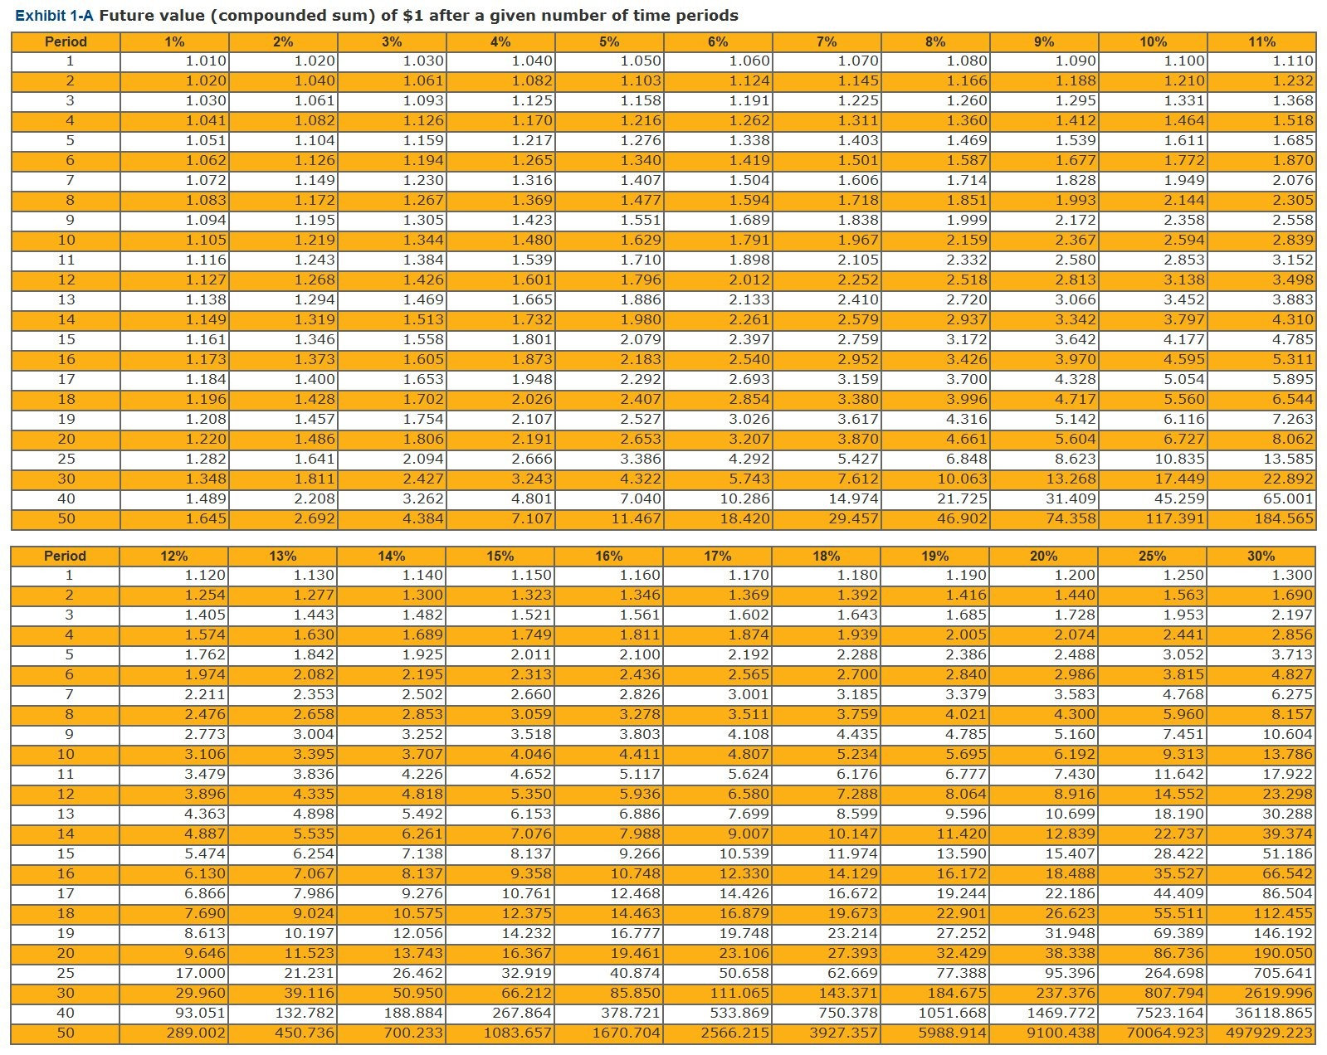
A) $40,300
B) $41,200
C) $42,000
D) $43,720
E) $46,000

Answer: B
Explanation: Future value of a single amount [$40,000 + ($40,000 × 0.03 × 1 year)] = $41,200.
Difficulty: 2 Medium
Topic: Future Value
Learning Objective: 01-04 Calculate time value of money to analyze personal financial decisions.
Bloom's: Apply
Accessibility: Keyboard Navigation; Screen Reader Compatible
Gradable: automatic

86) The future value of $50 deposited each year for 6 years earning 7 percent would be approximately: Use Exhibit 1-B. (Round time value factors to 3 decimal places and final answer to the nearest dollar amount.)

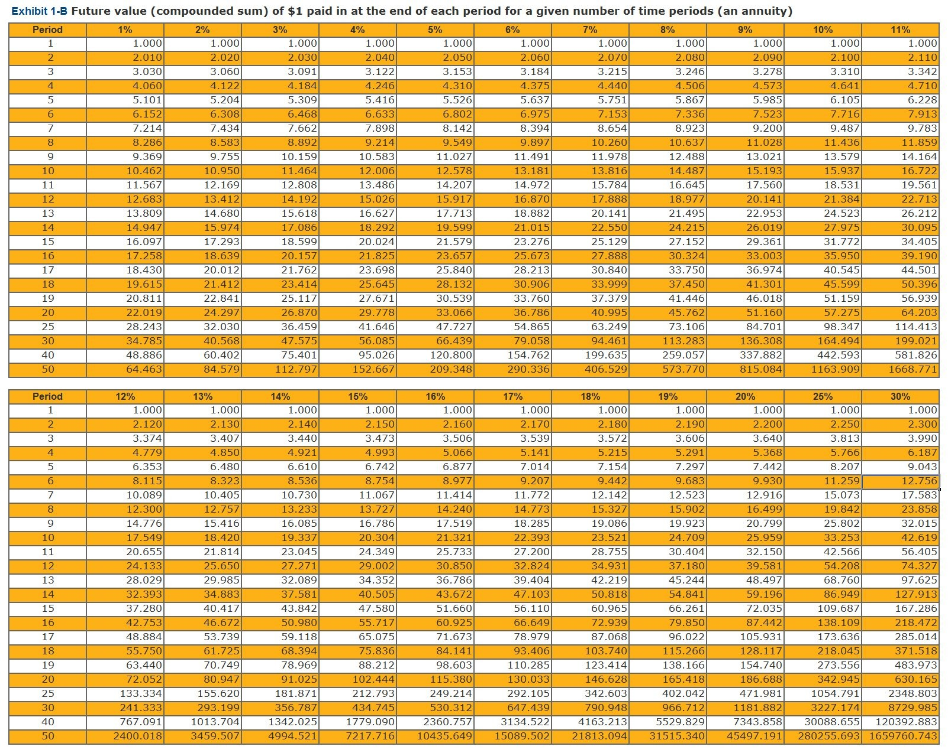
A) $50
B) $300
C) $358
D) $371
E) $428

Answer: C
Explanation: Future Value of a series of deposits (annuity): (Exhibit 1-B in Chapter 1 appendix), $50 × 7.153 = $357.65 = approximately $358.
Difficulty: 2 Medium
Topic: Future Value
Learning Objective: 01-04 Calculate time value of money to analyze personal financial decisions.; Chapter 1 Appendix: The Time Value of Money
Bloom's: Apply
Accessibility: Keyboard Navigation; Screen Reader Compatible
Gradable: automatic
87) You are planning to buy a house in five years. Approximately how much do you need to deposit today to have a $10,000 down payment if your investment will make 6%?

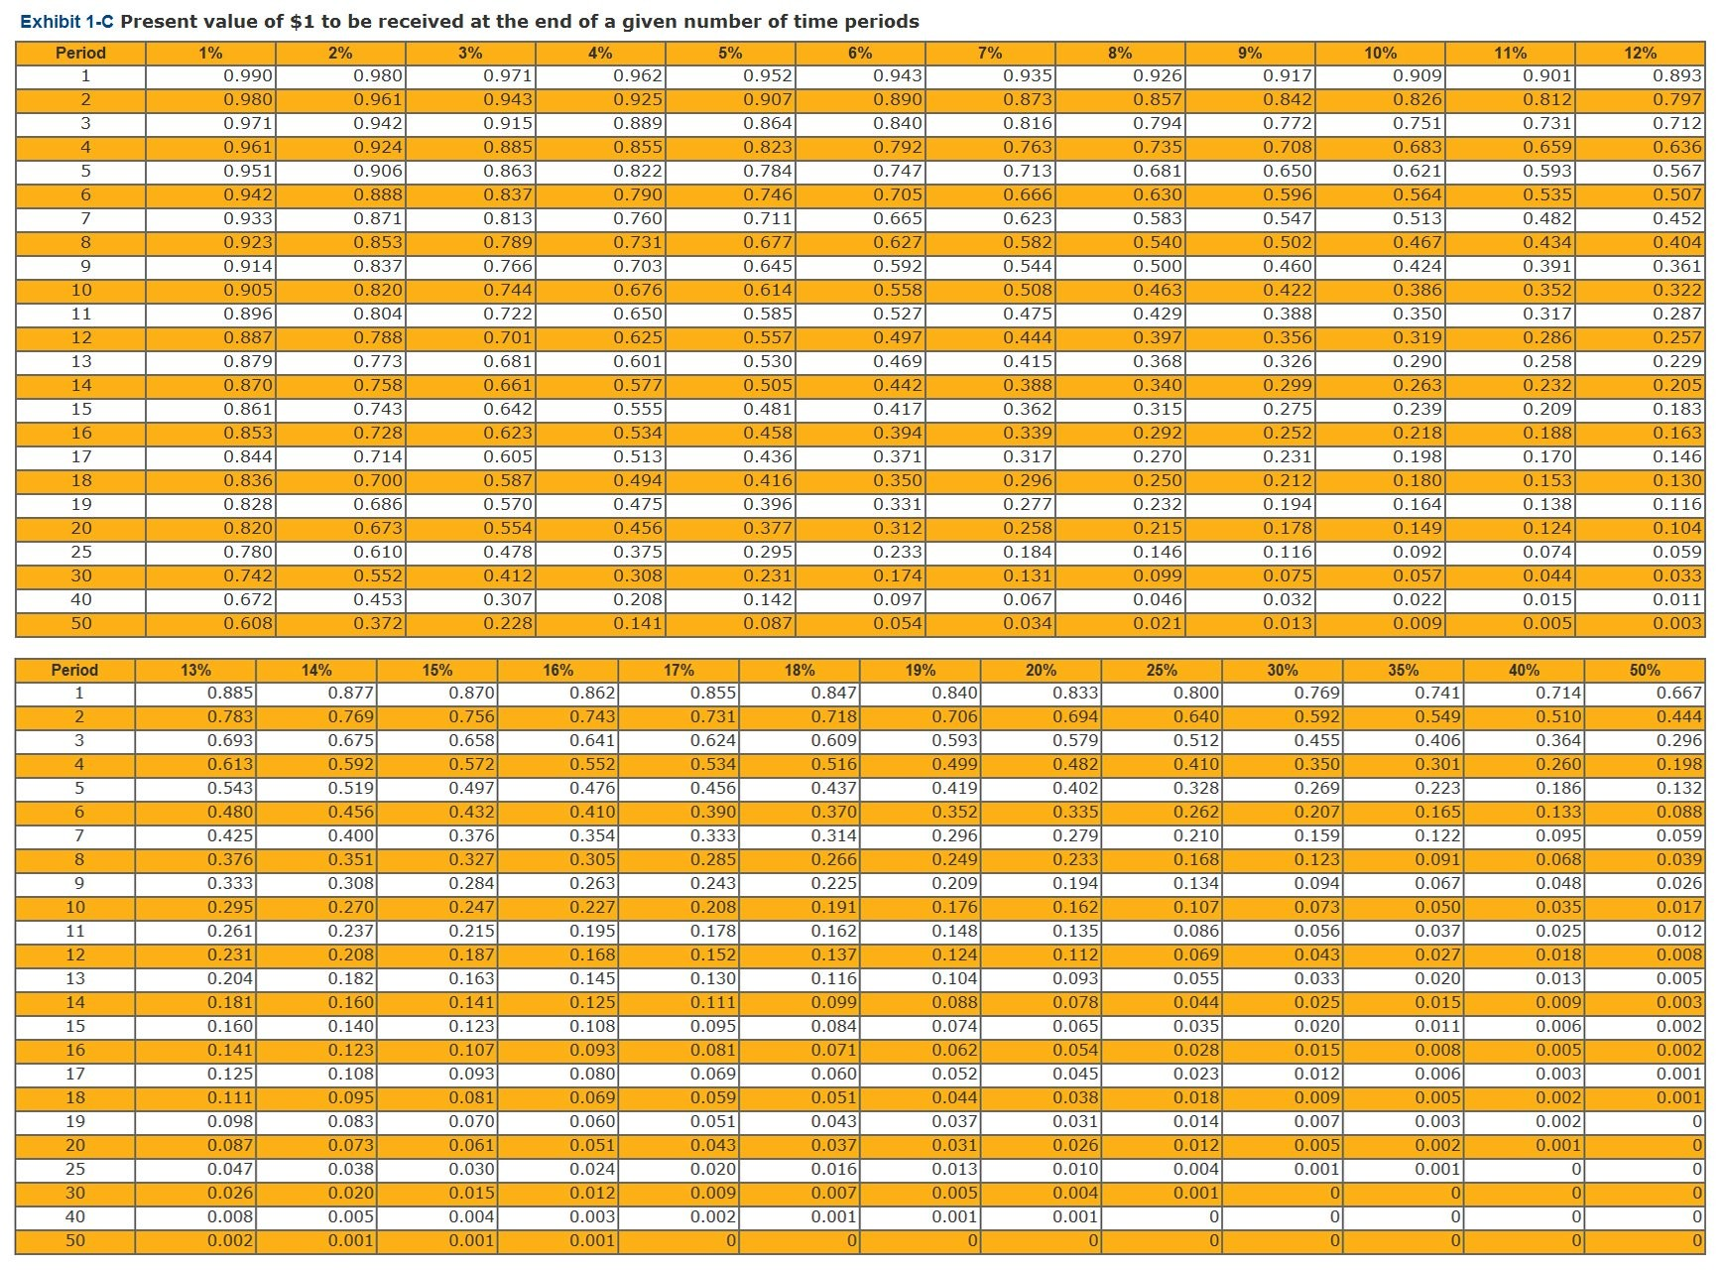
A) $6,000
B) $6,590
C) $7,470
D) $9,400
E) $10,000

Answer: C
Explanation: Present Value of a single amount (Exhibit 1-C in Chapter 1 appendix), $10,000 × 0.747 = $7,470.
Difficulty: 2 Medium
Topic: Present Value
Learning Objective: 01-04 Calculate time value of money to analyze personal financial decisions.; Chapter 1 Appendix: The Time Value of Money
Bloom's: Apply
Accessibility: Keyboard Navigation; Screen Reader Compatible
Gradable: automatic

88) Benjamin is planning to go to graduate school in a program that will take three years. Benjamin wants to have $10,000 available each year for his school and living expenses. If he earns 6% on his investments, approximately how much must be deposited at the start of his studies for him to withdraw $10,000 a year for three years?

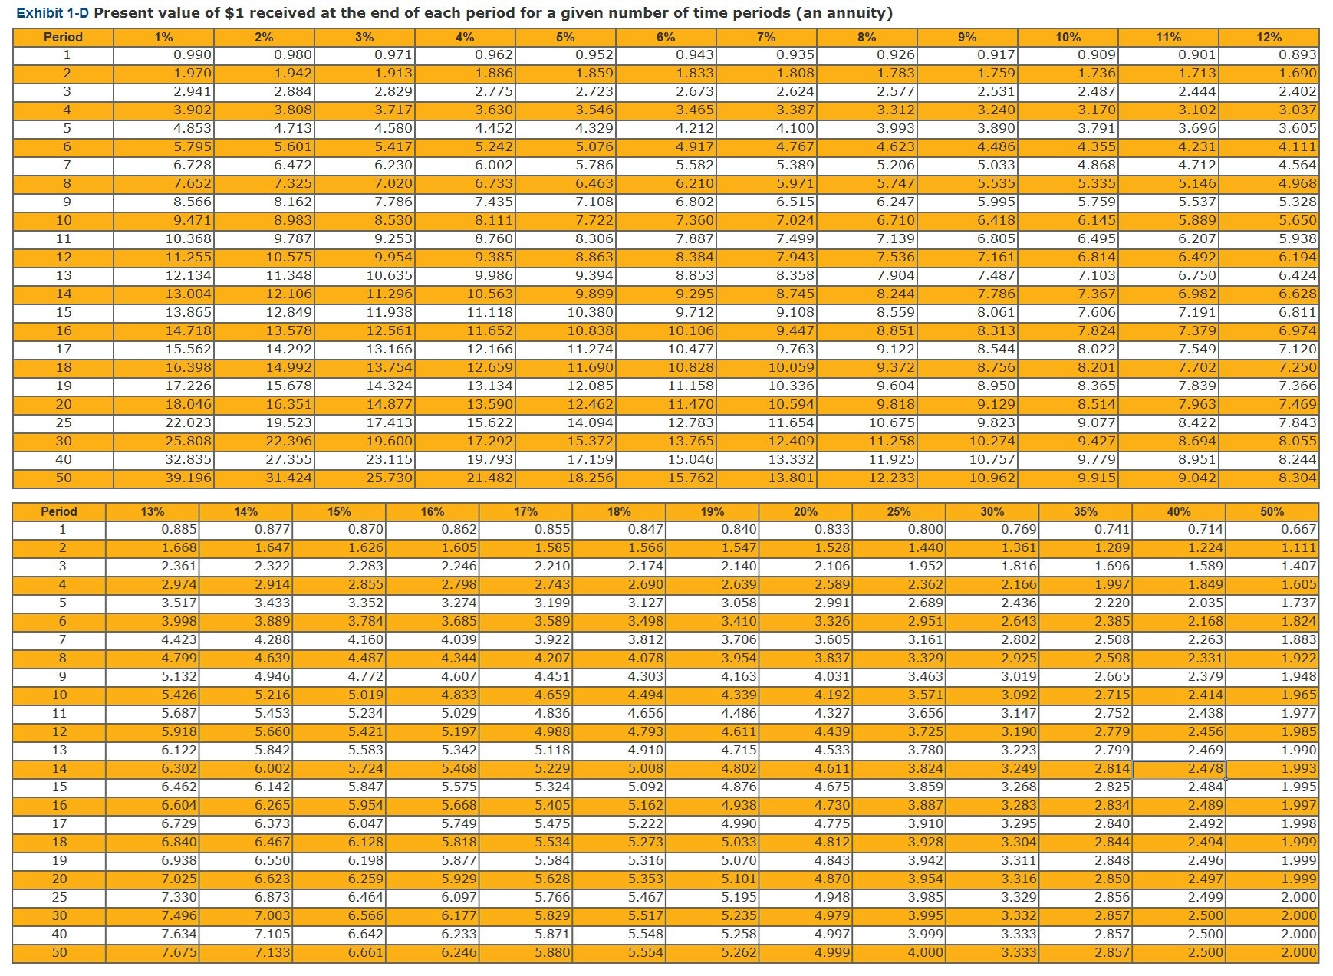
A) $10,000
B) $18,390
C) $26,730
D) $29,100
E) $30,000

Answer: C
Explanation: Present Value of a series of deposits (annuity): (Exhibit 1-D in Chapter 1 appendix), $10,000 × 2.673 = $26,730
Difficulty: 2 Medium
Topic: Present Value
Learning Objective: 01-04 Calculate time value of money to analyze personal financial decisions.; Chapter 1 Appendix: The Time Value of Money
Bloom's: Apply
Accessibility: Keyboard Navigation; Screen Reader Compatible
Gradable: automatic

89) Natalie Smith's new job is very demanding. She regularly works long hours and on the weekends. As a result, Natalie has not had much time for her family and friends. This is an example of:
A) deflation.
B) financial opportunity cost.
C) personal opportunity cost.
D) time value of money.
E) inflation.

Answer: C
Difficulty: 2 Medium
Topic: Opportunity Costs
Learning Objective: 01-04 Calculate time value of money to analyze personal financial decisions.
Bloom's: Apply
Accessibility: Keyboard Navigation; Screen Reader Compatible
Gradable: automatic

90) During ________, even though prices decline, spending slows because consumers expect prices to continue to decline.
A) deflation
B) depreciation
C) appreciation
D) economic recovery
E) inflation

Answer: A
Difficulty: 2 Medium
Topic: Economic conditions and factors
Learning Objective: 01-02 Assess personal and economic factors that influence personal financial planning.
Bloom's: Remember
Accessibility: Keyboard Navigation; Screen Reader Compatible
Gradable: automatic

91) Financial institutions include the following:
A) banks.
B) credit unions.
C) insurance companies.
D) investment companies.
E) All of these.

Answer: E
Difficulty: 1 Easy
Topic: Financial institutions
Learning Objective: 01-01 Analyze the process for making personal financial decisions.
Bloom's: Remember
Accessibility: Keyboard Navigation; Screen Reader Compatible
Gradable: automatic

92) More recently, the annual price increase for most goods and services as measured by the consumer price index has been less than ________ percent.
A) 1
B) 2
C) 3
D) 4
E) 5

Answer: B
Difficulty: 2 Medium
Topic: Economic conditions and factors; Financial system
Learning Objective: 01-02 Assess personal and economic factors that influence personal financial planning.
Bloom's: Remember
Accessibility: Keyboard Navigation; Screen Reader Compatible
Gradable: automatic

93) Increased home building results in:
A) increased job opportunities.
B) higher wages.
C) increased consumer spending.
D) overall economic expansion.
E) All of these.

Answer: E
Difficulty: 2 Medium
Topic: Economic conditions and factors
Learning Objective: 01-02 Assess personal and economic factors that influence personal financial planning.
Bloom's: Understand
Accessibility: Keyboard Navigation; Screen Reader Compatible
Gradable: automatic

94) Developing financial goals is the ________ step in the financial planning process.
A) first
B) second
C) third
D) fourth
E) fifth

Answer: B
Difficulty: 2 Medium
Topic: Financial Planning Process; Financial Goals
Learning Objective: 01-01 Analyze the process for making personal financial decisions.
Bloom's: Remember
Accessibility: Keyboard Navigation; Screen Reader Compatible
Gradable: automatic

95) The following are examples of intangible-purchase goals, except:
A) obtaining a college degree.
B) going on a cruise vacation.
C) buying a house.
D) losing weight.
E) getting more sleep.

Answer: C
Difficulty: 1 Easy
Topic: Financial Goals
Learning Objective: 01-03 Develop personal financial goals.
Bloom's: Understand
Accessibility: Keyboard Navigation; Screen Reader Compatible
Gradable: automatic

96) Developing and using a budget is part of which component of financial planning?
A) Retirement and estate planning
B) Investing
C) Spending
D) Managing risk
E) Planning

Answer: E
Difficulty: 2 Medium
Topic: Components of Financial Planning
Learning Objective: 01-05 Identify strategies for achieving personal financial goals for different life situations.
Bloom's: Remember
Accessibility: Keyboard Navigation; Screen Reader Compatible
Gradable: automatic

97) Determining your current financial situation is a part of which step in the financial planning process?
A) First
B) Second
C) Third
D) Fourth
E) Fifth

Answer: A
Difficulty: 2 Medium
Topic: Financial Planning Process
Learning Objective: 01-01 Analyze the process for making personal financial decisions.
Bloom's: Remember
Accessibility: Keyboard Navigation; Screen Reader Compatible
Gradable: automatic

98) Evaluating risk associated with making most financial decisions is difficult because of what factor(s)?
A) Inflation risk
B) Interest rate risk
C) Personal risk
D) Liquidity risk
E) All of these.

Answer: E
Difficulty: 1 Easy
Topic: Financial Planning Process; Investment risks and measures
Learning Objective: 01-01 Analyze the process for making personal financial decisions.
Bloom's: Understand
Accessibility: Keyboard Navigation; Screen Reader Compatible
Gradable: automatic

99) Financial planning information sources generally do not include:
A) print media
B) financial specialists
C) financial institutions
D) personal friends
E) digital media

Answer: D
Difficulty: 2 Medium
Topic: Financial Planning Process
Learning Objective: 01-01 Analyze the process for making personal financial decisions.
Bloom's: Understand
Accessibility: Keyboard Navigation; Screen Reader Compatible
Gradable: automatic

100) Inflation risk may include changes in buying power and:
A) rising prices.
B) falling prices.
C) decisions to buy later.
D) decisions to buy now.
E) All of these.

Answer: E
Difficulty: 2 Medium
Topic: Investment risks and measures
Learning Objective: 01-01 Analyze the process for making personal financial decisions.
Bloom's: Remember
Accessibility: Keyboard Navigation; Screen Reader Compatible
Gradable: automatic

101) Types of risks associated with financial decisions may include:
A) Income risk
B) Personal risk
C) Liquidity risk
D) Inflation risk
E) All of these

Answer: E
Difficulty: 2 Medium
Topic: Investment risks and measures
Learning Objective: 01-01 Analyze the process for making personal financial decisions.
Bloom's: Understand
Accessibility: Keyboard Navigation; Screen Reader Compatible
Gradable: automatic

102) Developing financial goals does not involve:
A) Analyzing your financial values several times a year
B) Differentiating your needs from your wants
C) Allowing others to decide which goals you should pursue
D) Creating specific financial goals
E) None of these

Answer: C
Difficulty: 2 Medium
Topic: Financial Planning Process; Financial Goals
Learning Objective: 01-01 Analyze the process for making personal financial decisions.
Bloom's: Remember
Accessibility: Keyboard Navigation; Screen Reader Compatible
Gradable: automatic

103) Analyzing your current financial position is a part of which step of the financial planning process:
A) Step 1, Determine current financial situation
B) Step 2, Develop financial goals
C) Step 3, Identify alternative courses of action
D) Step 4, Evaluate alternatives
E) Step 5, Create and implement the action plan

Answer: A
Difficulty: 1 Easy
Topic: Financial Planning Process
Learning Objective: 01-01 Analyze the process for making personal financial decisions.
Bloom's: Remember
Accessibility: Keyboard Navigation; Screen Reader Compatible
Gradable: automatic

104) The advantages of personal financial planning include:
A) Increased effectiveness in obtaining, using and protecting your financial resources
B) Increased control of your financial affairs by avoiding excessive debt and bankruptcy
C) Improved personal relationships resulting from better communicated financial decisions
D) All of these
E) None of these

Answer: D
Difficulty: 2 Medium
Topic: Financial Planning Process
Learning Objective: 01-01 Analyze the process for making personal financial decisions.
Bloom's: Understand
Accessibility: Keyboard Navigation; Screen Reader Compatible
Gradable: automatic

105) Personal financial activities involve the following main decision areas:
A) Spending
B) Saving
C) Sharing
D) All of these
E) None of these

Answer: D
Difficulty: 2 Medium
Topic: Financial Planning Process
Learning Objective: 01-01 Analyze the process for making personal financial decisions.
Bloom's: Understand
Accessibility: Keyboard Navigation; Screen Reader Compatible
Gradable: automatic

106) When identifying alternative courses of action, possible courses of action include:
A) Continue with the same course of action
B) Expand the past situation
C) Change the past situation
D) Take an old course of action
E) All of these

Answer: A
Difficulty: 2 Medium
Topic: Financial Planning Process
Learning Objective: 01-01 Analyze the process for making personal financial decisions.
Bloom's: Understand
Accessibility: Keyboard Navigation; Screen Reader Compatible
Gradable: automatic

107) If you are concerned about year-end tax payments and need an action plan, you may take the following action(s):
A) increase the amount withheld from each paycheck
B) file quarterly tax payments
C) shelter current income in a tax-deferred retirement program
D) invest in tax-exempt securities
E) All of these

Answer: E
Difficulty: 2 Medium
Topic: Financial Planning Process; Financial situation analysis
Learning Objective: 01-01 Analyze the process for making personal financial decisions.
Bloom's: Understand
Accessibility: Keyboard Navigation; Screen Reader Compatible
Gradable: automatic

108) The appropriate path for daily money decisions will:
A) take some time
B) take some effort
C) result in lower stress
D) result in personal financial security
E) all of these

Answer: E
Difficulty: 2 Medium
Topic: Economic conditions and factors
Learning Objective: 01-02 Assess personal and economic factors that influence personal financial planning.
Bloom's: Understand
Accessibility: Keyboard Navigation; Screen Reader Compatible
Gradable: automatic

109) The earnings you receive as a saver or an investor reflect:
A) past interest rates
B) a risk premium based on length of the savings period
C) expected deflation
D) the extent of certainty about getting your money back
E) a positive credit rating

Answer: B
Difficulty: 2 Medium
Topic: Economic conditions and factors
Learning Objective: 01-02 Assess personal and economic factors that influence personal financial planning.
Bloom's: Understand
Accessibility: Keyboard Navigation; Screen Reader Compatible
Gradable: automatic

110) In most societies, the forces of ________ set prices for securities, goods, and services.
A) supply and demand
B) inflation
C) business
D) government
E) foreign competition

Answer: A
Difficulty: 1 Easy
Topic: Economic conditions and factors
Learning Objective: 01-02 Assess personal and economic factors that influence personal financial planning.
Bloom's: Understand
Accessibility: Keyboard Navigation; Screen Reader Compatible
Gradable: automatic

111) A security is a financial instrument and includes all of the following, except:
A) bonds
B) stocks
C) certificates of deposit
D) mutual funds
E) rare coins

Answer: E
Difficulty: 3 Hard
Topic: Economic conditions and factors
Learning Objective: 01-02 Assess personal and economic factors that influence personal financial planning.
Bloom's: Remember
Accessibility: Keyboard Navigation; Screen Reader Compatible
Gradable: automatic

112) Robo-advisors, 3-D printing, robotics, wearable technology, and other innovations will influence your financial decisions in the following ways, except:
A) how you earn
B) how you spend
C) how you invest
D) how you travel
E) how you save

Answer: D
Difficulty: 2 Medium
Topic: Financial Planning Process
Learning Objective: 01-01 Analyze the process for making personal financial decisions.
Bloom's: Understand
Accessibility: Keyboard Navigation; Screen Reader Compatible
Gradable: automatic

113) Describe the S-M-A-R-T approach to developing financial goals. Give an example.

Answer: Financial Goals should be specific, measurable, action-oriented, realistic and time-based. Examples will vary.
Difficulty: 2 Medium
Topic: Financial Goals; SMART approach
Learning Objective: 01-03 Develop personal financial goals.
Bloom's: Apply
Accessibility: Keyboard Navigation; Screen Reader Compatible
Gradable: manual

114) What are the eight Components of Financial Planning?

Answer: The main Components of Financial Planning are obtaining, planning, saving, borrowing, spending, managing risk, investing, and retirement/estate planning.
Difficulty: 2 Medium
Topic: Components of Financial Planning
Learning Objective: 01-05 Identify strategies for achieving personal financial goals for different life situations.
Bloom's: Remember
Accessibility: Keyboard Navigation; Screen Reader Compatible
Gradable: manual

115) People are commonly overwhelmed by the many influences on personal financial decisions. What are the factors affecting personal financial planning?

Answer: Students answers will vary. Factors might include life situation and personal values. Life situation is affected by personal factors such as household size, age, income,, personal beliefs, and the adult life cycle. The adult life cycle is the stages in the family and financial needs of an adult. The financial system and daily economic activities also influence financial planning. The global economy, foreign investors, and competition are also important influences.
Difficulty: 2 Medium
Topic: Life Cycle; Personal values; Life events and their effects
Learning Objective: 01-02 Assess personal and economic factors that influence personal financial planning.
Bloom's: Remember
Accessibility: Keyboard Navigation; Screen Reader Compatible
Gradable: manual

116) What types of risks are commonly associated with personal financial decisions? How can these risks be evaluated and minimized to reduce personal and financial difficulties?

Answer: Common risks are inflation risk, interest rate risk, income risk, personal risk, and liquidity risk. Risks can be evaluated and minimized by gathering information based on your experience and the experience of others and using financial planning information sources.
Difficulty: 2 Medium
Topic: Investment risks and measures
Learning Objective: 01-01 Analyze the process for making personal financial decisions.
Bloom's: Understand
Accessibility: Keyboard Navigation; Screen Reader Compatible
Gradable: manual

117) Natalie Smith is trying to decide whether to keep her money in a savings account or in a mutual fund. What would you tell her to help her analyze her decision?

Answer: Students answers will vary. Suggested responses might mention gathering information, comparing alternatives, analyzing risks, assessing personal goals, and contacting financial planning specialists.
Difficulty: 2 Medium
Topic: Financial Planning Process; Financial situation analysis
Learning Objective: 01-01 Analyze the process for making personal financial decisions.
Bloom's: Understand
Accessibility: Keyboard Navigation; Screen Reader Compatible
Gradable: manual

118) What are the six steps in the financial planning process?

Answer: The personal financial planning process involves: (1) determine your current financial situation, (2) develop financial goals, (3) identify alternative courses of action, (4) evaluate your alternatives, (5) create and implement a financial action plan, and (6) review and revise the financial plan.
Difficulty: 1 Easy
Topic: Financial Planning Process
Learning Objective: 01-01 Analyze the process for making personal financial decisions.
Bloom's: Remember
Accessibility: Keyboard Navigation; Screen Reader Compatible
Gradable: manual

119) Explain why borrowers benefit more than lenders in times of high inflation.

Answer: Inflation can adversely affect lenders of money. Unless an adequate interest rate is charged, amounts repaid by borrowers in times of inflation have less buying power than the money they borrowed. If you pay 4 percent interest on a loan and the inflation rate is 6 percent, the dollars you pay the lender have lost buying power.
Difficulty: 3 Hard
Topic: Economic conditions and factors
Learning Objective: 01-02 Assess personal and economic factors that influence personal financial planning.
Bloom's: Understand
Accessibility: Keyboard Navigation; Screen Reader Compatible
Gradable: manual

120) What is meant by the term "Time Value of Money"?

Answer: Time value of money refers to the increase of an amount of money as a result of interest earned. You can calculate the increased value of your money in two ways: You can calculate the total amount that will be available later (future value) or you can determine the current value of an amount desired in the future (present value). Future value and present value can both be calculated by using a single sum or a series of deposits or payments (annuity).
Difficulty: 2 Medium
Topic: Time value of money - interest rates and inflation
Learning Objective: 01-04 Calculate time value of money to analyze personal financial decisions.
Bloom's: Remember
Accessibility: Keyboard Navigation; Screen Reader Compatible
Gradable: manual

121) Describe the relationship between the annual inflation rate and prices using the Rule of 72.

Answer: The Rule of 72 helps determine how fast prices (or your savings) will double using the following formula: 72 / annual inflation rate = number of years it takes to double prices (or your savings).
Difficulty: 3 Hard
Topic: Economic conditions and factors; Time value of money - interest rates and inflation
Learning Objective: 01-02 Assess personal and economic factors that influence personal financial planning.
Bloom's: Apply
Accessibility: Keyboard Navigation; Screen Reader Compatible
Gradable: manual

122) Many events affect your life situation and occur within the adult life cycle. List five events.

Answer: Answers will vary.

Graduation (at all education levels)
Engagement and marriage
The birth or adoption of a child
A career change or a move to a new area
Dependent children leaving home
Changes in health
Divorce
Retirement
The death of a spouse, family member, or other dependent
Difficulty: 2 Medium
Topic: Life Cycle; Life events and their effects
Learning Objective: 01-02 Assess personal and economic factors that influence personal financial planning.
Bloom's: Remember
Accessibility: Keyboard Navigation; Screen Reader Compatible
Gradable: manual

