Chapter 01 - Limits, Alternatives, and Choices

McConnell Brue Flynn 22e

DISCUSSION QUESTIONS

1. What is an opportunity cost? How does the idea relate to the definition of economics?
Which of the following decisions would entail the greater opportunity cost: Allocating a square block in the heart of New York City for a surface parking lot or allocating a square block at the edge of a typical suburb for such a lot? Explain. LO1

Answer: An opportunity cost is what was sacrificed to do or acquire something else. The condition of scarcity creates opportunity cost. If there was no scarcity, there would be no need to sacrifice one thing to acquire another. The opportunity cost would be much higher in New York City as the alternative uses for that square block are much more valuable than for a typical suburban city block.

2. Cite three examples of recent decisions that you made in which you, at least implicitly, weighed marginal cost and marginal benefit. LO1

Answer: Answers will vary, but may include the decision to come to class, to skip breakfast to get a few extra minutes of sleep, to attend college, or to make a purchase. Marginal benefits of attending class may include the acquisition of knowledge, participation in discussion, and better preparation for an upcoming examination. Marginal costs may include lost opportunities for sleep, meals, or studying for other classes. In evaluating the discussion of marginal benefits and marginal costs, be careful to watch for sunk costs offered as a rationale for marginal decisions.

3. What is “utility” and how does the idea relate to purposeful behavior? LO1

Answer: “Utility” refers to the pleasure, happiness, or satisfaction gained from engaging in an activity (eating a meal, attending a ball game, etc.). It is an important component of purposeful behavior because people will allocate their scarce time, energy, and money in an attempt to gain the most utility possible.

4. What are the key elements of the scientific method, and how does this method relate to economic principles and laws? LO2

Answer: The key elements include the gathering of data (observation), the formulation of possible explanations (hypothesis), testing the hypothesis, determining the validity of the hypothesis, and repeated testing of hypotheses that have appeared to be valid in prior tests.

The scientific method is the technique used by economists to determine economic laws or principles. These laws or principles are formulated to explain and/or predict behavior of individuals or institutions.

5. Make (a) a positive economic statement of your choice, and then (b) a normative economic statement relating to your first statement. LO3

Answer: Answers will vary. Example: (a) The unemployment rate is 4.8 percent; (b) the unemployment rate is too high. In general, we treat “what is” statements as positive, “what should be” as normative, but keep an eye out for statements like “at full employment an increase in the production of pizzas should come at the cost of less robots.” Some students may incorrectly identify the statement as normative because of the term “should.”

6. How does the slope of a budget line illustrate opportunity cost and trade-offs? How does a budget line illustrate scarcity and the effect of limited incomes? LO4

Answer: Budget lines are always sloped downward. This downward slope shows an inverse relationship between the two goods, meaning that as you increase one, the other must decrease. This decrease is what you are giving up, or opportunity cost, of the good you are getting more of.
Budget lines illustrate scarcity in that they show you are limited by your income. Since they slope downward, they show you cannot keep getting more and more of both goods. There is always a trade-off. The area beyond the budget line represents combinations of the goods that are beyond your income.

7. What are economic resources? What categories do economists use to classify them? Why are resources also called factors of production? Why are they called inputs? LO5

Answer: Economic resources are the natural, human, and manufactured inputs used to produce goods and services.

Economic resources fall into four main categories: labor, land (natural resources), real capital (machines, factories, buildings, etc.,) and entrepreneurs.

Economic resources are also called factors of production because they are used to produce goods and services. They are called inputs because they go in to a production process (like ingredients go into a bowl to make a cake), with the resulting goods and services also being referred to as output.

8. Why is money not considered to be a capital resource in economics? Why is entrepreneurial ability considered a category of economic resource, distinct from labor? What roles do entrepreneurs play in the economy? LO5

Answer: Money is not considered a capital resource because money is not productive – it provides access to resources but itself does not directly contribute to the production of goods and services. Additionally, the quantity of money in circulation does not determine an economy’s productive capacity, while the amount of capital and other resources does. Doubling the amount of money in circulation does not change the economy’s physical capacity to produce goods and services. Money is, however, referred as a financial resource and financial capital, reflecting its ability to acquire real economic resources.

Entrepreneurial ability and labor are both human resources, but they perform different functions in the productive process. Entrepreneurial ability does not directly produce goods and services; it organizes the resources that do. Labor refers to the human inputs that directly engage in production.

Entrepreneurs are risk-takers: They coordinate the activities of the other three inputs for profit—or loss, which is why they are called risk-takers. Entrepreneurs sometimes manage companies that they own, but a manager who is not an owner is not necessarily an entrepreneur but may be performing some of the entrepreneurial functions for the company. Entrepreneurs are also innovators, or perhaps inventors, and profits help to motivate such activities.

9. Explain the typical shapes of marginal-benefit and marginal-cost curves. How are these curves used to determine the optimal allocation of resources to a particular product? If current output is such that marginal cost exceeds marginal benefit, should more or fewer resources be allocated to this product? Explain. LO6

Answer: The marginal benefit curve is downward sloping, MB falls as more of a product is consumed because additional units of a good yield less satisfaction than previous units. The marginal cost curve is upward sloping, MC increases as more of a product is produced since additional units require the use of increasingly unsuitable resource. The optimal amount of a particular product occurs where MB equals MC. If MC exceeds MB, fewer resources should be allocated to this use, as the additional cost is more than the additional benefit. The resources are more valuable in some alternative use (as reflected in the higher MC) than in this use (as reflected in the lower MB).

10. Suppose that, on the basis of a nation’s production possibilities curve, an economy
must sacrifice 10,000 pizzas domestically to get the 1 additional industrial robot it desires but it can get the robot from another country in exchange for 9,000 pizzas. Relate this information to the following statement: “Through international specialization and trade, a nation can reduce its opportunity cost of obtaining goods and thus ‘move outside its production possibilities curve.” LO7

Answer: The message of the production possibilities curve is that an individual nation is limited to the combinations of output indicated by its production possibilities curve. International specialization means directing domestic resources to output which a nation is highly efficient at producing. International trade involves the exchange of these goods for goods produced abroad. Specialization and trade have the same effect as having more and better resources or discovering improved production techniques. The output gains from greater international specialization and trade are the equivalent of economic growth.

11. LAST WORD Starbucks has $1 billion to invest. It can either purchase a rival coffee
shop chain or build additional Starbucks shops. If Starbucks chooses to purchase the rival chain, what does that say about the relative profitability of purchasing and owning the rival’s existing shops versus building additional Starbucks shops? Explain.

Answer: If Starbucks made the decision to invest the $1 billion by purchasing a rival chain rather than building additional Starbucks shops, we can assume that Starbucks' management had made a careful comparison of the marginal costs and marginal benefits of each option and found that the net marginal benefit (or profitability) of purchasing the rival chain to be higher. Of course, the management team also determined that expected marginal benefits exceeded marginal costs. Otherwise, it would not make sense to pursue either option because they would be unprofitable.

REVIEW QUESTIONS

1. Match each term with the correct definition. LO1
economics
opportunity cost
marginal analysis
utility
a. The next-best thing that must be foregone in order to product one more unit of a given product.
b. The pleasure, happiness, or satisfaction obtained from consuming a good or service.
c. The social science concerned with how individuals, institutions, and society make optimal (best) choices under conditions of scarcity.
d. Making choices based on comparing marginal benefits with marginal costs.

Answer: a. Opportunity cost; b. Utility; c. Economics; d. Marginal analysis

2. Indicate whether each of the following statements applies to microeconomics or macroeconomics: LO3
a. The unemployment rate in the United States was 3.7 percent in December 2018.
b. A U.S. software firm laid off 15 workers last month and transferred the work to
India.
c. An unexpected freeze in central Florida reduced the citrus crop and caused the
price of oranges to rise.
d. U.S. output, adjusted for inflation, increased by 2.3 percent in 2017.
e. Last week Wells Fargo Bank lowered its interest rate on business loans by one-
half of 1 percentage point.
f. The consumer price index rose by 2.2 percent from November 2017 to November
2018.
Answer: a. Macroeconomics; b. Microeconomics; c. Microeconomics; d. Macroeconomics; e. Microeconomics; f. Macroeconomics
3. Suppose that you initially have $100 to spend on books or movie tickets. The books start off costing $25 each and the movie tickets start off costing $10 each. For each of the following situations, would the attainable set of combinations that you can afford increase or decrease? LO4
a. Your budget increases from $100 to $150 while the prices stay the same.
b. Your budget remains $100, and the price of books remains $25, but the price of
movie tickets rises to $20.
c. Your budget remains $100, and the price of movie tickets remains $10, but the
price of a book falls to $15.

Answer:
- Increase because a larger budget allows you to purchase not only the
combinations that you could afford before but also new combinations that you could not afford before (for example, you can now afford to purchase 4 books and 5 movie tickets);

b. Decrease because certain combinations are no longer affordable (for example, you can no longer purchase 10 movie tickets with your $100 budget);

c. Increase because the lower price allows you to purchase combinations that you could not afford before (for example, you can now purchase 6 books and 1 movie ticket)].

4. Suppose that you are given a $100 budget at work that can be spent only on two items: staplers and pens. If staplers cost $10 each and pens cost $2.50 each, then the opportunity cost of purchasing one stapler is: LO4
a. 10 pens.
b. 5 pens.
c. zero pens.
d. 4 pens.

Answer: 4 pens. You must forego purchasing 4 pens if you are to free up enough money (4 × $2.50 = $10) to purchase a stapler.

5. For each of the following situations involving marginal cost (MC) and marginal benefit (MB), indicate whether it would be best to produce more, fewer, or the current number of units. LO4
a. 3,000 units at which MC = $10 and MB = $13.
b. 11 units at which MC = $4 and MB = $3.
c. 43,277 units at which MC = $99 and MB = $99.
d. 82 units at which MC < MB.
e. 5 units at which MB < MC.

Answer:
a. More because MB > MC -- the benefit of consuming one more unit exceed the opportunity costs (scarce resources used elsewhere) of producing that additional unit.

b. Fewer because MC > MB -- the opportunity costs (scarce resources used elsewhere) of producing one more unit exceed the benefit of consuming that additional unit.

c. Current amount because MB = MC -- there is no net gain in using scarce resources in producing and consuming one more unit.

d. More because MB > MC -- see the explanation for part (a)

e. Fewer because MB < MC -- see the explanation for part (b)

6. Explain how (if at all) each of the following events affects the location of a country’s
production possibilities curve. LO6
a. The quality of education increases.
b. The number of unemployed workers increases.
c. A new technique improves the efficiency of extracting copper from ore.
d. A devastating earthquake destroys numerous production facilities.

Answer:
a. Assuming better education translates into better work skills, then productivity should increase, and this would shift the curve outward.
b. Should not affect location of curve. Production moves inward, away from the curve.
c. The curve should shift outward as more production is possible with existing resources
d. The curve should shift inward with the destruction of resources (capital).

7. What are the two major ways in which an economy can grow and push out its production possibilities curve? LO7
a. Better weather and nicer cars.
b. Higher taxes and lower spending.
c. Increases in resource supplies and advances in technology.
d. Decreases in scarcity and advances in auditing.

Answer: The economy produces output from resource inputs like land, labor, and capital. So one major way for an economy to grow and push out its production possibilities curve is for it to obtain more resources. The second major way is to develop new and better technologies so that the economy can produce more from any given amount of resources.

PROBLEMS

1. Potatoes cost Janice $1 per pound, and she has $5.00 that she could possibly spend on potatoes or other items. If she feels that the first pound of potatoes is worth $1.50, the second pound is worth $1.14, the third pound is worth $1.05, and all subsequent pounds are worth $0.30 per pound, how many pounds of potatoes will she purchase? How many pounds will she purchase if she has only $2 to spend? LO1

Answer: 3; 2

Feedback: Janice will purchase potatoes until the value of potatoes is less than the cost of potatoes or until her income has been exhausted. For example, assume Janice has $5.00 to spend on potatoes or other items and the cost of a pound of potatoes is $1. Now assume the first pound of potatoes is worth $1.50 to Janice. She will purchase this pound of potatoes since the value of the pound of potatoes ($1.50) is greater than the cost ($1). If the second pound is worth $1.14 and the third pound is worth a $1.05 then Janice will purchase these as well since the value exceeds the cost of $1. If all remaining pounds are worth $0.30 then Janice will not purchase these because the value is less than the cost. So, Janice will purchase 3 pounds of potatoes at total cost of $3.00.

Now assume Janice only has $2.00 to spend on potatoes. She will purchase the first pound because it is worth $1.50 to her and it only costs a $1. She will purchase the second pound because it is worth $1.14. She has now spent her entire income on potatoes. She would like to purchase the third pound because the value of this pound of potatoes is $1.05, but she does not have the income to make this purchase. So, Janice will purchase 2 pounds of potatoes at a total cost of $2.00.

2. Pham can work as many or as few hours as she wants at the college bookstore for $12 per hour. But due to her hectic schedule, she has just 15 hours per week that she can spend working at either the bookstore or at other potential jobs. One potential job, at a café, will pay her $15 per hour for up to 6 hours per week. She has another job offer at a garage that will pay her $13 an hour for up to 5 hours per week. And she has a potential job at a daycare center that will pay her $11.50 per hour for as many hours as she can work. If her goal is to maximize the amount of money she can make each week, how many hours will she work at the bookstore? LO1

Answer: 4.

Feedback: Pham will choose to work at the bookstore as long as the wage rate at the bookstore exceeds her other opportunities. However, if another job offers a higher wage rate she will choose employment there. She will work until her total time allotment (for work) is exhausted.
She will choose to work at the café for the full 6 hours because the wage rate at the café is $15 per hour, which is greater than the wage rate at the bookstore of $12. This leaves her with 9 hours of work time remaining. Next, she will choose to work at the garage for the full 5 hours because the wage rate here is $13, which again is greater than the bookstore wage rate $12. After this decision she only has 4 hours of work time remaining. She will choose to work these last 4 hours at the bookstore because the bookstore wage rate of $12 exceeds the daycare center wage rate of $11.50.

3. Suppose you won $15 on a lotto ticket at the local 7-Eleven and decided to spend all the winnings on candy bars and bags of peanuts. Candy bars cost $0.75 each while bags of peanuts cost $1.50 each. LO5
a. Construct a table showing the alternative combinations of the two products that are available.
b. Plot the data in your table as a budget line in a graph. What is the slope of the budget line? What is the opportunity cost of one more candy bar? Of one more bag of peanuts? Do these opportunity costs rise, fall, or remain constant as additional units are purchased?
c. Does the budget line tell you which of the available combinations of candy bars and bags of peanuts to buy?
d. Suppose that you had won $30 on your ticket, not $15. Show the $30 budget line in your diagram. Has the number of available combinations increased or decreased?

Answers:
Part a:

Consumption alternatives
Goods | A | B | C | D | E | F
Candy bars | 0 | 4 | 8 | 12 | 16 | 20
Bags of peanuts | 10 | 8 | 6 | 4 | 2 | 0

Part b:

Feedback: The slope for the budget line above, with candy bars on the horizontal axis, is -0.5 (= -P_{cb}/P_{bp}). Note that the figure could also be drawn with bags of peanuts on the horizontal axis. The slope of that budget line would be -2. The opportunity cost of one more candy bar is ½ of a bag of peanuts. The opportunity cost of one more bag of peanuts is 2 candy bars. These opportunity costs are constant. They can be found by comparing any two of the consumption alternatives for the two goods.

Part c: No; it only tells you what is possible.

Feedback: The budget line does not tell you which of the available combinations of candy bars and bags of peanuts to buy. You will need to use your preference relationship for candy bars and bags of peanuts to determine which combination to buy. The budget line only tells you which combinations are feasible.

Part d: Increased.

Feedback: The budget line at $30 would be preferable because it would allow greater consumption of both goods.

4. Suppose that you are on a desert island and possess exactly 20 coconuts. Your neighbor, Friday, is a fisherman, and he is willing to trade 2 fish for every 1 coconut that you are willing to give him. Another neighbor, Kwame, is also a fisherman, and he is willing to trade 3 fish for every 1 coconut. LO5
a. On a single figure, draw budget lines for trading with Friday and for trading with Kwame. (Put coconuts on the vertical axis.)
b. What is the slope of the budget line from trading with Friday?
c. What is the slope of the budget line from trading with Kwame?
d. Which budget line features a larger set of attainable combinations of coconuts and fish?
e. If you are going to trade coconuts for fish, would you rather trade with Friday or Kwame? Why?
Answers:

Part a:
Coconuts
Fish
20
40
60
Trade with Friday
Slope = -1/2
Trade with Kwame
Slope = -1/3

Part b: -1/2

Feedback: The slope of the budget line from trading with Friday equals -(1/2). This implies that for every coconut I give up, Friday must give up two fish. Or, for every fish that Friday gives up, I must give up (1/2) a coconut.

Part c: -1/3

Feedback: The slope of the budget line from trading with Kwame equals -(1/3). This implies that for every coconut I give up, Kwame must give up three fish. Or, for every fish that Friday gives up, I must give up (1/3) a coconut.

Part d: The budget line from trading with Kwame

Feedback: The budget line from trading with Kwame features a larger set of attainable combinations of coconuts and fish. Because Kwame is willing to give up more fish per coconut, you can consume more of both (assuming you make a trade). This implies that you would prefer to trade with Kwame.

Part e: Kwame

Feedback: Because Kwame is willing to give up more fish per coconut, you can consume more of both (assuming you make a trade). This implies that you would prefer to trade with Kwame.
5. Below is a production possibilities table for consumer goods (automobiles) and
capital goods (forklifts): LO6

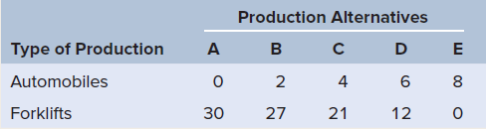

a. Show these data graphically. Upon what specific assumptions is this production possibilities curve based?
b. If the economy is at point C, what is the cost of one more automobile? Of one more forklift? Which characteristic of the production possibilities curve reflects the law of increasing opportunity costs: its shape or its length?
c. If the economy characterized by this production possibilities table and curve is producing 3 automobiles and 20 fork lifts, what could you conclude about its use of its available resources?
d. Is production at a point outside the production possibilities curve currently possible? Could a future advance in technology allow production beyond the current production possibilities curve? Could international trade allow a country to consume beyond its current production possibilities curve?

Answers:

Part a: (See figure below.) The assumptions are full employment, fixed supplies of resources, fixed technology and two goods.
automobiles
forklifts
8
30
D (12,6)
C (21,4)
B (27,2)
Part b: 4 automobiles and 21 forklifts; its shape.

Feedback: Consider the following example:

Assume the economy is producing at point C. Thus, the economy is producing 4 automobiles and 21 forklifts.

The cost of producing one more automobile can be found by moving to point D and calculating the number of forklifts given up for the 2 additional automobiles. At point D the economy is producing 12 forklifts, which is a loss of 9 forklifts (moving from C to D) for the 2 additional automobiles. Thus the cost of 1 more automobile equals 9 (forklifts) divided by 2 (automobiles), or (9/2) = 4.5 forklifts.

The cost of producing one more forklift can be found in an equivalent fashion. First, we will move to point B (from point C). Here we must give up 2 automobiles to get 6 forklifts. Thus, the cost of 1 more forklift equals 2 (automobiles) divided by 6 (forklifts), which is (2/6) = (1/3).

In review, take the cost (loss) and divide by the gain. If we were at point D, the cost of one more forklift equals 2 automobiles (loss) divided by 9 forklifts (gain). Thus, the cost of 1 more forklift at point B is (2/9) automobiles.

Increasing opportunity cost implies that we must give up more of a particular good to get an additional unit of a different good. This implies as we move along the production possibilities curve (from left to right) I must give up more automobiles to get an additional forklift. Thus, the SHAPE of the schedule captures the increasing opportunity cost concept.

Part c: Underutilizing.

Feedback: The economy is underutilizing resources (inside the PPC).

Part d: No; Yes; Yes.

Feedback: No, the country cannot produce outside its PPC. Yes, a technological advance would shift the PPC outward allowing the country produce more with a given amount of inputs. Yes, by specializing in goods we have a comparative advantage producing we can trade to gain access to goods beyond our own PPC.

6. Look at Figure 1.3. Suppose that the cost of cheese falls, so that the marginal cost of producing pizza decreases. Will the MC curve shift up or down? Will the optimal amount of pizza increase or decrease? Explain. LO6

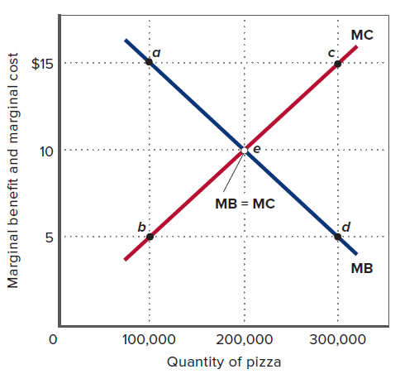
Answers: MC will shift down; the optimal amount of pizza will increase.

Feedback: To think about cost schedules we must think about input costs. If the cost of cheese falls, then the cost of making pizza is cheaper for all pizzas. This implies that the marginal cost schedule will shift down reflecting the lower input cost. For a given demand schedule, the optimal amount pizza produced and sold will increase and the equilibrium price would fall. The opposite story would apply if the cost of cheese were to increase.

7. Referring to the table in problem 5, suppose improvement occurs in the technology of producing forklifts but not in the technology of producing automobiles. Draw the new production possibilities curve. Now assume that a technological advance occurs in producing automobiles but not in producing forklifts. Draw the new production possibilities curve. Now draw a production possibilities curve that reflects technological improvement in the production of both goods. LO7

Answers: See figures.

Technological advance in producing forklifts and not automobiles.

Feedback: This implies we can produce more forklifts with the given resources, so the schedule will shift out along the horizontal axis.
automobiles
forklifts
8
30
Technological advance in producing automobiles and not forklifts.

Feedback: This implies we can produce more automobiles with the given resources, so the schedule will shift up along the vertical axis.
automobiles
forklifts
8
30

Technological in advance in producing automobiles and forklifts.

Feedback: This implies we can produce more forklifts and automobiles with the given resources, so the schedule will shift up out along the vertical and horizontal axes.
automobiles
forklifts
8
30
8. Because investment and capital goods are paid for with savings, higher savings rates
reflect a decision to consume fewer goods for the present in order to be able to invest in more goods for the future. On average, households in China save 40 percent of their annual income each year, whereas households in the United States save less than 5 percent. At the same time, production possibilities are growing at roughly 7 percent annually in China and 3 percent in the United States. Use graphical analysis of “present goods” versus “future goods” to explain the differences in growth rates. LO7

Answers: See figures below

Feedback: Since the United States is consuming more today rather than saving, their production possibilities curve will shift out slower (less) over time because they are accumulating less capital. China's production possibilities curve will shift out faster (more) over time because they are accumulating more capital. See diagrams above.

Chapter 01 Appendix

McConnell Brue Flynn 22e

APPENDIX DISCUSSION QUESTIONS

1. What is an inverse relationship? How does it graph? What is a direct relationship? How does it graph? LO8

Answer: Graphs help us visualize relationships between key economic variables in the data. For example, the relationship between the price of oranges and the number of oranges purchased is likely to be an inverse relationship. An inverse relationship is one where we observe one variable increasing and the other variable decreasing as a result (moving in opposite directions). Thus, as the prices of oranges increase we would expect to see a decrease in the quantity of oranges purchased. Graphically, we represent this inverse relationship as follows.
Price of Oranges
Quantity of Oranges
Inverse Relationship
As another example, the relationship between the quality of a textbook and the number of textbooks sold is likely to be a direct relationship. A direct relationship is one where we observe one variable increasing and the other variable increasing as a result (moving in the same direction). Thus, as the quality of the textbook increases the number of books sold also increases. Graphically, we represent this direct relationship as follows.
Number of Textbooks Sold
Quality of the Textbook
Direct Relationship

2. Describe the graphical relationship between ticket prices and the number of people choosing to visit amusement parks. Is that relationship consistent with the fact that, historically, park attendance and ticket prices have both risen? Explain. LO8

Answer: There is likely an inverse relationship between ticket prices and the number of people visiting amusement parks. As ticket prices increase relative to other goods, people will spend their income on these other goods. For example, they may decide to go to the movies instead of visiting the now more expensive amusement park.

The fact that, historically, park attendance and ticket prices have both risen over time does not change our story. This relationship is most likely the result of a change in demand, not a change in quantity demanded. The demand schedule for amusement parks has probably shifted to the right (an increase in demand) over time leading to an increase in attendance and prices.

3. Look back at Figure 2, which shows the inverse relationship between ticket prices and game attendance at Gigantic State University. (a) Interpret the meaning of both the slope and the intercept. (b) If the slope of the line were steeper, what would that say about the amount by which ticket sales respond to increases in ticket prices? (c) If the slope of the line stayed the same but the intercept increased, what could you say about the amount by which ticket sales respond to increases in ticket prices? LO8

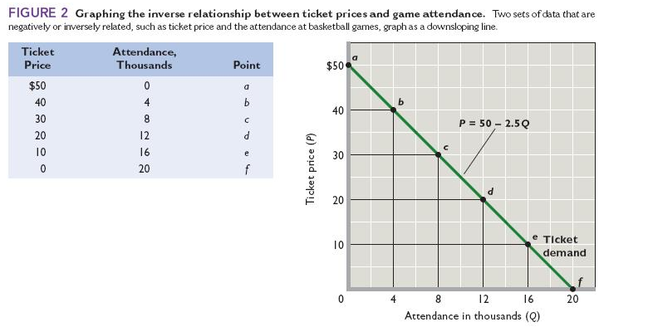
Answer:
Part a: The slope of this relationship tells us how much the price of a ticket must fall to induce someone to buy an additional ticket. In this case, the slope of -2.5 tells us that the price must fall by $2.50 to sell one more ticket (or to induce someone to buy one more ticket). The vertical intercept tells us the price at which no tickets will be sold. Here, this price is $50. Combining these two components tells us that if the initial price is $50 per ticket and the price falls to $40, then 4 tickets will be purchased (one for each reduction in price of $2.50, which is the slope).

Part b: If the slope of this line were steeper this would imply that the price must fall by more than $2.50 to sell one more ticket. Or, thinking about this in the other direction, a steeper line would result in a smaller decrease in tickets purchased for a given increase in price. In other words, ticket sales (purchases) are less responsive to price movements.

Part c: If the vertical intercept increased this would imply that individuals are willing to purchase more tickets at every price. This will be an increase in the demand for tickets. This will not affect the slope or the quantity response to a change in the price of tickets. We still have the relationship that the price must fall by $2.50 to sell one more ticket (or to induce someone to buy one more ticket).

APPENDIX REVIEW QUESTIONS

1. Indicate whether each of the following relationships is usually a direct relationship or
an inverse relationship. LO8
a. A sports team's winning percentage and attendance at its home games.
b. Higher temperature and sweater sales.
c. A person's income and how often they shop at discount stores.
d. Higher gasoline prices and miles driven in automobiles.

Answer:
a. Direct relationship because winning reams are typically more popular.
b. Inverse relationship because as higher temperatures people usually
purchase fewer sweaters
c. Inverse relationship because as people get richer, they typically shop less
often at discount stores.
d. Inverse relationship because higher gas prices cause most people to cut
back on their driving.

2. Erin grows pecans. The number of bushels (B) that she can produce depends on the number of inches of rainfall (R) that her orchards get. The relationship is given by the following equation: B = 3,000 + 800R. Match each part of this equation with the correct term. LO8

B slope
3,000 dependent variable
800 vertical intercept
R independent variable
Answer:
B goes with dependent variable.
3,000 goes with vertical intercept.
800 goes with slope.
R goes with independent variable.

APPENDIX PROBLEMS

1. Graph and label as either direct or indirect the relationships you would expect to find between (a) the number of inches of rainfall per month and the sale of umbrellas, (b) the amount of tuition and the level of enrollment at a university, and (c) the popularity of an entertainer and the price of her concert tickets. LO8

Answer:
Part a:
Sale of Umbrellas
Inches of Rainfall
Direct Relationship
Part b:
Student Enrollment
Tuition
Inverse Relationship

Part c:
Price of Concert Tickets
Popularity of the Entertainer
Direct Relationship

Feedback: Consider the following situations:

Part a: The number of inches of rainfall per month and the sale of umbrellas: There is likely a direct relationship between the number of inches of rainfall per month and the sale of umbrellas (more rain implies more umbrellas).
Sale of Umbrellas
Inches of Rainfall
Direct Relationship
Part b: The amount of tuition and the level of enrollment at a university: There is likely an inverse relationship between the amount of tuition and the level of enrollment at a university. As tuition increases less students will attend the university.
Student Enrollment
Tuition
Inverse Relationship

Part c: The popularity of an entertainer and the price of her concert tickets: There is likely a direct relationship between the popularity of an entertainer and the price of her concert tickets. The more popular the entertainer, the more people are willing to pay to see her in concert.

Price of Concert Tickets
Popularity of the Entertainer
Direct Relationship

2. Indicate how each of the following might affect the data shown in the table and graph in Figure 2 of this appendix: LO8
a. GSU’s athletic director schedules higher-quality opponents.
b. An NBA team locates in the city where GSU plays.
c. GSU contracts to have all its home games televised.

Answer: (a) increase in demand; shift to the right; (b) decrease in demand; shift to the left; (c) decrease in demand; shift to the left.

Feedback: Consider the three scenarios:

Part a: By scheduling higher quality opponent the will be an increase in demand. That is, more tickets will be purchased at every price. The demand schedule will shift to the right.

Part b: If an NBA team locates in the same city, this will reduce demand because the NBA team's games are likely a substitute for GSU's games. That is, fewer tickets will be purchased at every price. The demand schedule will shift to the left.

Part c: If GSU contracts to have all its home games televised, this will reduce demand because individuals can watch the game on television. That is, fewer tickets will be purchased at every price. The demand schedule will shift to the left.

3. The following table contains data on the relationship between saving and income. Rearrange these data into a logical order and graph them on the accompanying grid. What is the slope of the line? The vertical intercept? Write the equation that represents this line. What would you predict saving to be at the $12,500 level of income? LO8

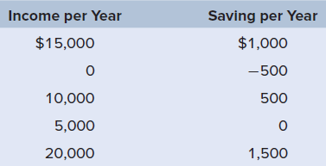

Answer:

Income per Year | Saving per Year
0 | -$500
$5,000 | 0
$10,000 | $500
$15,000 | $1,000
$20,000 | $1,500

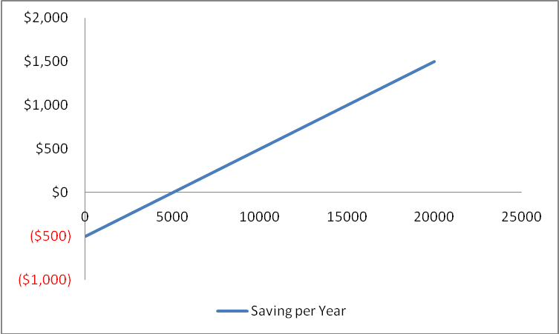

Slope equals (500/5000) or 0.10; the vertical intercept equals -$500. The equation representing this data is : Saving = -$500 + 0.1 x Income. The predicted level of saving is $750.

Feedback: Consider the following data:

Income per Year | Saving per Year
$15,000 | $1,000
0 | -$500
$10,000 | $500
$5,000 | 0
$20,000 | $1,500

To rearrange the above data into a meaningful order, we start with the lowest income and saving pair. We then continue with sequentially higher values of both income and saving. The reason for this ordering is that economic theory (and data) suggests that as income increases so does saving. The data are reordered as follows (you could also reorder from highest to lowest, but this is less intuitive).

Income per Year | Saving per Year
0 | -$500
$5,000 | 0
$10,000 | $500
$15,000 | $1,000
$20,000 | $1,500

Graphically, we have the following.

The slope of the saving line can be found by dividing the change in saving by the change in income between any two points. For example we have the entry (5000 (income), 0 (savings)) and the entry (10000 (income), 500 (savings)). This implies that the change in saving equals 500 minus zero (= 500) and the change in income equals 10000 minus 5000 (= 5000), therefore the slope equals (500/5000) or 0.10. That is, for every additional dollar an individual earns (net income) he or she will save 10 cents and consume 90 cents. The vertical intercept equals -$500. This implies that if the individual does not earn an income he or she either borrows $500 or reduces past savings (stock variable) by $500.

The equation representing this data is : Saving = -$500 + 0.1xIncome.

To find the predicted amount of saving for a given level of income we substitute the income level into the equation above. For example if income equals $12,500, then the predicted level of saving equals -$500 + (0.1 × $12,500). Thus the predicted level of saving is $750 (= -$500 + $1,250).

4. Construct a table from the data shown on the graph below. Which is the dependent
variable and which the independent variable? Summarize the data in equation form. LO8

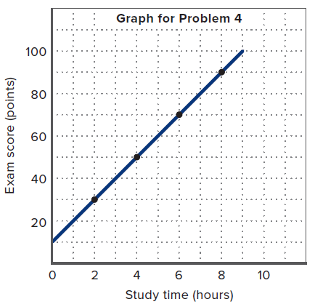
Answer:

Study Time (hours) | Exam Score (points)
0 | 10
2 | 30
4 | 50
6 | 70
8 | 90
9 | 100

The dependent variable is Exam Score (points); Study Time (hours) is the independent variable. Thus, the equation representing this relationship is: Exam Score = 10 + (10 × Study Time).

Feedback: The table for this data is as follows:

Study Time (hours) | Exam Score (points)
0 | 10
2 | 30
4 | 50
6 | 70
8 | 90
9 | 100

The dependent variable is Exam Score (points) because we assume Study Time (hours) influences your score. The more hours you spend studying will increase your exam score. This means that Study Time (hours) is the independent variable.

The vertical intercept for this relationship is your exam score if you choose not to study (zero hours). From the table above this value is 10.

To find the slope we divide the change in your Exam Score by the change in Study Time for any two points. For example, we have the entry 2 (study time), 30 (exam score) and the entry (4, 50). This implies the slope equals (50 – 30) divided by (4 – 2), which equals 20/2, or 10. For every additional hour you spend studying your exam score will increase by 10 point. Thus, the equation representing this relationship is: Exam Score = 10 + (10 × Study Time).

5. Suppose that when the interest rate on loans is 16 percent, businesses find it
unprofitable to invest in machinery and equipment. However, when the interest rate is 14 percent, $5 billion worth of investment is profitable. At 12 percent interest, a total of $10 billion of investment is profitable. Similarly, total investment increases by $5 billion for each successive 2-percentage-point decline in the interest rate. Describe the relevant relationship between the interest rate and investment in a table, on a graph, and as an equation. Put the interest rate on the vertical axis and investment on the horizontal axis. In your equation use the form i = a + bI , where i is the interest rate, a is the vertical intercept, b is the slope of the line (which is negative), and I is the level of investment. LO8

Answer:
Interest  rate  (in percent) |  | Amount of  investment  (billions of dollars)
16  14  12  10  8  6  4  2  0 |  | $ 0  5  10  15  20  25  30  35  40

Equation: i = 16 - (2/5)I or I = 16 – (0.4)I

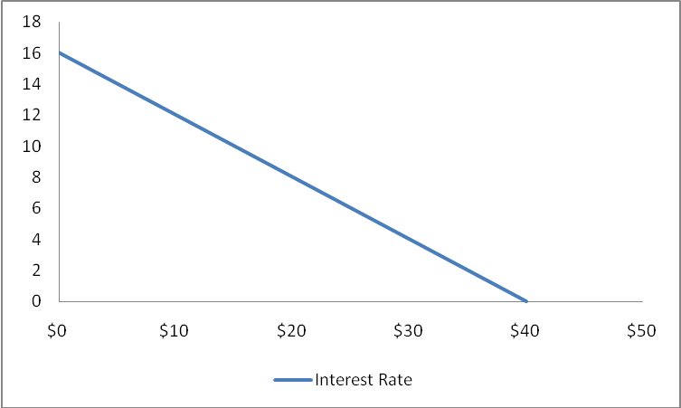

Feedback: Consider the following data as an example:
Suppose that when the interest rate on loans is 16 percent, businesses find it unprofitable to invest in machinery and equipment. However, when the interest rate is 14 percent, $5 billion worth of investment is profitable. At 12 percent interest, a total of $10 billion of investment is profitable. Similarly, total investment increases by $5 billion for each successive 2-percentage-point decline in the interest rate.

Interest  rate  (in percent) |  | Amount of  investment  (billions of dollars)
16  14  12  10  8  6  4  2  0 |  | $ 0  5  10  15  20  25  30  35  40

When the interest rate is 16%, investment spending will be zero. When the interest rate is 14%, investment spending will be $5 billion. For each successive drop of 2 percentage points in the interest rate, investment spending will increase by $5 billion.
Graphically we have the following relationship.

6. Suppose that C = a + bY , where C = consumption, a = consumption at zero income, b = slope, and Y = income. LO8
a. Are C and Y positively related or are they negatively related?
b. If graphed, would the curve for this equation slope upward or slope downward?
c. Are the variables C and Y inversely related or directly related?
d. What is the value of C if a = 10, b = .50, and Y = 200?
e. What is the value of Y if C = 100, a = 10, and b = .25?

Answers: (a) positively related; (b) upward; (c) directly related; (d) C = 110; (e) Y = 360.

Feedback:

(a) C and Y are positively related because the slope, b, is positive by assumption. As individual income increases the individual will spend some of this additional income on consumption.

(b) The curve would slope upward because the slope is positive.

(c) C and Y are directly related because C and Y are positively related (move in the same direction).

(d) Consider the following values: If a = 10, b = .50, and Y = 200, then C = 110. If a = 10 and b = .50, then the consumption function takes the following form C = 10 + 0.50 x Y. If income equals 200, Y = 200, then consumption at this level of income equals C = 10 + 0.50 x 200 = 110.

(e) Consider the following values: Y if C = 100, a = 10, and b = .25, then Y = 360. If a = 10 and b = .25, then the consumption function takes the following form C = 10 + 0.25 x Y. We can solve for Y as a function of C.

STEP 1: 0.25 x Y = C - 10

STEP 2: Y = (1/0.25) x C - (10/0.25) = 4 x C - 40

STEP 3: Substitute in the value of consumption given, C = 100. Y = 4 x 100 - 40 = 360.

7. The accompanying graph shows curve XX’ and tangents at points A, B, and C. Calculate the slope of the curve at these three points. LO8

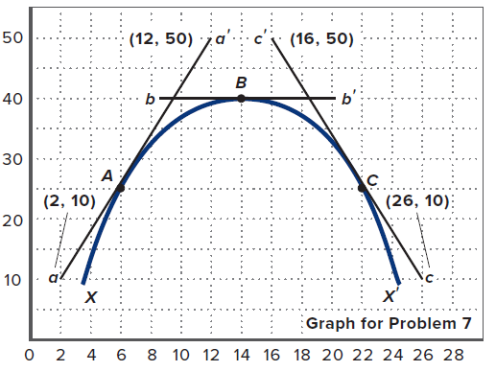

Answer: Point A, slope = 4; Point B, slope = 0; Point C, slope = -4.

Feedback: To calculate the slope of the function use the "rise-over-run" approach. The "rise" is the change in the variable on vertical axis as you move between entries (points) and the "run" is the change in the variable on the horizontal axis as you move between the SAME two entries (points).

Point A has a slope that equals 4. To see this, we use the two entries (2,10) and (12,50). The "rise" equals 50 - 10 = 40. The "run" equals 12 - 2 = 10. To find the slope we use the rule "(rise/run)", which equals (40/10) = 4.

Point B has a slope equal to zero. There is no "rise" here, so we do not need coordinates to calculate this value.

Point C has a slope that equals -4. To see this, we use the two entries (16,50) and (26,10). The "rise" equals 10 - 50 = -40 (note that "rise" can be negative). The "run" equals 26 - 16 = 10. To find the slope we use the rule "(rise/run)", which equals (-40/10) = -4.

8. In the accompanying graph, is the slope of curve AA’ positive or negative? Does the slope increase or decrease as we move along the curve from A to A’? Answer the same two questions for curve BB’.

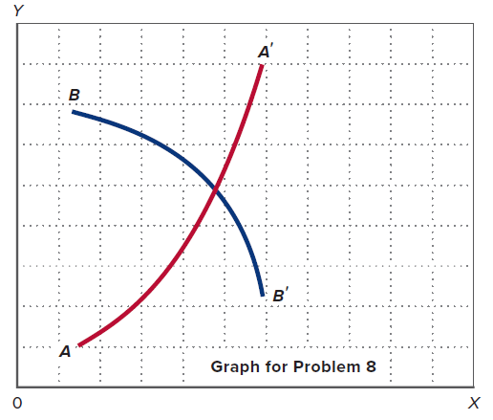

Answer: Slope of AA’ is positive; increases; Slope of BB’ is negative; decreases.

Feedback: Slope of AA’ is positive (rising from left to right). The slope increases as we move from A to A’.

Slope of BB’ is negative (dropping from left to right). The slope becomes more negative, thereby decreasing, as we move from B to B’.

