Test Bank
to accompany
Language in Mind: An Introduction to Psycholinguistics, Second Edition
Julie Sedivy

Chapter 2: Origins of Human Language

Multiple Choice

1. The theoretical perspective that humans’ ability to learn language is not the result of innate or genetically based predisposition that evolved specifically for language, but an aspect of our cognitive abilities, including general abilities of learning and memory is known as
a. anti-nativist theory.
b. linguistic theory.
c. psychodynamic theory.
d. evolutionary theory.
Answer: a
Textbook Reference: 2.1 Why Us?
Bloom’s Level: 1. Remembering

2. Which language researcher attempted to define language with 16 characteristics, or design features, of spoken human language?
a. Chomsky
b. Hockett
c. Pinker
d. Darwin
Answer: b
Textbook Reference: 2.1 Why Us?
Bloom’s Level: 1. Remembering

3. Bees introduced into a hive of bee species different from their own will likely “dance” according to
a. the new hive style.
b. their own unique style, unrelated to past experience.
c. the style of their own genetic ancestors.
d. a combination of old and new styles.
Answer: c
Textbook Reference: 2.1 Why Us?
Bloom’s Level: 1. Remembering

4. Which of Hockett’s design features of human language can also be attributed to honeybee communication?
a. Arbitrariness
b. Duality of patterning
c. Reflexiveness
d. Interchangeability
Answer: d
Textbook Reference: 2.1 Why Us?
Bloom’s Level: 4. Analyzing

5. Experiments in which apes are taught a language or symbolic system indicate that apes can
a. learn to use symbols to communicate, but only if they are not arbitrary.
b. learn to use words accurately, but only to refer to objects that are physically present.
c. use combinations of familiar symbols to express new concepts.
d. combine words into sentences as well as a human 3-year-old is able to.
Answer: c
Textbook Reference: 2.1 Why Us?
Bloom’s Level: 3. Applying

6. Even though vervet monkeys seem to be able to produce specific distress calls from birth without the benefit of experience, they acquire the ability to respond appropriately to those calls only after several months of life, presumably due to experience. This finding suggests that
a. human language and vervet calls arise from different cognitive mechanisms.
b. vervet calls are a direct evolutionary precursor of human language.
c. the ability to produce human language is innate but the ability to understand it is not.
d. human infants need a great deal of exposure to language before they can understand it, but less exposure is needed to produce it.
Answer: a
Textbook Reference: 2.1 Why Us?
Bloom’s Level: 5. Evaluating

7. An example of Hockett’s productivity characteristic in non-human primate communication would be demonstrated by an ape making the sign for
a. banana in order to ask a researcher for a banana.
b. banana when the researcher points to a banana.
c. sweet sausage when asked to identify a banana before having learned the sign for banana.
d. door when asked to identify a banana.
Answer: c
Textbook Reference: 2.1 Why Us?
Bloom’s Level: 3. Applying

8. The awareness between two or more individuals that they are paying attention to the same thing is known as
a. homesign.
b. linguistic code.
c. universal grammar.
d. joint attention.
Answer: d
Textbook Reference: 2.2 Social Underpinnings of Language
Bloom’s Level: 1. Remembering

9. Given a choice between two buckets in which only one bucket contains a treat, a chimpanzee will be _______ likely to choose a bucket that a human reached for _______ a bucket that a human pointed to.
a. less; than
b. more; than
c. equally; as
d. as un-; as
Answer: b
Textbook Reference: 2.2 Social Underpinnings of Language
Bloom’s Level: 1. Remembering

10. Hare and Tomasello found that chimpanzees will reach for a bucket containing a treat if a human reaches for the same bucket—but not if the human points to the bucket to signal the presence of a treat in it. This suggests that chimpanzees do not understand the
a. intention of others to act in certain ways.
b. language of others.
c. intention of others to communicate with them.
d. sign language of others.
Answer: c
Textbook Reference: 2.2 Social Underpinnings of Language
Bloom’s Level: 2. Understanding

11. Researchers have found that chimpanzees are not able to understand pointing cues but dogs are able to do so. This suggests that compared to chimpanzees, dogs
a. are more intelligent.
b. are better at picking up social cues.
c. have superior language skills.
d. are more motivated by food.
Answer: b
Textbook Reference: 2.2 Social Underpinnings of Language
Bloom’s Level: 4. Analyzing

12. A 30-month-old child, who at 6 months engaged relatively little with her parents in joint-attention activities, is expected to _________ than a 30-month-old who had at 6 months engaged more in joint-attention activities.
a. have a smaller vocabulary
b. demonstrate worse social skills
c. exhibit more imperative pointing
d. exhibit more declarative pointing
Answer: a
Textbook Reference: 2.2 Social Underpinnings of Language
Bloom’s Level: 2. Understanding

13. Research suggests that human children produce more examples of _______ communication than apes, who produce primarily _______ messages.
a. imperative; declarative
b. declarative; imperative
c. altruistic; declarative
d. imperative, altruistic
Answer: b
Textbook Reference: 2.2 Social Underpinnings of Language
Bloom’s Level: 1. Remembering

14. _______ is the set of rules that determines how linguistic elements, such as words, can be combined to convey meaning.
a. Evolutionary adaptation
b. Productivity
c. Recursion
d. Syntax
Answer: d
Textbook Reference: 2.3 The Structure of Language
Bloom’s Level: 1. Remembering

15. The theory of universal grammar claims that
a. all human languages can be described by essentially the same rules of grammar.
b. all species of primates have the capacity to learn grammar.
c. humans are born with implicit knowledge of the rules of grammar of all human languages.
d. humans are born with a predisposition to learn certain kinds of structures more easily than other kinds of structures.
Answer: d
Textbook Reference: 2.3 The Structure of Language
Bloom’s Level: 2. Understanding

16. Chomsky suggested that human knowledge must have a(n) _______ component, as evidenced by the slave boy/Pythagorean theorem dialogue demonstration.
a. learned
b. altruistic
c. memorized
d. innate
Answer: d
Textbook Reference: 2.3 The Structure of Language
Bloom’s Level: 1. Remembering

17. The theory of universal grammar predicts that
a. a new language discovered in a remote region of South America would have structural patterns that children are innately predisposed to learn.
b. learning French will be easier for a child born to French-speaking parents than for a child born to Japanese-speaking parents who was adopted by French-speaking parents as an infant.
c. a child will be unable to learn a language with recursion.
d. all languages will be equally easy to learn at any time in one’s life.
Answer: a
Textbook Reference: 2.3 The Structure of Language
Bloom’s Level: 5. Evaluating

18. Keith and Cathy Hayes (1951) were able to teach Viki, a young female chimpanzee, to
a. utter several dozen vocalized human words.
b. utter just four indistinct human words.
c. utter several words in French.
d. communicate using American Sign Language.
Answer: b
Textbook Reference: 2.4 The Evolution of Speech
Bloom’s Level: 1. Remembering

19. Cross-fostering experiments suggest that the main reason primates do not produce human-like variety in their vocalizations is because apes
a. lack the motivation to speak.
b. are not raised in the same language-evoking way human infants are.
c. lack the physical apparatus and control over it to produce human-like speech.
d. cannot breathe and swallow simultaneously.
Answer: c
Textbook Reference: 2.4 The Evolution of Speech
Bloom’s Level: 5. Evaluating

20. A comparison of birdsong with human language suggests that
a. songbirds are pre-programmed to sing specific songs from birth, whereas children have to be exposed to speech sounds in order to be able to produce them.
b. songbirds can only produce memorized sequences of sounds, whereas children can produce novel combinations of words.
c. both human infants and young songbirds must practice their vocal skills in order to master them.
d. both children and songbirds show evidence of Hockett’s feature of semanticity in their communication.
Answer: c
Textbook Reference: 2.4 The Evolution of Speech
Bloom’s Level: 3. Applying

21. Some researchers argue that the birds and aquatic mammals that produce complex arrays of linguistic sounds to communicate with their peers are using a(n)
a. affective pathway.
b. cognitive pathway.
c. larynx.
d. universal grammar.
Answer: b
Textbook Reference: 2.4 The Evolution of Speech
Bloom’s Level: 2. Understanding

22. The difference between a monkey sounding an alarm call and a bird mimicking sounds from its environment is that the bird is using a(n)
a. in-born behavior.
b. affective pathway.
c. cognitive pathway.
d. social behavior.
Answer: c
Textbook Reference: 2.4 The Evolution of Speech
Bloom’s Level: 3. Applying

23. Which animal is able to gesture in a flexible way to indicate its intention?
a. Dog
b. Cat
c. Bee
d. Chimpanzee
Answer: d
Textbook Reference: 2.4 The Evolution of Speech
Bloom’s Level: 5. Evaluating

24. An infant born in the United States would demonstrate early attempts at language production through babbling. Her babbling would most likely
a. contain primarily the speech sounds made around her.
b. comprise random sounds, but be organized by a universal grammar.
c. contain some words she hears people speaking around her.
d. be unrelated to her parents’ speech.
Answer: a
Textbook Reference: 2.4 The Evolution of Speech
Bloom’s Level: 5. Evaluating

25. Can a young deaf child, born into a hearing family, communicate with her parents?
a. No, deaf children cannot communicate with anyone until someone teaches them sign language.
b. No, all children know American Sign Language at birth, but their hearing parents will have forgotten their knowledge of sign language from disuse.
c. Yes, deaf children usually invent a gestural language to communicate with their parents.
d. Yes, but only if their parents know sign language.
Answer: c
Textbook Reference: 2.5 How Humans Invent Language
Bloom’s Level: 1. Remembering

26. If a child is taught a foreign language during her sensitive period in language development, she will
a. most likely speak the language with her native accent and have difficulty mastering the language’s nuances.
b. most likely master and speak the foreign language as well as a native speaker.
c. learn pronunciation easily, but struggle to learn its grammatical rules.
d. have difficulty with pronunciation of the foreign language, but easily learn its grammatical rules.
Answer: b
Textbook Reference: 2.5 How Humans Invent Language
Bloom’s Level: 5. Evaluating

27. A 2009 study by Feher et al. showed that, over the course of several generations, the songs of birds raised by isolates become remarkably similar to those of normal adult birds. These results support the
a. nativist view of bird song origins.
b. anti-nativist view of bird song origins.
c. cultural transmission view of language change.
d. universal grammar perspective.
Answer: a
Textbook Reference: 2.5 How Humans Invent Language
Bloom’s Level: 3. Applying

28. Which statement conveys the most accurate comparison of spoken English and American Sign Language (ASL)?
a. ASL is a way for individuals in the deaf community to communicate with one another but is not as structured and organized as spoken English.
b. ASL uses grammatical rules and structures that are very similar to those found in English.
c. ASL uses grammatical structures that are systematic, but very different from those found in English.
d. ASL is a system of pantomime invented by the deaf community whereas spoken English is a real language.
Answer: c
Textbook Reference: 2.5 How Humans Invent Language
Bloom’s Level: 2. Understanding

29. The system of symbols, agreed upon by a community of language users, that conveys specific meaning is known as
a. a linguistic code.
b. a cognitive pathway.
c. homesign.
d. recursion.
Answer: a
Textbook Reference: 2.5 How Humans Invent Language
Bloom’s Level: 1. Remembering

30. _______ is a genetic disorder in which some language functions seem relatively intact, while other complex cognitive abilities are markedly impaired.
a. Working memory deficit
b. Williams syndrome
c. Downs syndrome
d. Specific language impairment
Answer: b
Textbook Reference: 2.6 Language and Genes
Bloom’s Level: 1. Remembering

31. Mental age can be defined as a person’s
a. measure of ability to carry out complex cognitive tasks.
b. overall level of social functioning as it relates to other individuals in his or her age group.
c. overall level of cognitive functioning as it relates to other individuals in his or her age group.
d. age at which he or she acquires most of the advanced problem-solving skills.
Answer: c
Textbook Reference: 2.6 Language and Genes
Bloom’s Level: 1. Remembering

32. Six-year old Olivia has trouble expressing herself verbally and seems to have an abnormally short working memory span. Doctors have not been able to find any specific neurological or physiological problems, but her twin sister, Jane, seems to have similar impairments. If you were her pediatrician, which of the following disorders of speech would you believe was affecting Olivia?
a. Downs syndrome
b. FOXP2 syndrome
c. Specific language impairment
d. Williams syndrome
Answer: c
Textbook Reference: 2.6 Language and Genes
Bloom’s Level: 5. Evaluating

33. A researcher who believes the domain-specific perspective of specific language impairment (SLI) would argue that SLI occurs due to
a. an interaction of language-related cognitive impairments.
b. a complex interaction of linguistic and non-linguistic cognitive impairments.
c. innate and genetic factors affecting general cognition.
d. an abnormal home environment affecting language acquisition.
Answer: a
Textbook Reference: 2.6 Language and Genes
Bloom’s Level: 2. Understanding

34. The evolution of the Al-Sayyid Bedouin Sign Language (ABSL) occurred over generations, guided by
a. a small, isolated, and highly homogenous population.
b. a large geographical and social pool of individuals.
c. an existing spoken language from which the critical components of ABSL were developed.
d. only the deaf members of the community.
Answer: a
Textbook Reference: 2.7 Survival of the Fittest Language?
Bloom’s Level: 1. Remembering

35. The cultural transmission view of language change holds that
a. the brains of geographically isolated individuals develop differently than the brains of those individuals that can exchange ideas and learn each others’ languages.
b. our brains adapt to the language we invent.
c. languages change over time, responding to pressures to be communicatively useful and easy to learn.
d. human language developed as a by-product of our physiology.
Answer: c
Textbook Reference: 2.7 Survival of the Fittest Language?
Bloom’s Level: 2. Understanding

36. Which scenario would most likely result in significant language change?
a. A community of deaf adults, who are native signers of American Sign Language, teaching American Sign Language to hearing children.
b. A community of hearing adults, who are native signers of American Sign Language, teaching American Sign Language to deaf children.
c. A community of native German-speaking adult immigrants to the United States speaking to their children in English from birth.
d. A community of native French speakers teaching English-speaking immigrant children to speak French in the first grade.
Answer: c
Textbook Reference: 2.7 Survival of the Fittest Language?
Bloom’s Level: 5. Evaluating

Short Answer

1. What empirical evidence suggests that bees have an innate dance “dialect?”
Answer: When bees from another species are introduced into a new hive, they continue to “dance” according to their genetic ancestors’ style, they do not take on the dance of their new hive members.
Textbook Reference: 2.1 Why Us?
Bloom’s Level: 2. Understanding

2. Viki, a chimpanzee, can produce only four indistinct words of spoken English, whereas Alex, a parrot, can clearly pronounce more than 100 words. Can we conclude from this that Alex’s linguistic capabilities are superior to Viki’s? Why or why not?
Answer: No. We are likely to underestimate Viki’s linguistic abilities if we consider only her spoken language because chimpanzees are limited by their vocal apparatus and may lack the cognitive ability to accurately imitate vocal sounds. The fact that they are able to acquire large vocabularies using signs or other symbols suggests that their speech does not accurately reflect their language skills. In addition, when assessing linguistic capabilities, it is important to consider not only whether an animal is capable of producing a word, but also whether it has understood its meaning. It is possible that Alex is simply imitating the sounds of words without being able to use them as meaningful symbols in a variety of appropriate contexts.
Textbook Reference: 2.1 Why Us?
Bloom’s Level: 5. Evaluating

3. In terms of social cognition and intention, how does human pointing behavior tend to differ from ape pointing behavior?
Answer: According to Tomasello (2006), apes point mostly to call attention to objects they wish to possess, whereas humans also often point in an effort to comment on aspects of the world and to assist others by conveying information about the environment, often in an altruistic manner.
Textbook Reference: 2.2 Social Underpinnings of Language
Bloom’s Category: 2. Understanding

4. Explain how comparative studies can help us understand various species’ cognitive abilities, and give an example of a comparative study.
Answer: Comparative studies are research designs in which the abilities of different species are compared to each other in targeted experiments. Researchers design tests that are appropriate for all of the species being studied and compare outcomes among the various species being studied. Such studies can illuminate similarities and differences among species, indicate possible evolutionary relationships, and provide evidence about which cognitive abilities tend to cluster together across species. An example would be the study by Hermann et al. (2007) in which researchers evaluated chimpanzees, orangutans, and human toddlers to see how they compared in their social understanding and their understanding of the physical world. They found that chimpanzees performed as well as human toddlers (and better than orangutans) in their understanding of the physical world, but both primate species performed much worse than humans on the social tasks. This suggests that understanding of the physical world and understanding of the social world have followed different evolutionary paths. Furthermore, because only humans spontaneously use language, this hints at a possible connection between the evolution of social skills and the evolution of language.
Textbook Reference: 2.2 Social Underpinnings of Language
Bloom’s Level: 3. Applying

5. What is duality of patterning, and how is this feature beneficial for a communication system?
Answer: Duality of patterning involves the combination of smaller units that alone convey no meaning, such as sounds, into larger, meaningful units, such as words. This feature is useful because it allows a relatively small number of units to be combined together to signal a very large set of unique meanings. Users of a communication system without duality of patterning would have to learn completely different holistic sounds corresponding to different meanings. For example, they might have to learn to produce a yelp to refer to the concept of a bat and a low guttural sound to refer to the concept of a cat, rather than re-using some of the sound units between one word and another. This would require them to be able to produce and memorize a very large set of completely distinct sounds. Difficulties in doing so might place an an upper limit on the number of words possible in the vocabulary of such a communication system.
Textbook Reference: 2.3 The Structure of Language
Bloom’s Level: 2. Understanding

6. Do you agree with the nativist view of the evolution of language? Provide evidence to support your argument.
Answer: .Answers may vary. Evidence against the nativist view:
a. Children receive much more linguistic input than previously estimated by supporters of the nativist view, undermining the idea that the linguistic input received by children is not sufficient to explain the complexity of their linguistic knowledge.
b. Cognitive processes that have been described in the past as being specific to language are now recognized as more generally cognitive and applying to tasks outside of language processing.
c. Non-human animals seem to possess language abilities that previously were believed to be associated only with humans.
d. Human languages appear to be much more diverse than was believed in the past, undermining the notion that humans are predisposed to learn a very constrained set of structures.
Evidence for the nativist view:
a. Some possible patterns of language (based on the number of possible combinations) do not occur, which was interpreted by Chomsky as evidence of some innate constraints on human linguistic behavior.
b. Other non-human animals seem to have been genetically pre-programmed for specific sounds and gestures, supporting the general idea that communicative behaviors may be genetically determined.
Textbook Reference: 2.3 The Structure of Language
Bloom’s Level: 5. Evaluating

7. Refer to the figure.

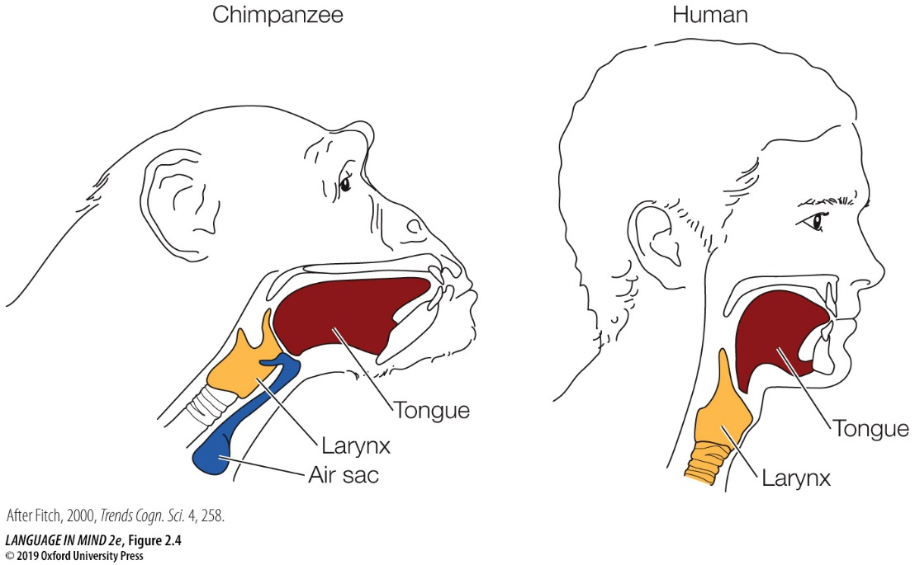

Discuss how the differences between chimpanzee and human vocal anatomy affect each species’ ability to produce vocal language. What is the evolutionary significance of these differences?
Answer: In humans, the larynx sits lower in the vocal tract than it does in chimpanzees, so the tongue has more room to move and articulate and is thus able to create a greater number of distinct sounds. In chimpanzees, the height of the larynx makes simultaneous breathing and swallowing possible. Although the shape and position of the human tongue may contribute to our ability to articulate sounds, it makes simultaneous breathing and swallowing impossible, introducing the (lethal) possibility of choking. This tradeoff suggests that the ability to create complex sounds and speech has been evolutionarily important.
Textbook Reference: 2.3 The Structure of Language
Bloom’s Level: 2. Understanding

8. Compare the language learning outcomes of: 1) a human infant raised by adoptive parents who speak a language other than that of the infant’s birth parents with 2) the sounds produced by rhesus macaque monkeys raised by Japanese macaques, instead of their biological parents.
Answer: When humans are raised by adoptive human parents from infancy, they are able to acquire the language of their adoptive parents perfectly, whereas cross-fostered macaques will sound much more similar to their biological parents than their adoptive parents.
Textbook Reference: 2.4 The Evolution of Speech
Bloom’s Level: 3. Applying

9. How does the use of gesture by apes in the wild differ from the use of alarm calls by vervet monkeys? Which more closely resembles the linguistic behavior of humans?
Answer: Wild ape gestures appear to be learned within a community of apes, so apes in one group may use gestures that are different from those of another group. Apes can use the same gesture in a variety of communicative contexts, demonstrating that their use of gestures is highly flexible. In contrast, vervet monkeys appear to be born with the ability to produce certain threat-specific alarm calls, which are understood by all other vervets. Moreover, unlike ape gestures, vervet calls lack flexibility because they are only used to communicate warnings. Ape gestures resemble human linguistic communication more closely than vervet calls do because, rather than being biologically programmed, human language must be learned within a community of other humans using language and human language also exhibits flexibility.
Textbook Reference: 2.4 The Evolution of Speech
Bloom’s Level: 3. Applying

10. Refer to the figure.

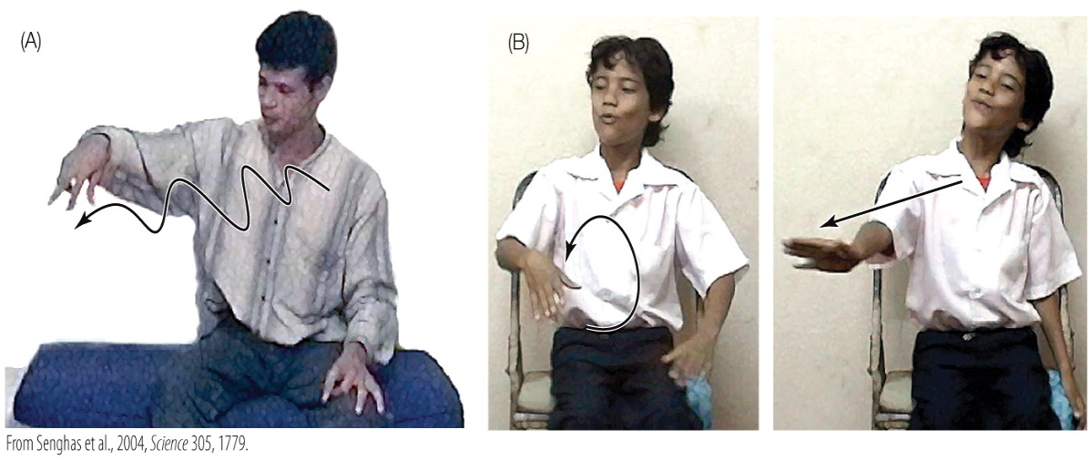

Figure A demonstrates how a hearing individual might use a gesture, along with speech, to describe rolling downhill. Figure B demonstrates how someone using sign language might gesture to convey the same action. What do the images tell us about how each individual uses gestures to convey information? Why is this an important distinction in linguistics, and how does it allow sign languages to resemble spoken languages in terms of their expressive power? Answer: Hearing individuals tend to use gestures to supplement a verbal message. They incorporate multiple aspects of the message into one gesture, using it to illustrate or emphasize one aspect of the message. An individual fluent in NSL relies on signs to convey the core meaning of the message and as such, each critical aspect of the message is represented by a separate sign. This allows sign language to have similar expressive power to spoken languages because separate signs can be combined flexibly with other signs to express a great variety of complex ideas.
Textbook Reference: 2.4 The Evolution of Speech
Bloom’s Level: 4. Analyzing

11. Senghas et al. (2004) noticed that during the formation and evolution of Nicaraguan Sign Language, purely gestural signs tended to develop a more linguistic style as the sign language evolved from earlier to later “generations” of signers. How would a late-generation signer of NSL describe a bird flying up?
Answer: Instead of representing one motion of a “bird flying up” in one holistic gesture, a signer uses one gesture to convey the concept of a “bird” followed by a separate gesture conveying the action of “rising” or “flying.”
Textbook Reference: 2.5 How Humans Invent Language
Bloom’s Level: 3. Applying

12. Explain how Williams Syndrome (WMS) aids us in understanding how human language is organized in the brain.
Answer: Williams Syndrome is a genetically based set of symptoms in which certain cognitive, physical, and physiological problems are evident but language fluidity and expression remain quite high functioning. At first, WMS seemed to provide evidence for a genetically specific language module in the brain that is dissociated from overall intelligence, but further researcher suggested that, if you compare people with WMS to a control group of children with the same mental age, their language skills are not actually spared.
Textbook Reference: 2.6 Language and Genes
Bloom’s Level: 3. Applying

13. Jasmine is a 9-year-old whose IQ is lower than that of her peers. She also produces incoherent speech and demonstrates grammatical difficulties as well. In addition, she has trouble generating certain facial gestures and humming a jingle. Her younger sister is learning language normally and appears to have no other deficits. Identify the most likely explanation for Jasmine’s condition and why you arrived at your answer.
Answer: It is likely that Jasmine has inherited a FOXP2 mutation, which typically produces the cluster of symptoms described. The fact that Jasmine’s sister has not demonstrated these symptoms indicates that Jasmine’s problem is genetic and not a product of the environment in which both she and her sister live.
Textbook Reference: 2.6 Language and Genes
Bloom’s Level: 5. Evaluating

14. Refer to the figure shown here.

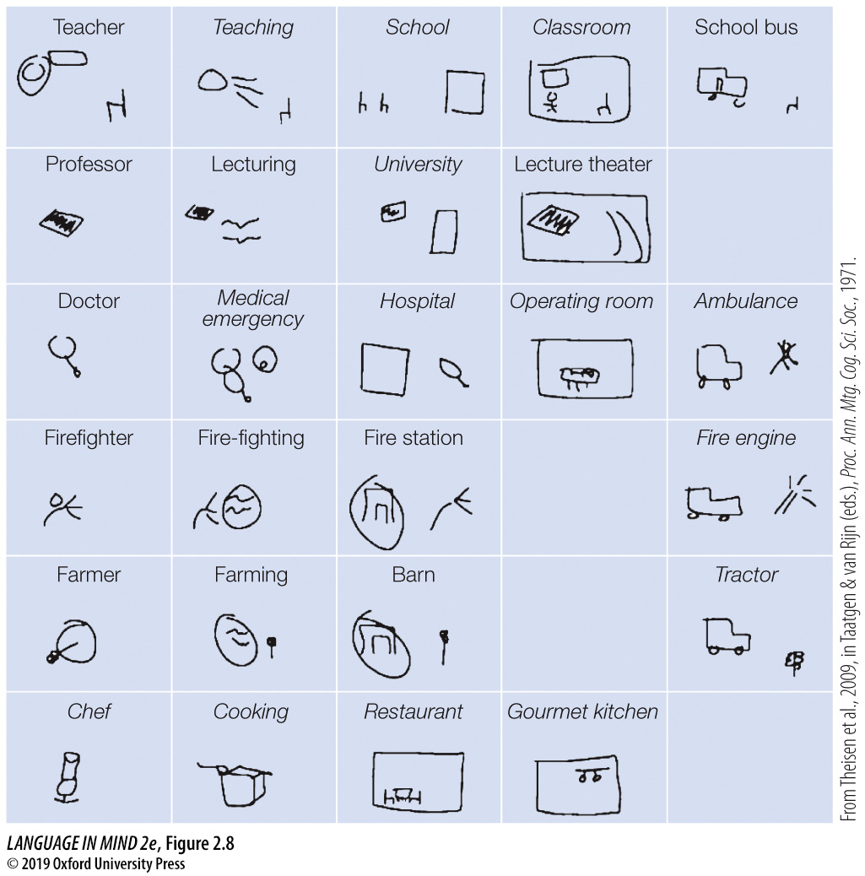

Consider the drawings and the words they represent from Theisen et al. (2010). Explain how the participants’ synthetic language “evolved” over the course of the experiment and what these changes imply about how other languages have evolved over time.
Answer: Over the course of the experiment, participants drew images that became less detailed and more abstract to express the same concepts. This development suggests that shared knowledge of symbols allows them to become simpler and more efficient. Another development in the synthetic visual language was that over time, users developed symbols to represent core concepts and combined them with other elements to express related concepts. For example, the same symbol resembling a piece of paper with writing on it appeared in the related concepts professor, lecturing, university, and lecture theater. This strategy suggests that when they invent a new communication system, people quickly settle on a system that combines elements in systematic ways, a property that is found in all human languages.
Textbook Reference: 2.7 Survival of the Fittest Language?
Bloom’s Level: 4. Analyzing

