# Chapter 2

2.1 Nominal: Occupation, undergraduate major. Ordinal: Rating of university professor, Taste test ratings. Interval: age, income

2.2 a Interval

b Interval

c Nominal

d Ordinal

2.3 a Interval

b Nominal

c Ordinal

d Interval

e Interval

2.4 a Nominal

b Interval

c Nominal

d Interval

e Ordinal

2.5 a Interval

b Interval

c Nominal

d Interval

e Nominal

2.6 a Interval

b Interval

c Nominal

d Ordinal

e Interval

2.7 a Interval

b Nominal

c. Nominal

d Interval

e Interval

f Ordinal

2.8 a Interval

b Ordinal

c Nominal

d Ordinal

2.9 a Interval

b Nominal

c Nominal

2.10 a Ordinal

b Ordinal

c Ordinal

2.11 a Nominal

b Interval

c Ordinal

2.12a Nominal

b Interval

c Interval

d Interval

2.13

2.14

2.15

2.16



2.17

2.18

2.19

2.20

2.21

2.22

2.23

2.24

2.25

2.26



2.27



2.28



The basement is the top choice followed by kitchen, bathroom, bedroom, and living/dining room.

2.29 a Newspaper Frequency Relative Frequency

Daily News 141 39.2%

Post 128 35.6%

Times 32 8.9%

WSJ 59 16.4%

b

The Daily News and the Post dominate the market

2.30a Degree Frequency

BA 88

BBA 37

B Eng 51

B Sc 24

Other 30

b.

c



d. About 4 applicants in 10 have the BA degree, about one-fifth have a BEng. and one-sixth have a BBA.

2.31a

b

c Dell is most popular with 40% proportion, followed by other, 26%, HP, 21% and Lenovo, 13%.

2.32 a Software Frequency

Excel 34

Minitab 17

SAS 3

SPSS 4

Other 12

b



c Excel is the choice of about half the sample, one-quarter have opted for Minitab, and a small fraction chose SAS and SPSS.

2.33



2.34

2.35

2.36 a

b

According to the survey Republicans favor the rich and Democrats are split among the middle class, poor, and rich.

2.37 a

Category ` Frequency Relative Frequency

Mom: Full time, Dad: Full time 403 46.0%

Mom: Part time, Dad: Full time 149 17.0%

Mom: Not employed, Dad: Full time 228 26.0%

Mom: Full time, Dad: Part time or not employed 53 6.0%

Mom: Not employed, Dad: Not employed 18 2.1%

Other 26 3.0%

b

c

d In most households Dad is working full time. There are very few households where neither Mom nor Dad are working.

2.38

A small majority oppose the Affordable Care Act.

2.39a

Views on social issues Frequency Relative Frequency

Liberal 322 31.4%

Moderate 328 32.0%

Conservative 375 36.6%

b

The country is split among the three views on social issues with a small plurality of conservatives.

2.40 a

Views on economic issues Frequency Relative Frequency

Liberal 208 20.3%

Moderate 354 34.5%

Conservative 463 45.2%

b

Economically the country is conservative.

2.41

There is decreasing numbers of Americans who did not finish high school and increasing numbers of those that go to college.

2.42

Spending is increasing in all seven areas.

2.43

In general crime was decreasing until 2014 when it started increasing.

2.44



Universities 1 and 2 are similar and quite dissimilar from universities 3 and 4, which also differ. The two nominal variables appear to be related.

2.45

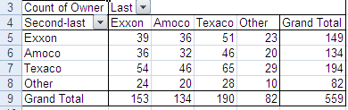

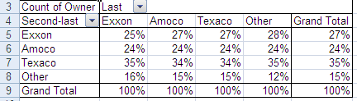

The column proportions are similar; the two nominal variables appear to be unrelated. There does not appear to be any brand loyalty.

2.46

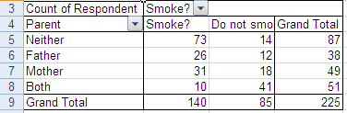

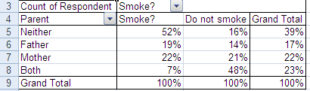

The two variables are related.

2.47

There are large differences between men and women in terms of the reason for unemployment.

2.48

The number of prescriptions filled by all stores except independent drug stores has increased substantially.

2.49



There appears to be differences between female and male students in their choice of light beer.

2.50

There are differences among the five groups.

2.51

All three groups say that upper-income people pay too little. However Conservatives are more likely to say fair share than Moderates or Liberals

2.52

Democrats support and Republicans oppose the Affordable Care Act.

2.53

No surprise-on social issues Democrats are liberal and Republicans are conservative.

2.54

On economic issues Republicans are very conservative whereas Democrats and Moderates are mixed.

2.55

2.56

2.57

2.58

The pattern is about the same for the three households.

2.59

2.60

There are decreases in almost every state. However, there are many Americans without health insurance.

2.61



More students disagree than agree.

2.62



More than 40% rate the food as less than good.

2.63



2.64



Customers with children rated the restaurant more highly than did customers with no children.

2.65



Males and females differ in their areas of employment. Females tend to choose accounting marketing/sales and males opt for finance.

b



Area and job satisfaction are related. Graduates who work in finance and general management appear to be more satisfied than those in accounting, marketing/sales, and others.

2.66

The survey oversampled women slightly.

2.67

2.68a

|  |  |
| --- | --- |
| Married | 1158 |
| Widowed | 209 |
| Divorced | 411 |
| Separated | 81 |
| Never married | 675 |

b. Pie chart

c.

2.69

2.70

The patterns are similar.

2.71

2.72

The patterns are similar.

2.73

Males are slightly more likely to be self-employed than females.

2.74

The ”married” categories (4 and 5) make up more than 60% of the households.

2.75

There are large differences between male and female heads of households.

2.76

Whites make up three quarters of the survey.

2.77

There are large differences between the four races in terms of family structure.

2.78

College degree holders are much more likely to own their homes.