Multiple Choice

1. Which is the set notation for the interval ?
​
a.
b.
c.
d.
e.

ANSWER: | d

2. Write the interval in set notation.
​
 | a.
 | b.
 | c. | ​
 | d.
 | e. | none of these choices

ANSWER: | c

3. Which number line correctly displays the graph of the interval ?
​
 | a. | ​  ​
 | b. | ​  ​
 | c. | ​  ​
 | d. | ​  ​
 | e. | ​  ​

ANSWER: | b

4. Given the equation how will y change if x increases by 6 units.
​
 | a. | decreases by 40 units
 | b. | decreases by 30 units
 | c. | increases by 40 units
 | d. | increases by 30 units
 | e. | decreases by 5 units

ANSWER: | b

5. Given the equation , how will y change if x decreases by 3 units.
​
 | a. | increases by 21 units
 | b. | increases by 42 units
 | c. | decreases by 21 units
 | d. | decreases by 42 units
 | e. | increases by 7 units

ANSWER: | a

6. Find the slope of the line passing through the given pair of points.
​
and
​
 | a. | 4
 | b. | ​
 | c. | –2
 | d. | –8
 | e. | The slope is undefined.

ANSWER: | c

7. Find the slope of the line passing through the given pair of points.
​
and
​
 | a.
 | b. | 1
 | c. | 5
 | d. | 7
 | e. | The slope is undefined.

ANSWER: | b

8. Find the slope of the line determined by the points and .
​
 | a. | ∞
 | b. | 3
 | c. | 0
 | d. | 7
 | e. | 2

ANSWER: | c

9. Find the slope of the line passing through the given pair of points.
​
and
​
 | a. | –1
 | b. | ​
 | c. | 3
 | d. | 0
 | e. | The slope is undefined.

ANSWER: | e

10. Find the slope m and y-intercept of the equation 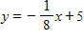.
​
a.
b.
c.
d.
e.

ANSWER: | b

11. Find the slope m and y-intercept b of the line whose equation is given below.
​
​
​
 | a. | m = –1, b = 0
 | b. | m = 0, b = 0
 | c. | m = –1, b = 1
 | d. | m = 0, b = –1
 | e. | Both m and b are undefined.

ANSWER: | d

12. Find the slope m and y-intercept b of the line whose equation is given below.
​
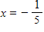
​
 | a. |  | b.
 | c. |  | d.
 | e. | Both m and b are undefined.

ANSWER: | e

13. Find the slope m and y-intercept b of the line whose equation is given below.
​
​
a.
b.
c.
d.
e.

ANSWER: | b

14. Write the equation and graph the line that passes through the given point and has the slope indicated.
​
with slope
​
 | a.
 | b. | ​
 | c.
 | d.
 | e.

ANSWER: | b

15. Write an equation for the horizontal line passing through the point .
​
a.
b.
c.
d.
e.

ANSWER: | a

16. Write the equation of the line passing through the given pair of points.
​
and
​
 | a.
 | b. | ​
 | c.
 | d.
 | e.

ANSWER: | d

17. Write the equation of the line passing through the given pair of points.
​
and
​
 | a.
 | b.
 | c.
 | d. | ​
 | e.

ANSWER: | b

18. Write an equation of the form for the line in the graph given below.
​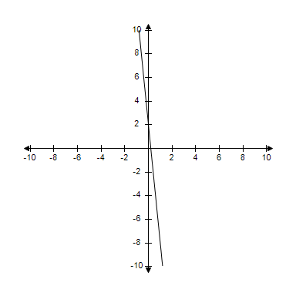
​
 | a. | y = –8x
 | b. | y = 2x + 2
 | c. | y = –10x + 2
 | d. | y = –12x + 2
 | e. | y = 2x

ANSWER: | c

19. Which set of equations gives the lines determining the four sides of the figure?
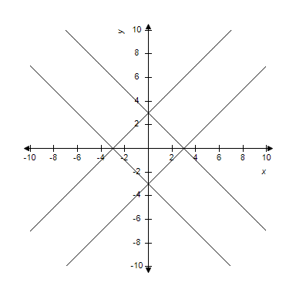
​
 | a. | ​ | b. | ​
 | c. | ​ | d. | ​
 | e. | ​

ANSWER: | e

20. Suppose a utility considers demand for electricity "low" if it is below 3 mkW (million kilowatts), "average" if it is at least 3 mkW but below 20 mkW, "high" if it is at least 20 mkW but below 40 mkW, and "critical" if it is 40 mkW or more. Express these demand levels in interval notation.
​
a.
b.
c.
d.
e.

ANSWER: | a

21. Suppose computer sales in the U.S. have been growing approximately linearly. In 2001 sales were 64.5 million units, and in 2006 were 86.5 million units. Use the first and last (Year, Sales) data points to find the linear relationship between x = Years since 2000 and y = Sales (in millions).
​
a.
b.
c.
d.
e.

ANSWER: | c

22. The linear relationship between Celsius and Fahrenheit temperature using the data points is given as . Based on this linear relationship, find the Fahrenheit temperature that corresponds to 80 Celsius.
​
 | a. | 112
 | b. | 176
 | c. | 160
 | d. | 208
 | e. | 144

ANSWER: | b

23. Evaluate 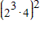 without using a calculator.
​
 | a. | 32
 | b. | 13122
 | c. | 48
 | d. | 16777216
 | e. | 1024

ANSWER: | e

24. Evaluate 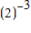 without using a calculator.
​
 | a.
 | b. | 8
 | c.
 | d. | 6
 | e. | ​

ANSWER: | c

25. Evaluate the expression 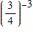 without using a calculator.
​
a.
b.
c.
d.
e.

ANSWER: | a

26. Evaluate 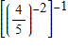 without using a calculator.
​
a.
b.
c.
d.
e.

ANSWER: | a

27. Evaluate 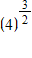 without using a calculator.
​
 | a. | 6
 | b. | 8
 | c.
 | d. | 24
 | e.

ANSWER: | b

28. Evaluate the expression 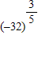 without using a calculator.
​
 | a. | 2
 | b. | –32
 | c. | 32
 | d. | 8
 | e. | –8

ANSWER: | e

29. Evaluate 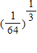 without using a calculator.
​
 | a.
 | b. | 4
 | c.
 | d.
 | e. | 192

ANSWER: | d

30. Evaluate the expression 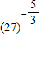 without using a calculator.
​
a.
b.
c.
d.
e.

ANSWER: | d

31. Evaluate the expression 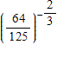 without using a calculator.
​
a.
b.
c.
d.
e.

ANSWER: | c

32. Use a calculator to evaluate the expression.
​
​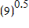
​
 | a. | 0.0020
 | b. | 3.0000
 | c. | 0.3333
 | d. | 4.5000
 | e. | 6.0000

ANSWER: | b

33. Use a graphing calculator to evaluate 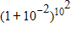. Round your answer to thousandths place.
​
 | a. | 1
 | b. | 1.011
 | c. | 2
 | d. | 2.209
 | e. | 11

ANSWER: | d

34. Write the expression 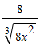 in power form for numbers a and b.

a.
b.
c.
d.
e.

ANSWER: | b

35. Write the expression 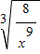 in power form for numbers a and b.

a.
b.
c.
d.
e.

ANSWER: | a

36. Simplify 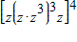.
​
a.
b.
c.
d.
e.

ANSWER: | e

37. Simplify 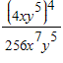.
​
a.
b.
c.
d.
e.

ANSWER: | c

38. Simplify 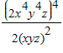.
​
 | a.
 | b.
 | c.
 | d.
 | e. | ​

ANSWER: | a

39. Many chemical and refining companies use "the rule of point six" to estimate the cost of new equipment. According to this rule, if a piece of equipment (such as storage tank) costs C dollars, then the cost of similar equipment that is x times as large will be approximately 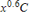dollars. Use this rule of .6 to find how costs change if a company wants to grow its capacity to be eight times its current value.
​
 | a. | To increase the capacity by 700% costs only about 274% more.
 | b. | To increase the capacity by 700% costs only about 248% more.
 | c. | To increase the capacity by 700% costs only about 298% more.
 | d. | To increase the capacity by 700% costs only about 322% more.
 | e. | To increase the capacity by 700% costs only about 344% more.

ANSWER: | b

40. The relationship between the heart rate of an animal in beats per minute and its weight in pounds is given by 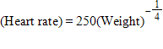. Estimate the heart rate of a 16-pound animal.
​
 | a. | 135 beats/minute
 | b. | 130 beats/minute
 | c. | 125 beats/minute
 | d. | 120 beats/minute
 | e. | 115 beats/minute

ANSWER: | c

41. Police or insurance investigators often want to estimate the speed of a car from the skidmarks it left while stopping. A study found that for standard tires on dry asphalt, the speed (in mph) is given approximately by , where x is the length of the skidmarks in feet. (This formula takes into account the deceleration that occurs even before the car begins to skid.) Estimate the speed of a car if it left skidmarks of 325 feet. Round your answer to nearest integer.
​
 | a. | 74 mph
 | b. | 78 mph
 | c. | 87 mph
 | d. | 80 mph
 | e. | 83 mph

ANSWER: | d

42. Which of the graphs below represent y as a function of x?
​
(a)
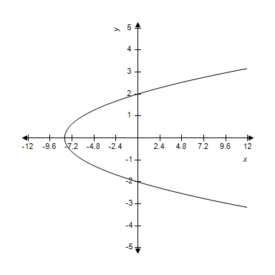
(b)
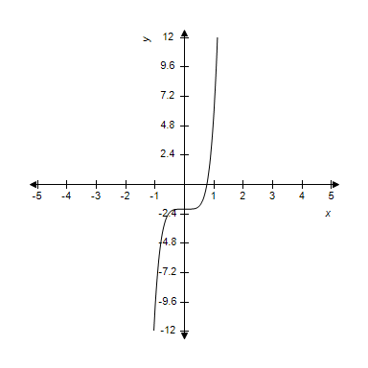
​
 | a. | only (a)
 | b. | both (a) and (b)
 | c. | only (b)
 | d. | neither (a) nor (b)

ANSWER: | c

43. Which of the graphs below represent y as a function of x?
​
(a)
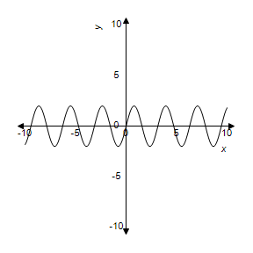
(b)
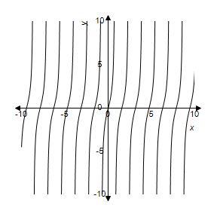
​
 | a. | both (a) and (b)
 | b. | only (b)
 | c. | only (a)
 | d. | neither (a) nor (b)

ANSWER: | a

44. A function and its graph are given. Find the domain.
​
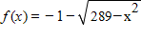
​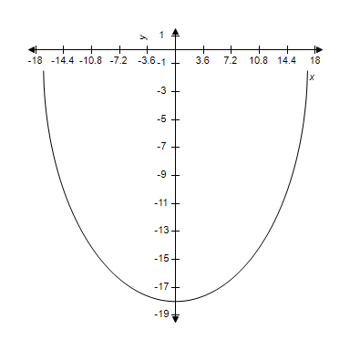
​
 | a. | domain:
 | b. | domain:
 | c. | domain:
 | d. | domain:
 | e. | domain:

ANSWER: | d

45. Find the domain and range of the function graphed below.
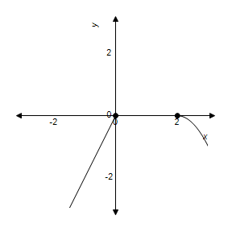
​
 | a. | ​
 | b. | ​​
 | c. | ​​
 | d. | ​​
 | e. | ​​

ANSWER: | a

46. For the function 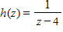, find h(8).
​
 | a. | h(8) =
 | b. | h(8) =
 | c. | h(8) = 12
 | d. | h(8) = 4
 | e. | h(8) = 0

ANSWER: | b

47. Find the domain of the function 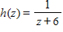.
​
a.
b.
c.
d.
e.

ANSWER: | c

48. Find the range of the function 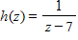.
​
a.
b.
c.
d.
e.

ANSWER: | e

49. Find the domain and range of the function below.
​
​
 | a. | domain: real numbers  range: real numbers
 | b. | domain: real numbers  range: real numbers
 | c. | domain: all reals  range: real numbers
 | d. | domain: real numbers  range: real numbers
 | e. | domain: all reals  range: real numbers

ANSWER: | b

50. For the function 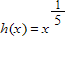, find h(32).
​
 | a. | h(32) = 1
 | b. | h(32) = –5
 | c. | h(32) = –2
 | d. | h(32) = 2
 | e. | h(32) = 5

ANSWER: | d

51. Find the domain of the function 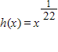.
​
a.
b.
c.
d.
e.

ANSWER: | e

52. Find the range of the function 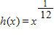.
​
a.
b.
c.
d.
e.

ANSWER: | d

53. For the function 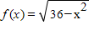, find .
​
a.
b.
c.
d.
e.

ANSWER: | e

54. Find the domain of the function 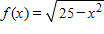.
​
a.
b.
c.
d.
e.

ANSWER: | c

55. Find the range of the function 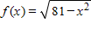.
​
a.
b.
c.
d.
e.

ANSWER: | e

56. Graph the function .
​
 | a. | ​  ​ | b. | ​  ​
 | c. | ​  ​ | d. | ​  ​
 | e. | ​  ​

ANSWER: | a

57. Solve the equation by factoring.
​
 | a.
 | b. | ​
 | c.
 | d.
 | e.

ANSWER: | b

58. Solve the equation by using the quadratic formula. Give real answers rounded to two decimal places.
​
​
a.
b.
c.
d.
e.

ANSWER: | a

59. Solve the equation by factoring.
​
a.
b.
c.
d.
e.

ANSWER: | d

60. Solve the equation by factoring.
​
a.
b.
c.
d.
e.

ANSWER: | b

61. Solve the equation by using the quadratic formula. Give real solutions only.
​
​
 | a.
 | b.
 | c.
 | d. | No real solutions
 | e.

ANSWER: | d

62. Solve the equation by factoring.
​
 | a.
 | b.
 | c.
 | d.
 | e. | no real solutions

ANSWER: | e

63. A company manufactures bicycles at a cost of $60 each. If the company's fixed costs are $600, express the company's costs as a linear function of x, the number of bicycles produced.
​
 | a.
 | b. | ​
 | c.
 | d.
 | e.

ANSWER: | b

64. In seawater, the pressure p is related to the depth d according to 33p – 18d = 515, where d is in feet and p is in pounds per square inch. The Titanic was discovered at a depth of 12440 ft. Find the pressure at this depth. Round your answer to the nearest whole number.
​
 | a. | 6770 lbs/sq in
 | b. | 22835 lbs/sq in
 | c. | 22778 lbs/sq in
 | d. | 6801 lbs/sq in
 | e. | 12469 lbs/sq in

ANSWER: | d

65. The number of cells in a culture after t days is given by 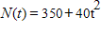. Find the size of the culture after 5 days.
​
 | a. | 1390
 | b. | 550
 | c. | 1790
 | d. | 1350
 | e. | 1700

ANSWER: | d

66. Suppose a radio manufacturer has the total cost function and the total revenue function , where x represents the number of radios produced and sold. Write down the profit function P(x) and then use this function to determine how many radios must be sold to avoid losing money.
​
 | a. | 700
 | b. | 25
 | c. | 26
 | d. | 255
 | e. | 1845

ANSWER: | a

67. Find the range and domain of the function graphed below.
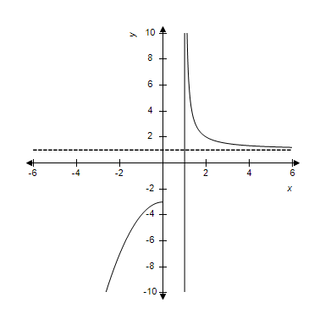
​
 | a. | domain: ;
 | b. | domain: ;
 | c. | domain: ; range:
 | d. | domain: ; range:
 | e. | domain: ; range:

ANSWER: | c

68. Evaluate the expression for the equation 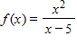.
​
a.
b.
c.
d.
e.

ANSWER: | e

69. Find the domain of the function 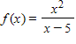.
​
a.
b.
c.
d.
e.

ANSWER: | a

70. Evaluate the expression for the equation 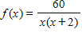.
​
 | a. | 4
 | b. | 3
 | c. | 5
 | d. | 12
 | e. | 15

ANSWER: | a

71. Find the domain of the function 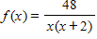.
​
a.
b.
c.
d.
e.

ANSWER: | c

72. Evaluate the expression 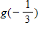 for the equation .
​
 | a.
 | b.
 | c.
 | d. | 2
 | e. | –2

ANSWER: | b

73. Find the domain of the function .
​
 | a.
 | b.
 | c. | Set of all real numbers.
 | d. | Set of all integers.
 | e.

ANSWER: | c

74. Solve the equation by factoring.
​
a.
b.
c.
d.
e.

ANSWER: | d

75. Solve the equation by factoring.
​
 | a.
 | b.
 | c.
 | d.
 | e. | ​

ANSWER: | e

76. Solve the equation 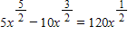 by factoring.
​
a.
b.
c.
d.
e.

ANSWER: | b

77. Graph the function 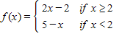.
​
 | a. | ​  ​ | b. | ​  ​
 | c. | ​  ​ | d. | ​  ​
 | e. | ​  ​

ANSWER: | b

78. Which graph represents the function ?
​
 | a. | ​  ​ | b. | ​  ​
 | c. | ​  ​ | d. | ​  ​
 | e. | ​  ​

ANSWER: | e

79. Identify the type of the function 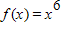.
​
 | a. | polynomial
 | b. | rational
 | c. | exponential
 | d. | piecewise linear
 | e. | none of these choices

ANSWER: | a

80. What type of function is ?
​
 | a. | exponential
 | b. | radical
 | c. | polynomial
 | d. | piecewise linear
 | e. | logarithmic

ANSWER: | a

81. What type of function is 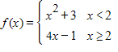?
​
 | a. | exponential
 | b. | rational
 | c. | none of these
 | d. | polynomial
 | e. | piecewise liner

ANSWER: | c

82. Identify the type of the function 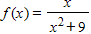.
​
 | a. | polynomial
 | b. | rational
 | c. | exponential
 | d. | piecewise linear
 | e. | none of these choices

ANSWER: | b

83. For 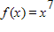 and , find .
​
 | a.
 | b. | ​
 | c.
 | d.
 | e.

ANSWER: | b

84. For 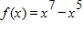 and , find .
​
a.
b.
c.
d.
e.

ANSWER: | d

85. For functions 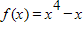 and 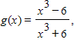 find .
​
a.
b.
c.
d.
e.

ANSWER: | d

86. For 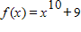 and 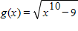, find and simplify completely.
​
a.
b.
c.
d.
e.

ANSWER: | a

87. For the function find and simplify .
​
a.
b.
c.
d.
e.

ANSWER: | e

88. For , find and simplify.
​
a.
b.
c.
d.
e.

ANSWER: | e

89. For the function find and simplify 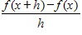.(Assume .)
​
a.
b.
c.
d.
e.

ANSWER: | b

90. For the function , find and simplify .(Assume .)
​
a.
b.
c.
d.
e.

ANSWER: | c

91. For the function find and simplify .(Assume .) [Hint: Use .]
​
a.
b.
c.
d.
e.

ANSWER: | c

92. For the function 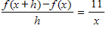, find and simplify .(Assume .)
​
a.
b.
c.
d.
e.

ANSWER: | d

93. How will the graph of differ from the graph of ?
​
 | a. | shifted left 8 units and up 9 units
 | b. | shifted right 9 units and up 8 units
 | c. | shifted right 8 units and up 9 units
 | d. | shifted left 9 units and down 8 units
 | e. | shifted right 9 units and down 8 units

ANSWER: | c

94. The following function expresses an income tax that is 10% for incomes below $5000, and otherwise is $500 plus 30% of income in excess of $5000.
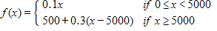
Calculate the tax on an income of $14000.
​
 | a. | $3200
 | b. | $1400
 | c. | $9500
 | d. | $2750
 | e. | $6200

ANSWER: | a

95. An electronics company's research budget is 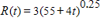 where t is the number of years from now. (R is in millions of dollars.) Evaluate the function at t = 7. Round your answer to the nearest cent.
​
 | a. | $3.02 millions
 | b. | $8.42 millions
 | c. | $9.06 millions
 | d. | $9.08 millions
 | e. | $6.90 millions

ANSWER: | c

96. An electronics company's research budget is 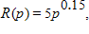 where p is the company's profit, and the profit is predicted to be where t is the number of years from now. (Both R and p are in millions of dollars.) Express the research expenditure R as a function of t.

 | a.
 | b. | ​
 | c.
 | d.
 | e.

ANSWER: | e

