Student name:__________
TRUE/FALSE - Write 'T' if the statement is true and 'F' if the statement is false.
1) Property rights have a positive effect in a market economy because they encourage owners to maintain their property.
⊚ true
⊚ false

2) The institution of private property is supported by clear claims to ownership.
⊚ true
⊚ false

3) Individual property rights are the right of the government to own, use, and dispose of resources in an economy.
⊚ true
⊚ false

4) An important part of the market system is that producers and consumers consider the public interest in making production and consumption decisions.
⊚ true
⊚ false

5) More specialization in a market economy generally leads to the more efficient use of its resources.
⊚ true
⊚ false

6) Specialization in production can occur based on geographic advantages.
⊚ true
⊚ false

7) A division of labor enhances society's output by permitting people to take advantage of existing differences in their abilities and skills.
⊚ true
⊚ false

8) Exchange by barter requires a coincidence of wants.
⊚ true
⊚ false

9) One of the most important economic resources is money.
⊚ true
⊚ false

10) The concept of consumer sovereignty refers to situations in which consumers are represented on the board of directors of large corporations.
⊚ true
⊚ false

11) Economic efficiency entails getting the smallest amount of output from a given level of input of scarce resources.
⊚ true
⊚ false

12) In the market system, prices tend to guide resources from less important to more important uses.
⊚ true
⊚ false

13) In a competitive market economy, firms and resource suppliers will seek to further their own self-interest, but at the same time, as if guided by an "invisible hand," they will promote the public interest.
⊚ true
⊚ false

14) It is generally agreed that a major advantage of the competitive price system is the achievement of greater efficiency.
⊚ true
⊚ false

15) A market system is characterized by the private ownership of resources and the use of markets and prices to coordinate and direct economic activity.
⊚ true
⊚ false

16) Command systems in the Soviet Union and Eastern Europe failed primarily because of a lack of resources.
⊚ true
⊚ false

17) Command systems in the Soviet Union and Eastern Europe failed primarily because of coordination and incentive problems.
⊚ true
⊚ false

18) In the circular flow model, households function on the selling side of the resource market and the buying side of product markets.
⊚ true
⊚ false

19) In the circular flow model, there is a money flow of economic resources and finished goods and services and a real flow of income and consumption expenditures.
⊚ true
⊚ false

20) The economy of the United States can best be described as pure capitalism.
⊚ true
⊚ false

21) In the U.S. economy, corporations account for about 18 percent of the firms and about 82 percent of the total sales revenue.
⊚ true
⊚ false

22) In the U.S. economy, sole proprietorships account for over half the firms and over half of total sales revenue.
⊚ true
⊚ false

23) In the U.S. economy, sole proprietorships account for over half the firms, but corporations account for over half of total sales revenue.
⊚ true
⊚ false

24) In 2015, three of the world's four largest corporations were headquartered in China.
⊚ true
⊚ false

25) In the U.S. economy, rents are the smallest source of household income.
⊚ true
⊚ false

26) In the U.S. economy, services account for over half of all consumer expenditures.
⊚ true
⊚ false

27) In the U.S. economy, housing accounts for over half of all consumer expenditures.
⊚ true
⊚ false

28) Durable goods are expected to last for at least 10 years.
⊚ true
⊚ false

MULTIPLE CHOICE - Choose the one alternative that best completes the statement or answers the question.
29) Economic systems differ according to what two main characteristics?
A) Ownership of resources and methods of coordinating economic activity.
B) Quantity of output produced and who receives the output.
C) Who produces the output and what technology is used to produce it.
D) The system of government and the quantity of natural resources available.

30) The private ownership of property resources and use of prices to direct and coordinate economic activity is characteristic of:
A) a command system.
B) a market system.
C) communism.
D) socialism.

31) In a capitalistic economy:
A) consumers are not sovereign.
B) markets are not competitive.
C) there is a reliance on the market system.
D) the government owns the means of production.

32) Which statement best describes a capitalist economy?
A) The production of goods and services is determined primarily by markets, but the allocation of goods and services is determined primarily by government.
B) The production of goods and services is determined primarily by government, but the allocation of goods and services is determined primarily by markets.
C) The production and allocation of goods and services is determined primarily through markets.
D) The production and allocation of goods and services is determined primarily through government.

33) Which statement best describes a command economy?
A) The production of goods and services is determined primarily by markets, but the allocation of goods and services is determined primarily by government.
B) The production of goods and services is determined primarily by government, but the allocation of goods and services is determined primarily by markets.
C) The production and allocation of goods and services is determined primarily through markets.
D) The production and allocation of goods and services is determined primarily through government.

34) Which would not be characteristic of a capitalist economy?
A) Government ownership of the factors of production.
B) Competition and unrestricted markets.
C) Reliance on the market system.
D) Free enterprise and choice.

35) A basic characteristic of a command system is that:
A) wages paid to labor are higher.
B) government owns most economic resources.
C) markets function mostly free from government intervention.
D) government planners play a limited role in deciding what goods will be produced.

36) The market system is an economic system that:
A) produces more consumer goods than capital goods.
B) produces more capital goods than consumer goods.
C) gives private individuals and institutions the right to own resources used in production.
D) gives the government the right to tax individuals and corporations for the production of capital goods.

37) Another term for capitalism is the:
A) command system.
B) socialist economy.
C) market system.
D) system of inputs and outputs.

38) Capitalism is an economic system that:
A) produces more capital goods than consumer goods.
B) produces more consumer goods than capital goods.
C) is characterized by government control of markets.
D) gives private individuals and corporations the right to own productive resources.

39) The Soviet Union economy of the 1980s would best be classified as:
A) a market system.
B) pure capitalism.
C) laissez-faire capitalism.
D) a command system.

40) The economy of South Korea would best be classified as:
A) a command system.
B) socialism.
C) pure capitalism.
D) a market system.

41) The economy of North Korea would best be classified as:
A) a laissez-faire economy.
B) a command system.
C) a capitalist economy.
D) a market system.

42) The economy of Cuba most closely approximates:
A) laissez-faire capitalism.
B) a command economy.
C) pure capitalism.
D) a market economy.

43) Since the end of World War II:
A) the economies of both North Korea and South Korea have grown at approximately the same rate.
B) both North and South Korea have adopted command economies.
C) North Korea's economy has achieved greater economic growth than South Korea.
D) the South Korean economy has grown faster than North Korea's economy.

44) Which of the following statements is most accurate about the economies of North Korea and South Korea?
A) The economies of both North Korea and South Korea have grown at approximately the same rate since Korea was divided after World War II.
B) Since their division after World War II, South Korea has grown much faster than North Korea, but their GDP per capita remains roughly equal.
C) Since their division after World War II, North Korea's economy has achieved greater economic growth than South Korea.
D) Starting from similar economic positions prior to their division after World War II, South Korea's economy has grown to about 40 times the size of the North Korean economy.

45) The market system is characterized by:
A) extensive government constraints on individual behavior.
B) private ownership of the means of production.
C) government control of all production decisions.
D) government rationing of all goods and services.

46) In a market system, well-defined property rights are important because they:
A) reduce unnecessary investment.
B) limit destructive economic growth.
C) create economic problems.
D) encourage economic activity.

47) Which is a major feature of the market system?
A) Government-established prices in all markets.
B) Reallocation of all resources from private to public uses.
C) The right to own private property and control resource uses.
D) Central planning by government to provide goods and services.

48) Legal and social rules that affect the ownership of property are:
A) property rights.
B) the coincidence of wants.
C) the division of labor.
D) the freedom of enterprise.

49) The institution of private property encourages:
A) lack of maintenance because people are not forced by law to do it.
B) lack of easy exchange because ownership is sometimes hard to prove.
C) easy exchange of some property because a formal title or deed exists.
D) lack of incentives because the owner is responsible for maintenance costs.

50) Which is characteristic of the market system?
A) Unselfish individuals
B) Centralized decision making
C) Free enterprise and choice
D) Government ownership of the means of production

51) By free enterprise, we mean that:
A) products are provided free to those who cannot afford to buy them.
B) individual producers determine how to produce, but government agencies determine what will be produced.
C) individuals may obtain resources, organize production, and sell the resulting output in any legal way they choose.
D) individuals are free to produce those products that government agencies determine can be produced profitably.

52) Based on the Index of Economic Freedom provided by the Heritage Foundation, which of the following nations is considered least free?
A) New Zealand.
B) Colombia.
C) Argentina.
D) Japan.

53) Which statement is correct?
A) The operation of a market system eventually results in an equal distribution of income.
B) Producers are "kings" in a market economy because they determine what is produced.
C) The market system is efficient at allocation of resources but not in getting consumer goods to their most valued uses.
D) Freedom of choice and enterprise are essential elements of the market system.

54) The maximization of profit and the minimization of losses is the primary factor affecting the economic decision making of:
A) workers.
B) consumers.
C) public officials.
D) entrepreneurs.

55) How do workers typically express self-interest?
A) By minimizing the economic losses of other business firms.
B) By maximizing the economic profits of other business firms.
C) By seeking the highest price when purchasing a consumer product.
D) By seeking jobs with the best combination of wages and benefits.

56) In a market economy, entrepreneurs are most concerned with:
A) maximizing utility or satisfaction from limited incomes.
B) increasing the wages and salaries of workers.
C) maximizing profits or minimizing losses.
D) the selfish pursuit of money.

57) Competition is more likely to exist when:
A) there is free entry into and exit out of industries.
B) there is a single supplier of all goods and services.
C) the government purchases most goods and services.
D) products are produced by a few large firms.

58) Which condition will encourage competition?
A) Government licensing requirements in order to enter an industry.
B) A small number of buyers and sellers in a market.
C) The freedom of sellers and buyers to enter or exit an industry.
D) The government serving as the only supplier of goods to consumers.

59) Which statement is correct?
A) In a market system, buyers and sellers must be in face-to-face contact with each other.
B) Prices affect the distribution of goods in a market system but not the allocation of resources.
C) In a market system, prices serve to ration goods and services to consumers.
D) The operation of a market system has little, if any, effect on the distribution of income in the economy.

60) A market system is best characterized by:
A) extensive government intervention in economic activity.
B) the private production of most capital goods.
C) government regulation of all private markets.
D) central planning and control.

61) A characteristic of the market system is:
A) frequent use of price controls.
B) frequent use of barter.
C) extensive use of capital goods.
D) low interest rates.

62) Which is assumed to be most limited in scope under a market system?
A) Freedom of enterprise
B) Freedom of choice
C) Competition
D) Government

63) All of the following accurately describe a market economy except:
A) government establishes maximum and minimum prices for most goods and services.
B) prices serve as a signaling mechanism to buyers and sellers.
C) the allocation of resources is determined by their prices.
D) the actions of buyers and sellers establish a product's price.

64) Which statement best describes a capitalist economy?
A) Society determines production and the allocation of goods and services only through markets.
B) Government policies determine the production and the allocation of goods and services.
C) Government policies determine the production, but not the allocation, of goods and services.
D) The role of individual self-interest is relatively unimportant because government makes most economic decisions.

65) The process in which workers do specialized tasks to make a product is referred to as:
A) a coincidence of wants.
B) roundabout production.
C) freedom of choice.
D) division of labor.

66) How does human specialization contribute to an economy's output?
A) It makes use of differences in abilities.
B) It is a process of creative destruction.
C) It works like an "invisible hand."
D) It decreases derived demand.

67) Specialization and trade are beneficial to society because:
A) the output of economic goods may be increased with no increase in resources.
B) scarce resources are utilized more efficiently.
C) a division of labor lowers prices for products.
D) all of these are correct.

68) Advantages of specialization do not include:
A) increased production of economic goods with no increase in resources.
B) the more efficient use of scarce resources.
C) increased ability to utilize the division of labor.
D) less interdependence.

69) Which of the following does not explain why specialization increases output?
A) Specialization capitalizes on differences in ability.
B) Specialization promotes self-sufficiency and independence.
C) Specialization fosters learning by doing.
D) Specialization saves time by eliminating shifting between tasks.

70) A prerequisite of specialization is:
A) a capitalistic economic system.
B) a medium of exchange or money system.
C) free enterprise.
D) competition.

71) Which is an example of barter?
A) A person trading a desk for a box of tools.
B) A person buying clothes at a used clothing store.
C) A gift of tuition money from parents to their children.
D) The purchase of stock on the New York Stock Exchange.

72) An economic system in which money is not used is a:
A) planned economy.
B) market economy.
C) mixed economy.
D) barter economy.

73) Which is necessary to make a trade in a barter economy?
A) Money
B) Unlimited wants
C) A medium of exchange
D) A coincidence of wants

74) Consider a barter situation where you have pens and you want pencils. To achieve your objective there must be a(n):
A) use of capital goods.
B) entry and exit from the market.
C) large number of sellers.
D) coincidence of wants.

75) The use of money for exchange:
A) increases the use of barter.
B) reduces consumer sovereignty.
C) increases the importance of a coincidence of wants.
D) encourages more specialization in production.

76) Which is the main problem with the barter system of exchange? Barter:
A) encourages self-interest and selfishness.
B) fosters specialization and division of labor.
C) requires a coincidence of wants.
D) undermines the right to leave property to one's heirs.

77) The direct exchange of goods for goods is:
A) barter.
B) the circular flow.
C) the invisible hand.
D) roundabout production.

78) Why might a company use barter rather than money to make a transaction?
A) Barter is generally more efficient than money exchanges.
B) Barter can enable two firms to trade when their cash flows are limited.
C) Money requires a coincidence of wants but barter is more direct.
D) Money is economically efficient for large transactions, but barter is preferred for smaller transactions.

79) Consumer sovereignty and "dollar votes" are most related to which fundamental question about a competitive market system?
A) What goods and services will be produced?
B) How will the goods and services be produced?
C) How will the system promote progress?
D) Who will get the goods and services?

80) Economic efficiency would be primarily discussed with respect to which of the fundamental questions about a competitive market economy?
A) What goods and services will be produced?
B) How will the goods and services be produced?
C) How will the system promote progress?
D) Who will get the goods and services?

81) Issues of the distribution of goods and services and incomes in a competitive market system are the primary topic of which fundamental question?
A) What goods and services will be produced?
B) How will the goods and services be produced?
C) How will the system promote progress?
D) Who will get the goods and services?

82) Which fundamental question about a competitive market system primarily focuses on technological progress and capital accumulation?
A) What goods and services will be produced?
B) How will the goods and services be produced?
C) How will the system promote progress?
D) Who will get the goods and services?

83) All economic systems must answer certain fundamental economic questions. Which is not one of these questions?
A) Which actions should government take to reduce inflation?
B) How will the goods and services be produced?
C) What goods and services will be produced?
D) Who is to receive the output?

84) Which is not one of the Four Fundamental Questions?
A) How will goods and services be produced?
B) How should the system promote progress?
C) Who is to receive the output of the system?
D) What goods and services should be produced by government?

85) In 2006, McDonald's introduced the "Snack Wrap" and it turned out to be a successful product. In the marketplace for fast-food products, this success would be an example of:
A) derived demand.
B) medium of exchange.
C) consumer sovereignty.
D) roundabout production.

86) In 2000, McDonald's introduced the "McSalad Shaker." It turned out to be an unsuccessful product. In the marketplace for fast-food products, this lack of success is an example of:
A) normal profit.
B) economic costs.
C) consumer sovereignty.
D) medium of exchange.

87) The introduction in 1968 of the "Big Mac" was a hit product for McDonald's. This example shows that in the market for such fast-food products:
A) normal profits are greater than economic profits.
B) the medium of exchange is more important than the message.
C) consumer sovereignty is less important than specialization.
D) the dollar votes of consumers determined which products succeed.

88) The process by which new products and technologies drive out existing products and techniques is known as:
A) destructive creation.
B) creative destruction.
C) consumer sovereignty.
D) capital accumulation.

89) What to produce in a market economy is ultimately determined by the:
A) output decisions of business firms.
B) income plans of households.
C) spending decisions of households.
D) workers' technical skills.

90) The term "consumer sovereignty" means that:
A) consumers are controlled by the actions of the marketplace.
B) what is produced is ultimately determined by what consumers purchase.
C) there are no limits on what consumers may buy under capitalism.
D) businesses produce with tax minimization as their primary goal.

91) Within a market economy, some industries may be declining while other industries may be expanding. This indicates that:
A) incomes are declining.
B) productive resources are being reallocated.
C) factors of production are scarce.
D) producers are not maximizing profits.

92) By consumer sovereignty we mean that:
A) government is responsible for protecting consumer interests.
B) consumers determine what goods and services are produced.
C) businesses decide what the consumer will buy.
D) all goods and services are produced by consumers.

93) The market system is said to be characterized by "consumer sovereignty." This is because:
A) a large number of consumer goods are produced.
B) the prices of consumer goods are regulated by government.
C) consumer goods are more profitable than investment goods.
D) of the major role of consumers in determining what goods are produced.

94) A major feature of a market system is that:
A) there is economic equality.
B) there is consumer sovereignty.
C) there is full employment.
D) all producers make profits.

95) The failure of the McDonald's Arch Deluxe burger was an example of:
A) an increase in demand.
B) consumer sovereignty.
C) technological advances.
D) economic profit.

96) The term "dollar votes" means:
A) inflation will occur if consumers do not spend wisely.
B) voters may be offered dollars to help elect certain political candidates.
C) government is responsible for determining what will be considered legal money.
D) consumers "vote" for certain products to be produced by how they spend their incomes.

97) From society's point of view, the economic function of profits is to:
A) equalize incomes.
B) ensure that the rich get richer.
C) provide revenues to pay high wages.
D) direct resources in response to changes in the economy.

98) In a market economy, the money incomes of individuals depend primarily upon:
A) government policies in setting wages and interest rates.
B) the value and amounts of the productive resources the individuals possess.
C) the amount of college education the individuals have.
D) who you know and how well you know them.

99) The idea that the desires of resource suppliers and producers to further their own self-interest will automatically further the public interest is known as:
A) consumer sovereignty.
B) the invisible hand.
C) derived demand.
D) profit maximization.

100) Which best describes the "invisible hand" concept?
A) Highly detailed central direction of an economy will maximize the public's best interests.
B) The market system works best when resources are highly substitutable.
C) The problem of scarcity can best be overcome in a system of mixed capitalism.
D) The desires of producers and resource suppliers to further their own self-interest will tend to promote the social interest.

101) The idea that firms and resource suppliers, while seeking to further their own self-interests in a market economy, also promote the public interest describes:
A) the guiding function of prices.
B) capital accumulation.
C) the "invisible hand."
D) "dollar votes."

102) The influential book written by Adam Smith was:
A) Capitalism and Freedom.
B) The Affluent Society.
C) The Age of the Economist.
D) The Wealth of Nations.

103) The "invisible hand" concept to describe the guiding function of prices was developed by:
A) Jeremy Bentham.
B) Adam Smith.
C) Milton Friedman.
D) David Ricardo.

104) The development of the Internet and e-mail to often replace regular mail services is an example of:
A) roundabout production.
B) derived demand.
C) creative destruction.
D) specialization.

105) The development of MP3 players and online streaming, which significantly reduced the market for CDs, is an example of:
A) specialization.
B) derived demand.
C) roundabout production.
D) creative destruction.

106) Which of the following statements is most accurate about capital accumulation in a market system?
A) Capital accumulation is generally insufficient because consumers don't directly cast dollar votes for capital goods.
B) The invisible hand directs the production of consumer goods, but government planning is required to effectively allocate resources to capital goods.
C) Capital good production is the primary driver of the demand for consumer goods.
D) Entrepreneurs and business owners cast dollar votes for capital goods based on the profitability of goods and services they sell to consumers.

107) The basic economic argument for the market system is that it promotes:
A) an efficient allocation of resources.
B) equality in the distribution of income.
C) personal freedom.
D) the use of money.

108) Command systems in the Soviet Union and pre-reform China failed primarily because of:
A) coordination and incentive problems.
B) greater resource scarcity than in market systems.
C) the failure to accumulate and use capital.
D) the failure to specialize in production.

109) Which of the following does not explain why the command systems of the Soviet Union and Eastern Europe failed?
A) Coordination problems
B) Prices and profits did not fluctuate to reflect wants for a different allocation of resources.
C) Incentive problems
D) The failure to use money for most exchanges

110) Coordination problems have led to the failure of command systems. Which of the following best exemplifies this problem?
A) Managers had no incentive to address market surpluses or shortages, as long as they met production goals.
B) Workers were not motivated to work hard because of a lack of consumer goods to purchase.
C) Command economies try to minimize the use of capital goods, making production less efficient.
D) The complexity of production processes made it difficult to assure that all necessary inputs were provided at the right time and in the right amount.

111) Which of the following success indicators is present in a market system but lacking in a command system?
A) Production targets
B) Wages
C) Income distribution standards
D) Profit

112) Which of the following statements best describes production outcomes in the Soviet Union and pre-reform China?
A) Output was often low quality because production managers were rewarded only for meeting quantitative production targets.
B) Output was often high quality but insufficient in quantity because production managers were rewarded only for meeting quality standards.
C) Output was generally high quality and sufficient in quantity because of the well-specified economic plans.
D) Output was of variable quality but sufficient in quantity because market signals were only consistent in telling managers how much to produce.

113) In the circular flow model, households:
A) buy products and resources.
B) sell products and resources.
C) buy products and sell resources.
D) sell products and buy resources.

114) The circular flow model:
A) assumes that central planning is taking place.
B) illustrates how natural resources are created.
C) illustrates how money is created by the banking system.
D) illustrates the interdependence of businesses and consumers.

115) The simple circular flow model shows that workers, entrepreneurs, and the owners of land and capital offer their services through:
A) product markets.
B) resource markets.
C) employment agencies.
D) business firms.

116) Markets in which firms sell their output of goods and services are called:
A) resource markets.
B) product markets.
C) command markets.
D) mixed markets.

117) The circular flow model shows that the goods and services produced by business firms are sold through:
A) product markets.
B) stock markets.
C) money markets.
D) resource markets.

118) In a circular flow model consisting of the household sector, the business sector, product markets, and resource markets:
A) households are sellers of products.
B) businesses are sellers of products.
C) households are buyers of productive resources.
D) resource markets are sellers of products.

119) In the simple circular flow model:
A) households are sellers of resources and demanders of products.
B) households are sellers of products and demanders of resources.
C) businesses are sellers of resources and demanders of products.
D) businesses are sellers of both resources and products.

120) In product markets:
A) households sell products to business firms.
B) households sell resources to business firms.
C) businesses sell resources to households.
D) businesses sell goods and services to households.

121) The money income of households consists of the sum of:
A) wages plus salaries plus benefits.
B) consumption expenditures plus profits.
C) wages plus rents plus interest plus profits.
D) consumption expenditures plus costs of resources.

122) Which of the following would be primarily determined in the resource market?
A) The price of compact discs.
B) The wage rates for electricians.
C) The number of automobiles produced.
D) The amount of money in circulation.

123) The fact that expenditures on products and payments to owners of resources used to produce those products flow in opposite directions is known as:
A) roundabout production.
B) a barter economy.
C) a pure economy.
D) the circular flow of income.

124) 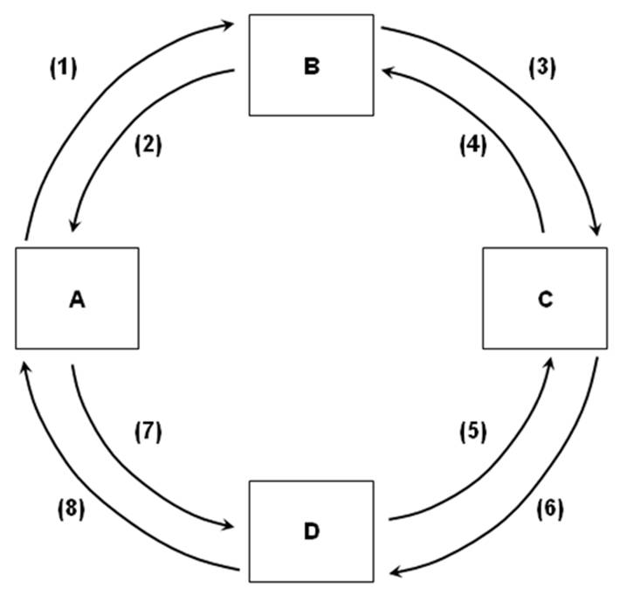
Refer to the above figure. If box B represents the resource market and flow (3) represents money income, then:
A) box A is the product market and box C is households.
B) box C is the product market and box A is households.
C) box D is the product market and box C is households.
D) box C is the product market and box D is households.

125)
Refer to the above figure. If box A represents businesses and flow (7) represents goods and services, then:
A) box D is the product market and box B is the resource market.
B) box D is the product market and box B is households.
C) box B is the product market and box C is households.
D) box C is the product market and box B is the resource market.

126) 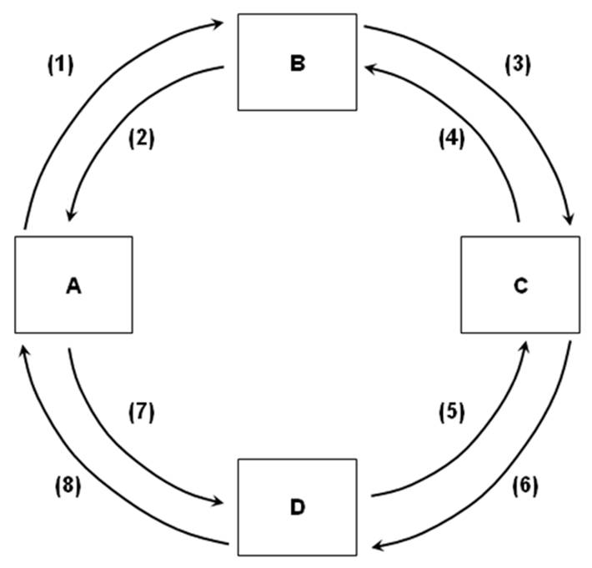
Refer to the above figure. If flow (1) is the cost businesses pay to the resource market, then:
A) (2) is the flow of productive resources.
B) (4) is the flow of goods and services.
C) (6) is the flow of money income.
D) (7) is the flow of revenue.

127)
Refer to the above figure. If box D represents the product market and flow (6) represents consumption expenditures, then box C is:
A) households, flow (7) is revenue, and flow (8) is goods and services.
B) businesses, flow (7) is revenue, and flow (8) is goods and services.
C) households, flow (7) is goods and services, and flow (8) is revenue.
D) businesses, flow (7) is goods and services, and flow (8) is revenue.

128)
Refer to the above figure. If box A represents businesses and box B represents the resource market in this circular flow model, then the real flow of goods, services, and economic resources would be represented by flows:
A) (1), (3), (6), and (8).
B) (7), (5), (4), and (2).
C) (1), (2), (3), and (4).
D) (5), (6), (7), and (8).

129)
Refer to the above figure. If box A represents businesses and box D represents the product market in this circular flow model, then money flow in the model would be represented by:
A) (1), (2), (3), and (4).
B) (5), (6), (7), and (8).
C) (1), (3), (6), and (8).
D) (7), (5), (4), and (2).

130)
Refer to the above figure. If flow (8) is revenues and flow (4) is economic resources (land, labor, capital, and entrepreneurial ability), then box:
A) A is the resource market and box B is the product market.
B) B is the resource market and box A is the product market.
C) C is the product market and box B is the resource market.
D) D is the product market and box B is the resource market.

131) Assume that rents flow clockwise in a circular economic flow diagram. This implies that land flows:
A) clockwise and capital flows counterclockwise.
B) clockwise and profits flow counterclockwise.
C) counterclockwise and capital flows clockwise.
D) counterclockwise and profits flow clockwise.

132) If goods and services flow clockwise in a circular economic flow diagram, then consumption expenditures flow:
A) clockwise and firm revenues flow clockwise.
B) clockwise and firm revenues flow counterclockwise.
C) counterclockwise and firm revenues flow clockwise.
D) counterclockwise and firm revenues flow counterclockwise.

133) In the circular economic flow diagram, households:
A) make consumption expenditures and pay for land, labor, and capital.
B) make consumption expenditures and receive goods and services.
C) buy resources and receive goods and services.
D) receive money income and supply resources.

134) As of 2015, approximately what percentage of U.S. firms are sole proprietorships?
A) 18 percent.
B) 50 percent.
C) 72 percent.
D) 84 percent.

135) According to the text, U.S. corporations generated approximately what percentage of total sales revenue in 2015?
A) 11 percent.
B) 20 percent.
C) 72 percent.
D) 82 percent.

136) According to the text, what is the largest source of earned income for U.S. households?
A) Wages and salaries
B) Interest
C) Proprietors' income
D) Corporate profits

137) Over half of U.S. consumer expenditures are for what?
A) Housing.
B) Services.
C) Nondurable goods.
D) Durable goods.

138) A durable consumer good is expected to last for at least how long?
A) 6 months
B) 1 year
C) 3 years
D) 10 years

139) As of 2015, approximately how many households are in the United States?
A) 75 million
B) 125 million
C) 210 million
D) 320 million

140) Which of the following is not considered a consumption expenditure?
A) Purchases of services
B) Purchases of houses
C) Purchases of nondurable goods
D) Purchases of durable goods

Answer Key
Test name: McConnel 2
1) TRUE
2) TRUE
3) FALSE
4) FALSE
5) TRUE
6) TRUE
7) TRUE
8) TRUE
9) FALSE
10) FALSE
11) FALSE
12) TRUE
13) TRUE
14) TRUE
15) TRUE
16) FALSE
17) TRUE
18) TRUE
19) FALSE
20) FALSE
21) TRUE
22) FALSE
23) TRUE
24) TRUE
25) FALSE
26) TRUE
27) FALSE
28) FALSE
29) A
30) B
31) C
32) C
33) D
34) A
35) B
36) C
37) C
38) D
39) D
40) D
41) B
42) B
43) D
44) D
45) B
46) D
47) C
48) A
49) C
50) C
51) C
52) C
53) D
54) D
55) D
56) C
57) A
58) C
59) C
60) B
61) C
62) D
63) A
64) A
65) D
66) A
67) D
68) D
69) B
70) B
71) A
72) D
73) D
74) D
75) D
76) C
77) A
78) B
79) A
80) B
81) D
82) C
83) A
84) D
85) C
86) C
87) D
88) B
89) C
90) B
91) B
92) B
93) D
94) B
95) B
96) D
97) D
98) B
99) B
100) D
101) C
102) D
103) B
104) C
105) D
106) D
107) A
108) A
109) D
110) D
111) D
112) A
113) C
114) D
115) B
116) B
117) A
118) B
119) A
120) D
121) C
122) B
123) D
124) C
125) A
126) A
127) C
128) B
129) C
130) D
131) D
132) D
133) D
134) C
135) D
136) A
137) B
138) C
139) B
140) B

