chapter 1 Music in Antiquity
MULTIPLE CHOICE

1. The earliest surviving musical instruments were made from
a. | bone. | d. | stone.
b. | clay. | e. | wood.
c. | metal.

ANS: A DIF: Easy REF: 5 TOP: The Earliest Music
MSC: Remembering

2. All of the following types of evidence about musical culture from ancient civilizations survive
today EXCEPT
a. | musical instruments. | d. | visual images of music-making.
b. | notated music. | e. | writings about music.
c. | recorded sound.

ANS: C DIF: Easy REF: 5 TOP: Music in Antiquity
MSC: Remembering

3. Historians mark the end of the prehistoric era at the time when people
a. | created the first cave paintings. | d. | learned how to carve stone.
b. | invented printing. | e. | learned how to work with metal.
c. | invented writing.

ANS: C DIF: Easy REF: 5 TOP: The Earliest Music
MSC: Remembering

4. The origins of Western music can be traced to civilizations from
a. | Arabia. | d. | Greece and Turkey.
b. | China and India. | e. | Iraq and Syria.
c. | Egypt and Israel.

ANS: E DIF: Moderate REF: 5
TOP: Music in Ancient Mesopotamia; Other Civilizations MSC: Analyzing

5. Why, throughout history, do scholars know more about the music-making activities of elite
members of any given society than of others in that society?
a. | The elite suppressed information about music-making in lower socioeconomic groups.
b. | Music-making activities of the elite are probably representative of the society as a whole.
c. | Only the elite could afford to pay composers to write music and artisans to make instruments.
d. | People of lower social status did not make music.
e. | The music of lower socioeconomic groups is not interesting.

ANS: C DIF: Moderate REF: 7
TOP: Music in Ancient Mesopotamia MSC: Analyzing

6. All of the following instruments existed in ancient Mesopotamia EXCEPT
a. | harps. | d. | percussion instruments.
b. | bowed instruments. | e. | pipes.
c. | lyres.

ANS: B DIF: Easy REF: 6
TOP: Music in Ancient Mesopotamia MSC: Remembering

7. The instrument shown in this image was used in which region?
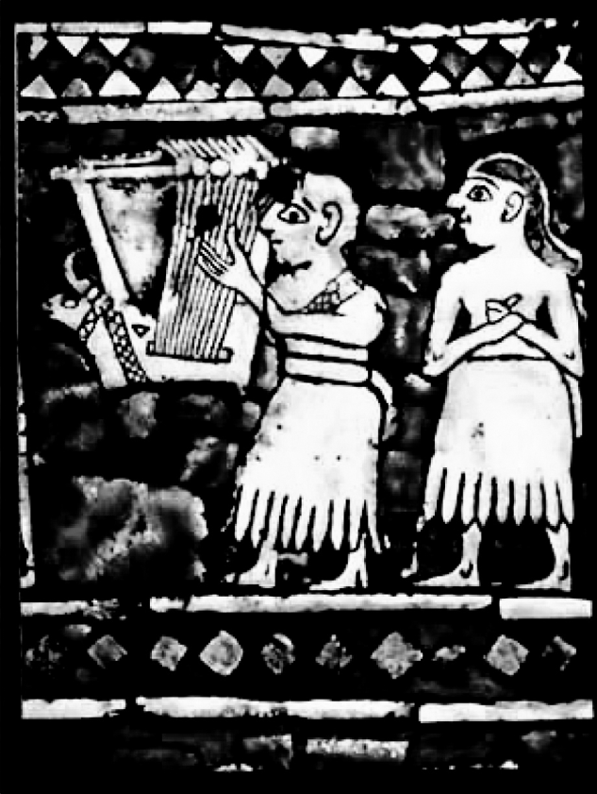
a. | Arabia | d. | Greece
b. | Babylonia | e. | the Roman Empire
c. | Egypt

ANS: B DIF: Moderate REF: 6–7 TOP: The Earliest Music
MSC: Applying

8. ________ is a type of music found in ancient Mesopotamia, but no longer used in Western
cultures today.
a. | Dance music | d. | Music to accompany epic poetry
b. | The funeral lament | e. | The nursery song
c. | Military music

ANS: D DIF: Easy REF: 7
TOP: Music in Ancient Mesopotamia MSC: Remembering

9. Enheduanna, the first composer known by name, was an Akkadian
a. | king. | d. | queen.
b. | priest. | e. | servant.
c. | priestess.

ANS: C DIF: Difficult REF: 7
TOP: Music in Ancient Mesopotamia MSC: Remembering

10. The earliest surviving complete piece of music is written on
a. | a clay tablet. | d. | paper.
b. | papyrus. | e. | a stone tablet.
c. | parchment.

ANS: A DIF: Difficult REF: 8
TOP: Music in Ancient Mesopotamia MSC: Remembering

11. In ancient Greek mythology, the lyre was associated with
a. | Apollo. | d. | Homer.
b. | Aristotle. | e. | Plato.
c. | Dionysus.

ANS: A DIF: Moderate REF: 10
TOP: Music in Ancient Greek Life and Thought: Instruments and Their Uses
MSC: Remembering

12. Scholars think that memory and improvisation played an important role in Greek
music-making because
a. | ancient Greek writings explain techniques for playing by ear.
b. | ancient Greek writings praise musicians for their excellent memories.
c. | images of music-making from ancient Greece rarely show performers reading music.
d. | no musical notation from ancient Greece survives.
e. | the musical notation from ancient Greece provides chord progressions on which to improvise.

ANS: C DIF: Moderate REF: 10
TOP: Music in Ancient Greek Life and Thought: Instruments and Their Uses
MSC: Analyzing

13. In this image a woman is playing the
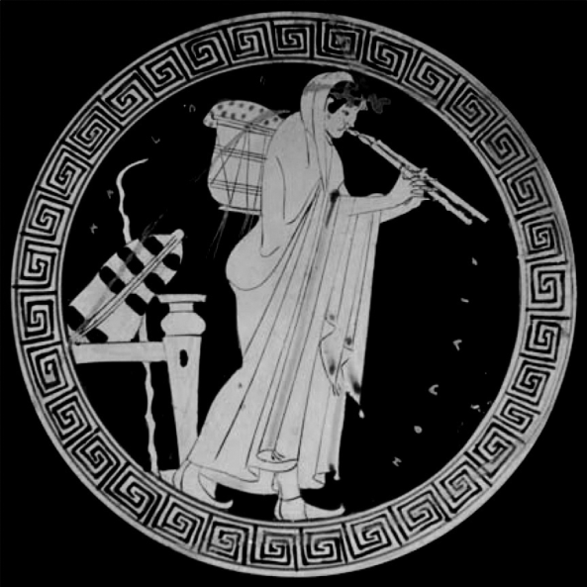
a. | aulos. | d. | lyre.
b. | bone flute. | e. | panpipes.
c. | kithara.

ANS: A DIF: Moderate REF: 9, 11
TOP: Music in Ancient Greek Life and Thought: Instruments and Their Uses
MSC: Applying

14. The ancient Greek civilization lasted for approximately how many years?
a. | 300 | d. | 1,500
b. | 500 | e. | 2,000
c. | 1,000

ANS: C DIF: Difficult REF: 9 (timeline); 10 (map and caption); 17
TOP: Music in Ancient Greek Life and Thought MSC: Remembering

15. All of the following wrote about Greek music EXCEPT
a. | Aristides Quintilianus. | d. | Plato.
b. | Aristotle. | e. | Pythagoras.
c. | Orpheus.

ANS: C DIF: Moderate REF: 11–13
TOP: Greek Musical Thought; Ancient Rome MSC: Remembering

16. ________ discovered the relationship between consonant intervals and mathematical ratios.
a. | Aristotle | d. | Ptolmey
b. | Aristoxenus | e. | Pythagoras
c. | Plato

ANS: E DIF: Moderate REF: 13 TOP: Greek Musical Thought
MSC: Remembering

