1. Copy the points (–2, 5), (3, –5), (–4, –1), (4, 0), (2, –3) in the Cartesian plane.
​
 | a. | ​ | b. | ​
 | c. | ​ | d. | ​
 | e. | ​

ANSWER: | c
POINTS: | 1
QUESTION TYPE: | Multiple Choice
HAS VARIABLES: | True
DATE CREATED: | 1/21/2016 10:01 AM
DATE MODIFIED: | 7/13/2017 3:56 AM

2. Find the distance between the points (–2, –5) and (–7, –10). Round your answer to the nearest hundredth if necessary.
​
 | a. | 17.49
 | b. | 0
 | c. | 7.07
 | d. | 3.16
 | e. | 50

ANSWER: | c
POINTS: | 1
DIFFICULTY: | Easy
QUESTION TYPE: | Multiple Choice
HAS VARIABLES: | True
DATE CREATED: | 1/21/2016 10:01 AM
DATE MODIFIED: | 7/13/2017 4:08 AM

3. Find the midpoint of the line segment joining between the points (7, –1) and (2, –6). Round your answer to the nearest hundredth if necessary.
​
 | a. | (4, 2.5)
 | b. | (4.5, –3.5)
 | c. | (14, 6)
 | d. | (3, –2)
 | e. | none of these choices

ANSWER: | b
POINTS: | 1
DIFFICULTY: | Easy
QUESTION TYPE: | Multiple Choice
HAS VARIABLES: | True
DATE CREATED: | 1/21/2016 10:01 AM
DATE MODIFIED: | 7/13/2017 4:20 AM

4. Find the length of each side of the right triangle from the following figure.

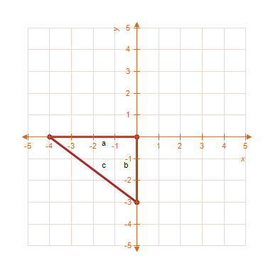
​
 | a. | , ,
 | b. | , ,
 | c. | , ,
 | d. | , ,
 | e. | , ,

ANSWER: | a
POINTS: | 1
DIFFICULTY: | Medium
QUESTION TYPE: | Multiple Choice
HAS VARIABLES: | True
DATE CREATED: | 1/21/2016 10:01 AM
DATE MODIFIED: | 7/13/2017 4:45 AM

5. Find x such that the distance between the points and is 5.
​
a.
b.
c.
d.
e.

ANSWER: | c
POINTS: | 1
DIFFICULTY: | Medium
QUESTION TYPE: | Multiple Choice
HAS VARIABLES: | True
DATE CREATED: | 1/21/2016 10:01 AM
DATE MODIFIED: | 4/5/2017 6:17 AM

6. Assume that the number (in millions) of cellular telephone subscribers in the United States from 1996 through 2005 is given in the following table. Use a graphing utility to graph a line plot of the given data. Describe any trends that appear within the last four years.
​
Year | 1996 | 1997 | 1998 | 1999 | 2000 | 2001 | 2002 | 2003 | 2004 | 2005
Subscribers | 56 | 62.3 | 71.5 | 79.7 | 97.4 | 117.9 | 136.5 | 158.4 | 195 | 214.1

 | a. | ​  The number of subscribers appears to be increasing. | b. | ​  The number of subscribers appears to be decreasing.
 | c. | ​  The number of subscribers appears to be constant. | d. | ​  The number of subscribers appears to be decreasing
 | e. | ​  The number of subscribers appears to be increasing.

ANSWER: | a
POINTS: | 1
DIFFICULTY: | Easy
QUESTION TYPE: | Multiple Choice
HAS VARIABLES: | True
DATE CREATED: | 1/21/2016 10:01 AM
DATE MODIFIED: | 3/31/2017 8:48 AM

