LAB 1 ANSWER KEY

ACTIVITY 1.1: Geologic Inquiry

1.1A. Observation, analysis, and description of the parts of Figure 1.1
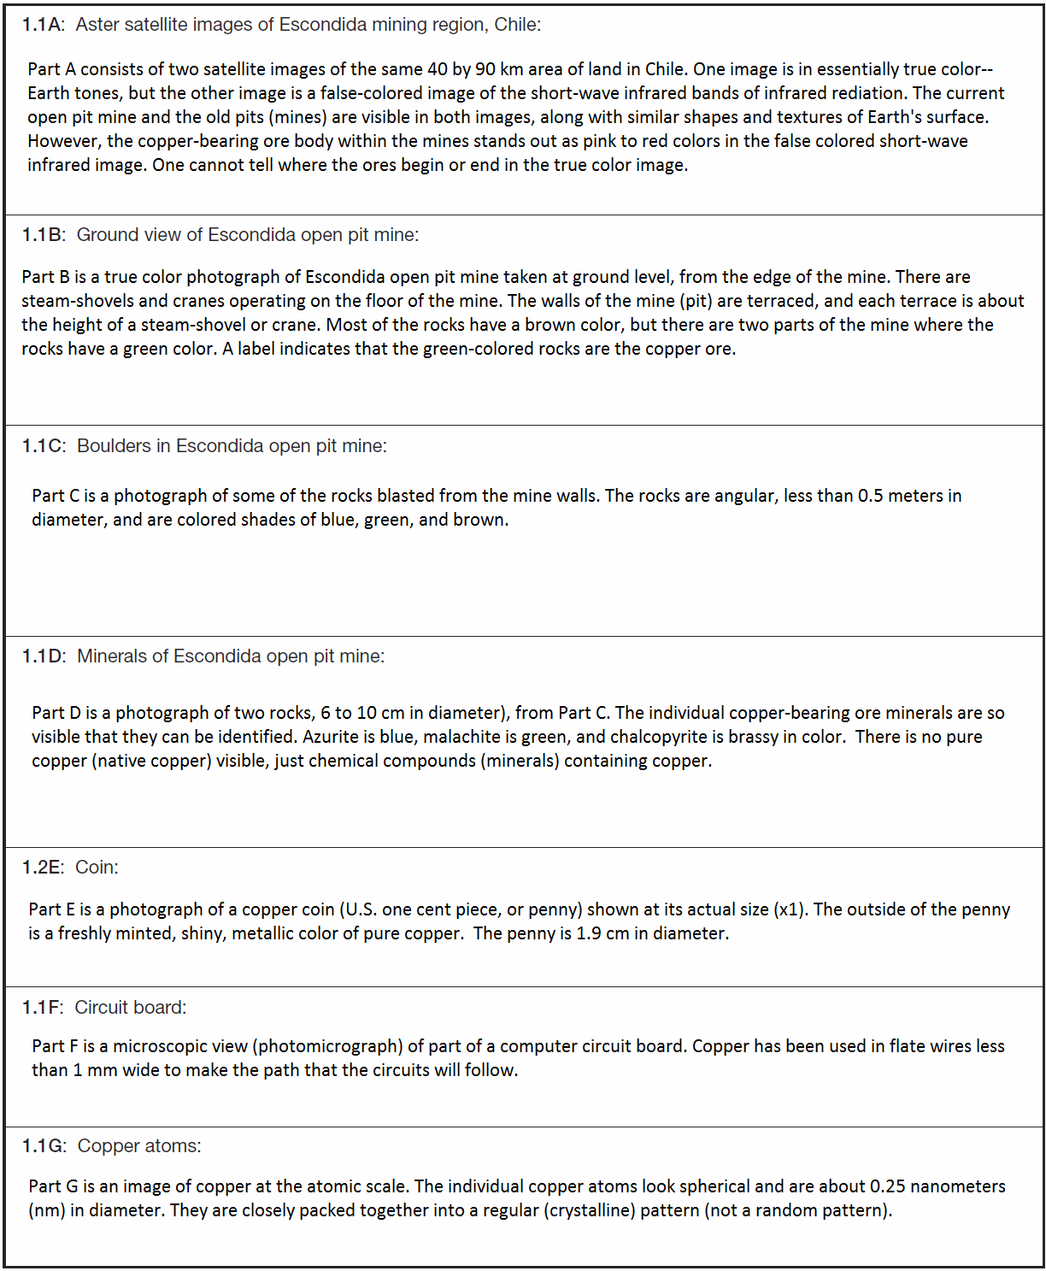

1.1B. Every part of Figure 1.1 shows objects that contain copper (Cu).

1.1C. Analyze Figure 1.1 and answer the following questions.
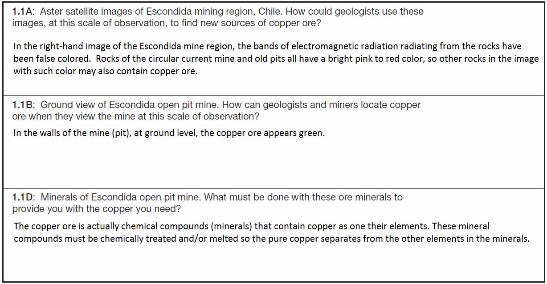

1.1D. 1. The best location for a new mine (pit) is location C, because the rocks there have the same pink-red color in the false-colored satellite image as the rocks of the current and old copper mine pits.

1.1D. 2. To see if location C is actually a good source for more copper ore, one must go there to collect samples of the rock and determine if it contains copper-bearing minerals in profitable quantities to be mined.

ACTIVITY 1.2: Spheres of Matter, Energy, and Change

1.2A.
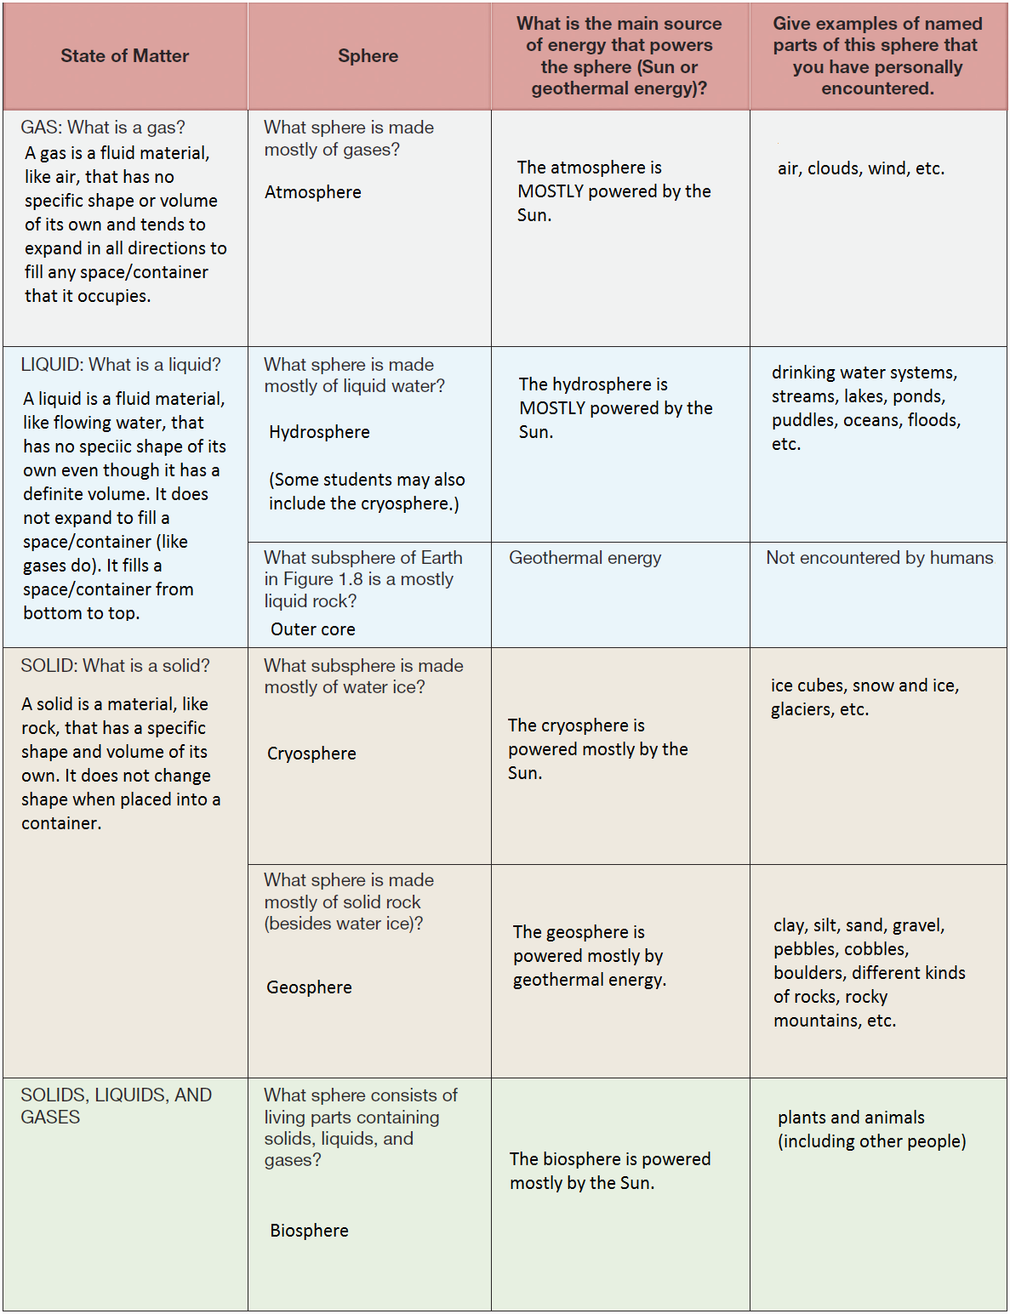

1.2B. answer sheet
