**Chapter 1 Functions and Relations**

**Section 1.1 The Rectangular Coordinate System and Graphing Utilities**

**1.** origin

**2.** quadrants

**3.** 

**4.** 

**5.** solution

**6.** 0

**7.** 0

**8.** 0; *y*

**9.**

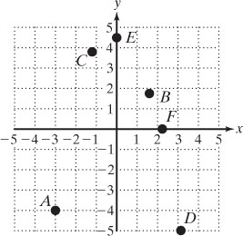

**10.**

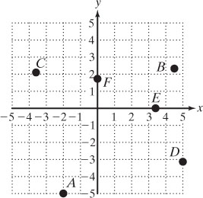

**11. a.** 

**b.**

**12. a.** 

**b.** 

**13. a.** 

**b.** 

**14. a.** 

**b.** 

**15. a.** 

**b.** 

**16. a.** 



**b.** 

**17. a.** 



**b.** 

**18. a.** 

**b.** 

**19.** 

   




Yes

**20.** 







Yes

**21.** 







No

**22.** 







No

**23. a.** 

Yes

**b.** 

No

**c.** 

Yes

**24. a.** 

Yes

**b.** 

No

**c.** 



Yes

**25.** 



**26.** 



**27.** 



**28.** 



**29.** 



**30.** 



**31.** 

|  |  |  |  |
| --- | --- | --- | --- |
| ***x*** | ***y*** |  | **Ordered pair** |
|  |  |  |  |
|  |  |  |  |
|  |  |  |  |
|  |  |  |  |
|  |  |  |  |
|  |  |  |  |
|  |  |  |  |