- CHAPTER OBJECTIVES
To create databases in Microsoft Access 2016
To create tables in Microsoft Access 2016
To understand Microsoft Access 2016 data types
To insert data into tables in Microsoft Access 2016
To create relationships between tables in Microsoft Access 2016
To create Query-by-Example (QBE) queries in Microsoft Access 2016
To create SQL views in Microsoft Access 2016
To understand the use of the Form Wizard in Microsoft Access 2016
To understand the use of the Report Wizard in Microsoft Access 2016
- ERRATA
There are no known errors at this time. Any errors that are discovered in the future will be reported and corrected in the Online DBP e15 Errata document, which will be available at http://www.pearsonhighered.com/kroenke.
- TEACHING SUGGESTIONS
Microsoft Access 2016 provides a good starting point for student DBMS use. Microsoft Access 2016 is commonly available in many computer labs, and many students will already be familiar with the software.
If your students are not familiar with Microsoft Access 2016, use this material at the start of your class. It should be completed before, or soon after, you start Chapter 1. Chapter 1 assumes student familiarity with Microsoft Access 2016, and the chapter figures contain screenshots from a database in Microsoft Access. In addition, the Chapter 1 Project Questions require student use of Microsoft Access 2016.
Microsoft Access 2016 is one of the software programs included in the set of software available through the Microsoft DreamSpark program. Participation by your department in this program will allow you to make Access available to your students for academic purposes at no cost to them. See the DreamSpark Web site (https://www.dreamspark.com/ )for more information.
The material in this Appendix is not intended to be a full coverage of Microsoft Access 2016. If you want your students to have a better Microsoft Access 2016 reference, you might consider supplementing this text with a Microsoft Access 2016 textbook.

Keep in mind that starting with Chapter 2, this text uses and illustrates features not available in Microsoft Access 2016. There are versions of Microsoft SQL Server 2017, Oracle Database 11g Express Edition and MySQL 5.7 that can be downloaded at no cost. Consider using one of these DBMSs as your primary teaching tool for later chapters.
- ANSWERS TO REVIEW QUESTIONS
- Microsoft Access 2016 includes an application generator. What capabilities does this feature add to Microsoft Access 2016 that are not usually found in enterprise-class DBMS products such as SQL Server 2017, Oracle Database, and MySQL 5.7?
The application generator has built-in support for forms and reports that are not found in enterprise-class DBMS products as programs have to be written to create applications.
A.2 What is a primary key? What is a foreign key? How are foreign keys used to create relationships between tables?
A primary key is an attribute in a relation that makes each row unique. It also establishes the ordering of rows in a table. A foreign key is an attribute that matches a primary key IN ANOTHER TABLE, thereby establishing a relationship between the two tables.
- What file extension is used to identify Microsoft Access 2016 database files?
Access database filenames end with the extension accdb that has been used since Access 2007.
- What is the Microsoft Office Fluent user interface? Describe the components of the Fluent user interface as used in Microsoft Access 2016.
The Office Fluent user interface is shared among most of the Office applications, so that learning one application will help with learning another Office application. It is comprised of the Ribbon and Command Tabs. The Ribbon contains sets of appropriate commands for the selected Command tab.
- What is the Microsoft Access 2016 Quick Access Toolbar, and what is it used for?
The Quick Access toolbar contains commonly-used commands such as accessing the File menu, along with Undo/Redo. It can be customized.
- What is the Microsoft Access 2016 Navigation Pane?
The Navigation Pane displays a list of the database objects, such as tables, queries, forms, and reports. The types of database objects displayed can be customized.
- How does Microsoft Access 2016 create surrogate keys in tables?
The AUTONUMBER datatype is used for that purpose. The Access DBMS supplies values for autonumber attributes.

- How do you create relationships in Microsoft Access 2016?
This is done graphically using the Relationship window. The participating tables are added to the window, then the Primary key of one table is connected to the Foreign key of another table via drag-and-drop. Internally this generates an SQL constraint between the tables.
- What is referential integrity, and why is it important?
Referential integrity is used to ensure that a foreign key field has a value in it that matches an existing primary key in another related table. This helps maintain data consistency.
- What is an SQL view, and how are views created in Microsoft Access 2016?
For Access, a view is simply a query that is saved along with other database objects. Other DBMSes store queries externally in script files, but store views as a part of the database. Views can have special restrictions that regular queries do not have in other DBMSes.
- ANSWERS TO EXERCISES
- Using the Student-Class-Grade database that you created in this Appendix:
  - Create and run an Access QBE query to duplicate the results in Figure 1-12. Save the query as QBE-Query-A-02.
See the file DBP-e15-IM-AppA-Student-Grade-Class.aacdb (database before our changes below) and DBP-e15-IM-AppA-Student-Grade-Class-Completed.aacdb (database after our changes below).
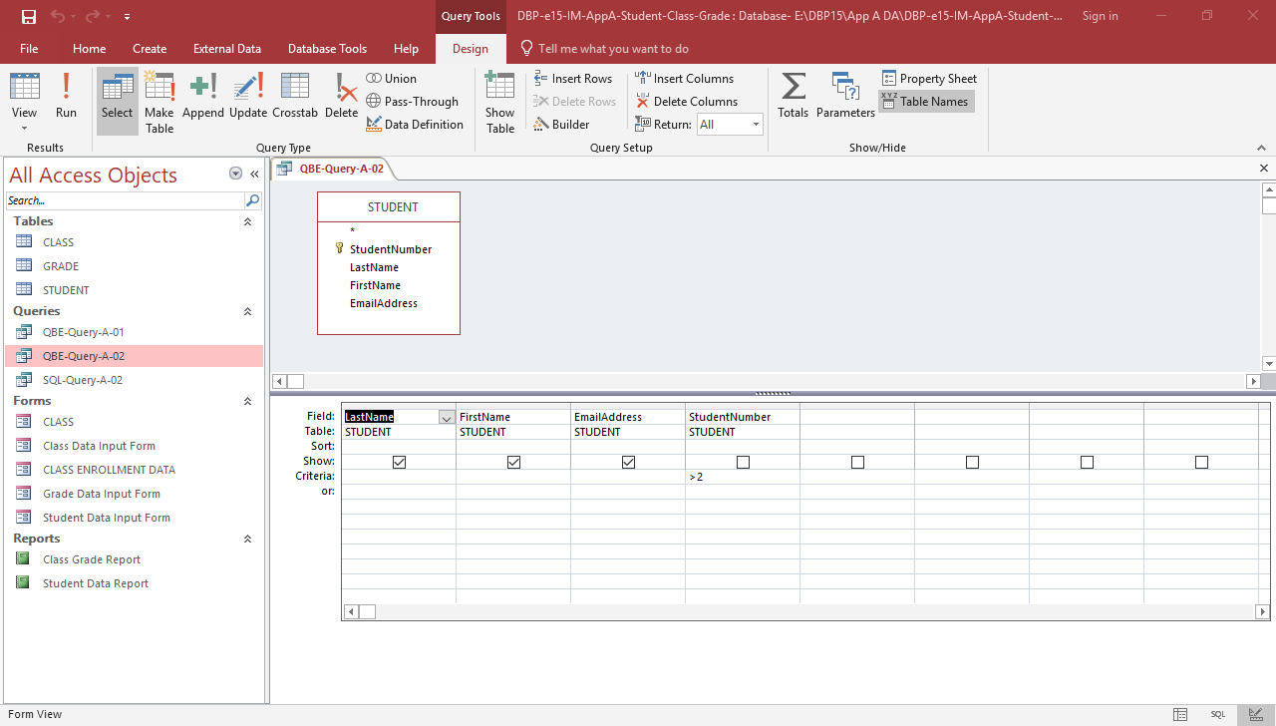
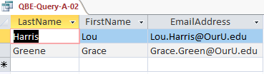

  - Use the Form Wizard to create a data input form for the STUDENT table. Name the form Student Data Input Form. Using the student data shown in Figure A-54, add the new students to the STUDENT table.
See the file DBP-e15-IM-AppA-Student-Grade-Class-Completed.aacdb.
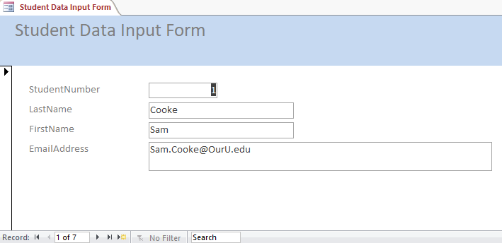
Use the “new record” button to add new rows
